AMT Assessment of a GoPro Recording Kit
for Recording On-Campus Classroom Instruction

Background and Overview:
The summary of 2020-2021 remote learning surveys and Student Focus Groups highlights the positive impact of course video recordings and the preference for its continuation with the return to in-person, on-campus instruction.

To accommodate, there are currently three campus teaching spaces with automated lecture capture capabilities: Annenberg 105, 201 E. Bridge, and Hameetman Auditorium. (Lecture capture includes built-in equipment to record and live stream video, audio, and projected materials, and cloud hosting to deliver links minutes after the recording ends. Courses using lecture capture can pre-schedule recording sessions, with its operation transparent to the instructor and students, and also use the flexible, ad-hoc recording option.) For all other venues, a manual recording solution will be required.

Per request of the CRCI, IACC, and the Office of the Provost, AMT tested the feasibility of an inexpensive, easy-to-use recording kit with a GoPro camera as a manual solution. The ~$950 kit includes a GoPro camera, Rode wireless lav microphone, tripod, mounts, adapters, and cables.

Conclusion: With approximately one hour of setup and post-recording processing per lecture, a GoPro kit is feasible to record on-campus classroom instruction. Note: The kit can be used with a laptop during recording to reduce the processing time per lecture at the cost of quality. Examples are provided below.

Please note: The GoPro Recording Kit is not a plug-and-play solution:
- The camera records HD format in 12-minute files, requiring an extra step of combining 5-6 files for a 1-hour lecture before encoding.
- Users will need to be trained on using the kit and workflow by reviewing Caltech-created tutorials or scheduling an appointment with AMT for location-specific training.
- Unlike automated lecture capture, this solution requires about one hour of labor per lecture to set up and strike equipment, and process and post the recording.

Below is a workflow recommendation, overview of tests, improvements to optimize the kit, and a resources.

GoPro Recording Kit Workflow Recommendation

For clear video and audio quality, and manageable file size, AMT recommends the following workflow:

- Set up the plugged-in GoPro camera to capture the instructor and all the teaching boards in one frame. The camera needs to be plugged in for long-form recordings due to the camera shutting down due to overheating if using batteries.
- Record internally to the camera’s micro SD card using the GoPro’s HD setting, 1920x1080, 24fps (~22 GB/hr).
- Use the Rode wireless lav microphone and charge the battery after every use.
- Use the free DaVinci Resolve application to combine 12-minute files and encode for delivery.
- Post final encoded file to Google Drive and provide link to students in Canvas.

Here are examples of this workflow
(also available in the Teaching Spaces table below, requires access.caltech credentials to view):
3x3 blackboard, 2x1 whiteboard, projection

This workflow requires ~1 hour of labor per lecture and results in a ~1.2 GB file for 1 hour of recorded lecture. The labor breakdown is as follows:

- 25 minutes to set up, do a quick record and playback test, and strike equipment
- 30 minutes to copy recording to a computer, combine files, and encode
- 5 minutes to upload to Google Drive using Caltech network

Note: To reduce the post-recording workflow, consider recording locally using Zoom, then post to Google Drive. This requires more set-up time before each class and results in a lower-quality video file, but reduces the post-recording workflow time from 1 hour to about 15 minutes.

The basis for this recommendation is from testing various elements listed below. Links to all the permutations of tests can be found in this speadsheet.

Overview of Tests

This section provides an overview of the spaces, equipment, equipment settings, workflows, and delivery platforms tested and justification for the recommendation of each (recommended option is orange and underlined.)

1. Teaching spaces - Two different but typical teaching spaces, both with a projector:

153 Noyes - 3x3 stackable blackboards | 213 Annenberg - 2x1 whiteboards
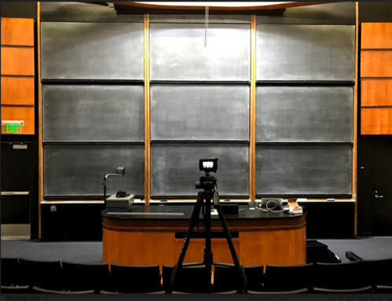 | 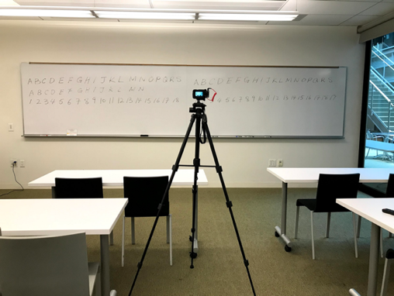
Click on an image below to review an HD recording example
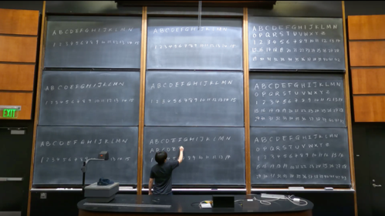 | 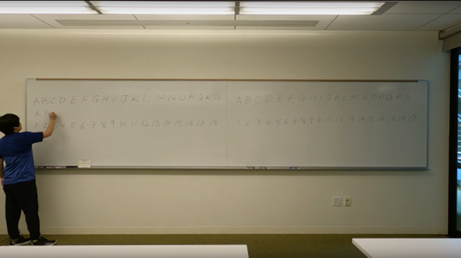
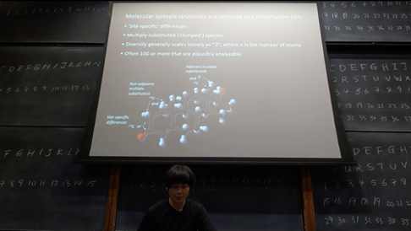 | 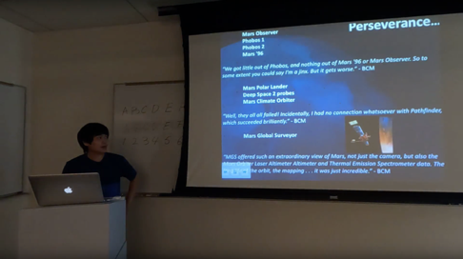

2. Camera resolutions - The GoPro camera offers many resolutions. The following were tested:

- 4K – 3,840 x 2,160 pixels (40 GB per hour)
- HD – 1,920 x 1,080 pixels (22 GB per hour)

AMT found that the clarity of the written work on the boards and projected image did not require 4K resolution for readability. Although image quality was greatly improved with the 4K setting, it does not warrant the larger file size and resulting upload time. Streaming 4K is also not available on the recommended teaching platforms – Google Drive and Canvas Studio.

Resolution comparison - HD vs. 4K:

153 Noyes - 3x3 stackable blackboards | 213 Annenberg - 2x1 whiteboards
Click on an image to view recording example
HD – linked from Google Drive
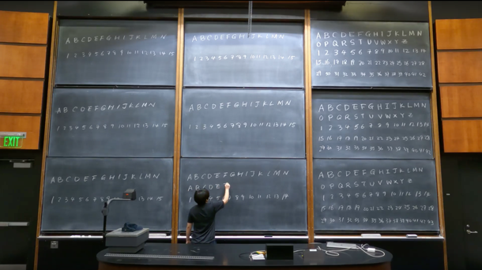 | 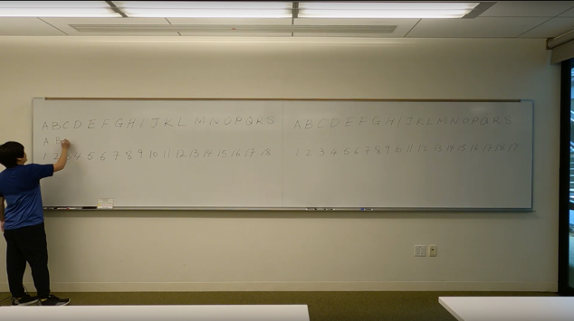
4K – linked from Google Drive (streams as HD)
compare to quality above, streaming from same platform as highest quality
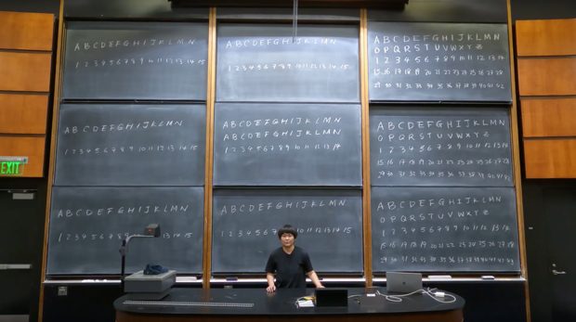 | 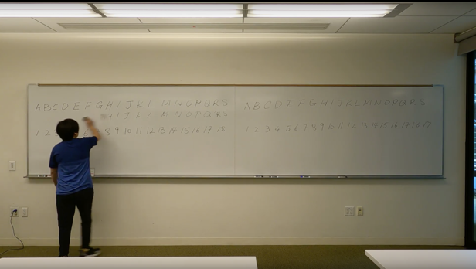
4K – linked from YouTube (streams as 4K)
compare to above quality, YouTube is the only 4k streaming video platform reviewed, ensure your YouTube player is set to play back the 4K setting by click on the gear icon in the player
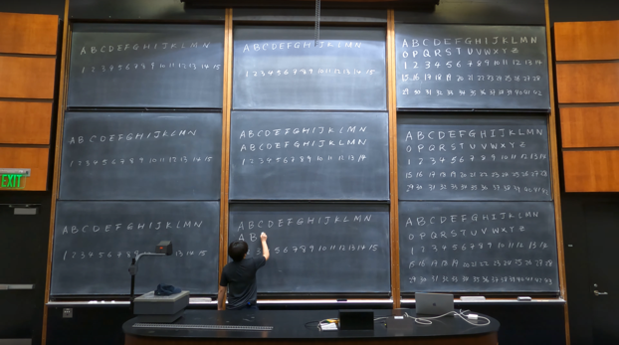 | 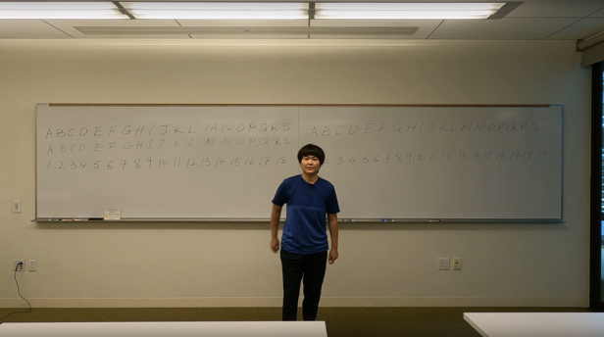

AMT recommends The GoPro Linear lens (L) choice to capture the entire blackboard or whiteboard set while minimizing distortion. The Super Wide and Wide lenses create the fisheye warping effect on the edges of the frame rendering board work unreadable.

The GoPro kit includes micro SD cards of the following sizes: 32 GB (1h 19 minutes as HD) which came as part of a cost-savings bundle, and 128 GB (5h 16m as HD).

3. Microphones – The following microphones were tested:
- GoPro built-in microphone
- External Rode wireless lavaliere microphone

As audio quality is the most important factor in the viewing satisfaction of a recording, we recommend using the Rode wireless lav. Its directionality follows the instructor if they turn to the board to write or move around the room. It is also a higher-quality microphone producing less noisy audio.

Microphone comparisons in both large and medium spaces:

Built-in GoPro mic |  | External Rode wireless lavaliere mic
 | Click on an image to listen to a recording example
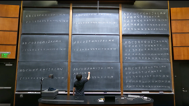 | 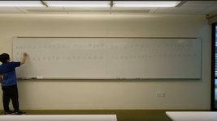 | 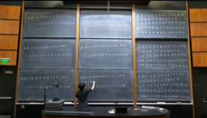
Large space  Built-in mic | Medium space  Built-in mic | Large space  External Lav mic | Medium space  External Lav mic

Note: A fully charged lav mic system can be used up to 7 hours. It is best practice to re-charge the system (both the transmitter and receiver) via USB-C cables to your computer after each lecture. It takes less than 2 hours to fully charge.

4. Post-production workflows – The following workflows were tested:
- AMT Recommended: Record internally to a micro SD card on the GoPro camera, copy to computer, combine files to one, and encode for delivery
  - Card reader is connected to computer to copy files to hard drive
  - Use DaVinci Resolve application (Mac+Windows+Linux) to stitch and encode (~15 minutes computer time)
  - Or, use the Joiner application (Mac+Windows) to stitch and encode (~80 minutes computer time)
  - Resulting quality of files from the stitcher/encoder software options are comparable to one another

- Schedule via Zoom LTI in Canvas, Record to Zoom Cloud via Zoom session. (~20 minutes to receive Zoom Cloud link which can automatically post to Canvas course)
  - The image quality is nearly unreadable for all board work and most text of projected image.
  - Requires a laptop, Zoom Pro account, and more set up and strike time.
  - No file transfer required, except to archive from Zoom Cloud.
  - Note: Simultaneously recording via Zoom and internally to the SD card is not possible.

AMT recommends recording to a micro SD card that is removed from the camera, placed in a card reader, and copied to a computer. The GoPro camera is designed for high-action, short-form recordings and records in 4 GB (~12 minute intervals for HD resolution) files that need to be combined into one file. The 20 GB/hr HD file size also needs to be compressed for final delivery. GoPro offers Joiner software but it takes 5x longer than using DaVinci Resolve – another free application and AMT’s recommended tool.

The Zoom Cloud recording offers a much easier post-production workflow, but is not recommended for the following reasons:
- More complicated setup and requires a laptop
- Poor readability of board work and projected images due to:
  - Much lower video resolution - 1280x720
  - Over compression and artifacts

Readability comparisons of recommended HD workflow and Zoom Cloud workflow:

HD | Zoom Cloud
Click on an image to view a recording example
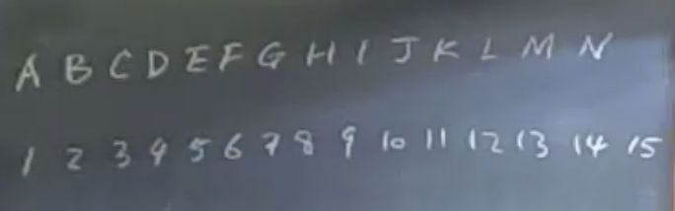 | 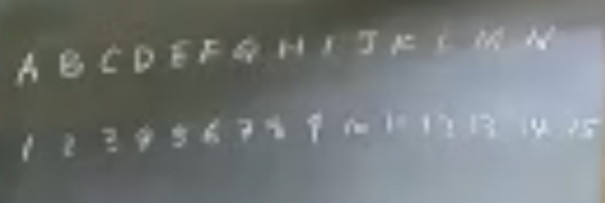
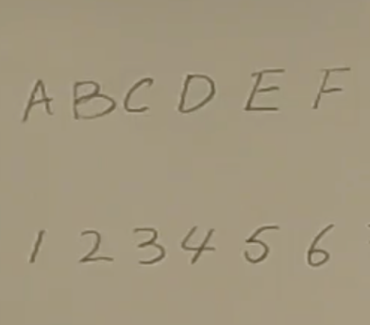 | 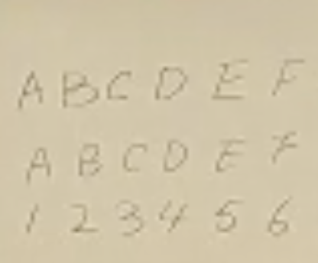
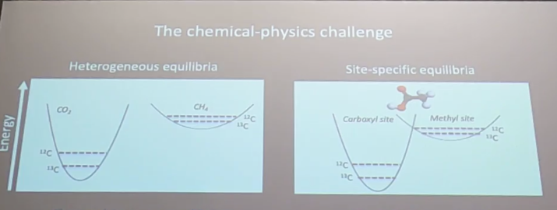 | 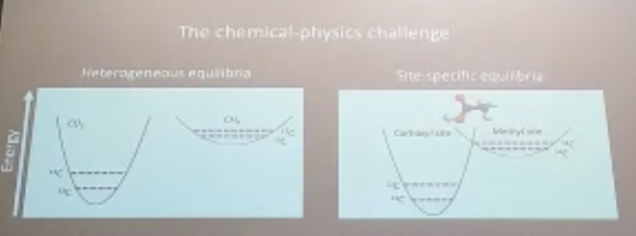

Recording with Zoom Cloud: If an instructor prefers the Zoom recording workflow (schedule recordings using the Zoom LTI offered in Canvas and move recordings to Google Drive after the term is over), AMT recommends the following:

- If recording the instructor and whiteboard, blackboard, or projection, provide lecture notes and slides along with the recording. The Zoom recording will be only a reference to the written and projected content as readability cannot be guaranteed.
- If only teaching with projected visuals, set up the camera on the instructor only and not include the projection screen. Record the slides in Zoom Cloud as a screenshare during the Zoom session.

Recording locally with Zoom (this option is recommended over recording to Zoom Cloud but results in lower quality video files than the HD internal recording): If an instructor prefers recording with Zoom, a higher quality video file can be achieved by recording locally. This does require a laptop to be part of the setup like Zoom Cloud. After instruction ends and the recording in stopped, Zoom needs to fully process the recording before turning off the computer. This can take from 5-15 minutes for a 1-hour local recording. Once processed, rename the Zoom_0.mp4 file to identify the lecture, and copy to Google Drive.

Readability comparisons of recommended Zoom Local workflow versus Zoom Cloud workflow:

Zoom Local | Zoom Cloud
Click on an image to view a recording example
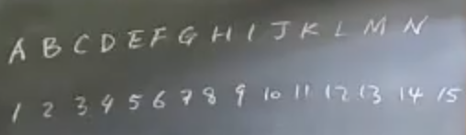 | 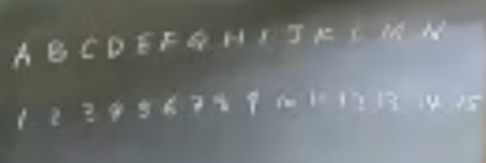

Notes on a popular recording application with the kit: AMT tested recording locally using OBS Studio, used by many instructor during the 2020-2021 academic year.The free, open-source tool creates higher-quality, real-time encoded files than Zoom, but does not reliably recognize the GoPro camera and Rode mic which made it not a viable solution.

5. Platform delivery – The following platforms were tested:

- Google Drive
  - Quick upload with minimal processing time.
  - Various data rates were offered.
  - Note: An uploaded 4K file is streamed as HD, but can be downloaded as 4K.
- Canvas Studio
  - Longer upload and processing times than above.
  - Various data rates were offered.
  - Note: A 4K file is streamed as HD.
- Box
  - Requires users to download files to view as Box is not a streaming video platform.
- YouTube – only if 4K is requested by instructor
  - Only platform that streams 4K quality.
  - Note: Content posted to YouTube will be viewable beyond access.caltech users. Care should be taken that recordings follow FERPA, copyright, and export compliance restrictions.

Delivery platform comparisons:

Google Drive – streaming HD  (4K can be downloaded) | 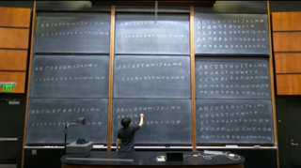
Canvas Studio – streaming HD | 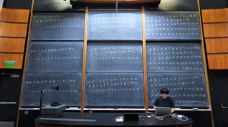
Box – for download only, not a video streaming platform | 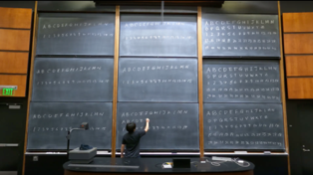
YouTube – streaming 4K | 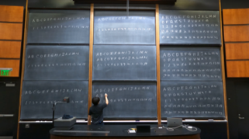

Kit improvements

Additional items to improve recordings with this kit:

- To improve readability of whiteboards:
  - add evenly distributed lighting to whiteboards.
  - use black markers only.
- To improve visibility of instructor when teaching with projection from a lectern:
  - Add a spotlight to the lectern region to room

Resources

- List of items in the GoPro Recording kit, including cost and links to purchase
- All recordings for the GoPro kit assessment
- Production photos: 153 Noyes and 213 Annenberg
- Step-by-step, How To videos on using the kit.

