
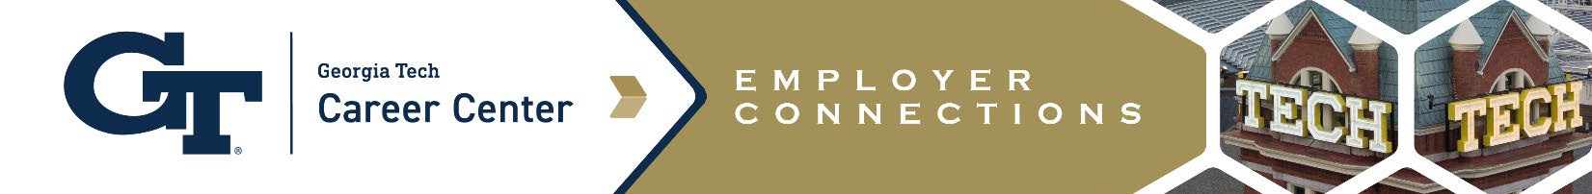
Recruiting Calendar

Fall 2024
Reservations for Fall 2023 On-Campus Recruiting Open | July 8
Classes Begin | August 19
Labor Day (Campus Closed) | September 2
Company Information Sessions  (reservations are available online through the Student Success Center) | August 29– November 22
Annual Fall All-Majors Career Fair | September 9- September 10
Fall Interviews* | September 10 –November 22  Offer Guideline: October 16 or 3 weeks whichever is longer
Fall Break (No Recruiting) | October 14 - October 15
Thanksgiving Break (No Recruiting/Campus Closed) | November 27 -November 29
Classes End | December 3
Final Exams (No Recruiting) | December 5- December 12
End of Term/Commencement | December 12-14
Winter Break (Campus Closed) | December 23 - December 27

Resources:
- Co-op & Internship: Calendar & Deadlines
- For Reference: Fall Semester 2024 Academic Calendar
*We encourage students to participate in their own religious and spiritual practice during the recruiting season. We ask employers to take this into consideration for hiring deadlines and be understanding of students who request accommodations for this reason. For your reference, please review Georgia Tech Diversity Calendar.

1

