
Policy: provision of Gender Neutral Toilets
Estates & Facilities

Unit name goes here

Purpose
This policy defines the University’s requirements for gender neutral (GN) toilets. We are committed to creating and sustaining an inclusive work and study environment for all staff and students. We recognise that some members of the University community may identify as being non-binary and/or do not identify as either male or female and that non-gendered facilities such as toilets and changing facilities should be provided where possible. We are also mindful that some groups may not be comfortable with gender neutral toilets for religious or cultural reasons and will therefore take steps to ensure that both gendered and gender-neutral toilets are available across our Estate.
The policy aims to provide guidance to project and maintenance teams relating to appropriate provision of gender neutral toilets across the University’s campuses in line with our Diversity and Inclusion aims, striking a balance between this and provision of gendered toilets which are important to other groups and which also support D&I.
Scope
This policy covers all the University’s campuses, but can be adapted as appropriate overseas.
Where there is a conflict between this policy and national policies such as building regulations or disability access requirements, the national guidelines must take precedence.
Definitions
Gender Neutral Toilets (GNT): we have adopted the NUS definition of GNTs as ‘toilets and/or bathroom facilities which do not have gendered signage and which do not require the person using them to define into a gender.’

Facilities
There are three main ways in which they can be installed:
- the Single Toilet Model, which is one or more single gender-neutral toilets with their own sink/hand dryers etc;
- the Multiple Cubicle Model, a set of toilets without gendered signage. This can be done by putting in a new set of toilets entirely, or by changing the signs on a set of existing toilets;
- the ‘Accessible’ Toilet Model, whereby the existing disabled toilet is changed into an ‘accessible’ toilet. These are accessible for disabled people and those who wish to use gender-neutral toilets.
Gender neutral facilities should not contain urinals.
New Build
New buildings shall all contain a minimum of one GN toilet, alongside provision of gendered toilets. The size and capacity of the building should be taken into account when determining whether one is sufficient.
Refurbishments
Major refurbishments should, where possible follow the guidance above for new build. For minor toilet refurbishment, consideration should be given to the distribution and quantity of other facilities in the building. If no GN toilets are currently provided, the opportunity to do so should be taken if at all possible. Any refurbishment of toilets should not cause the building provision to fall below minimum guidelines.
Distribution
The aim is to provide at least one GN toilet in all major buildings if possible whilst also maintaining gendered provision. This is particularly important in public or teaching buildings. This will take time and resources to implement and therefore will be developed over time. There should also be an awareness that not all buildings will be able to be configured appropriately to achieve this.
Signage
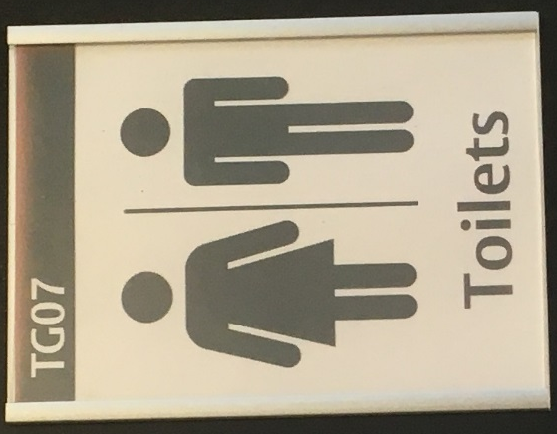
The following sign is to be used to identify GN facilities at the University:

ADVERTISING THE AVAILABILITY OF GENDER NEUTRAL TOILETS
The availability of gender neutral toilets across our campuses will be shown clearly on the standard campus maps, with this information updated annually.

Version control
Version | Keeper | Reviewed | Approved by | Approval date
1.0 | E&F | Every four years | UEB | 25.06.18

