Short term visit to Indian Institute of Technology Kharagpur for Coursework or Research not leading to a Degree
ONLINE PRELIMINARY APPLICATION FORM
Instructionsfor filling this form:
- Please treat all fields as mandatory. Incomplete application will not be considered. In case any field is not applicable then please put ‘NA’. It should take nearly about 45mins to complete the application.
- Please provide your personal details as per your passport.
- Please attach scan copies of your passport, current official transcripts, past educational degrees. Please note that your application will be processed only after we receive these scanned copies.
- After your preliminary application is approved you will be asked to complete your online application with
further details.

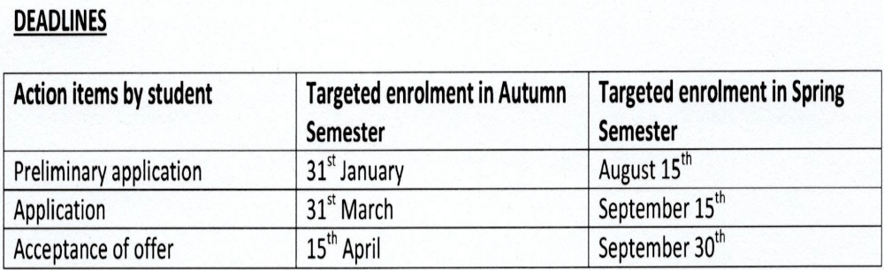

PERSONAL DETAILS:

Please provide your name, date of birth and gender as per your travel documents to be attached herewith.
Name as in Passport
Date of Birth
Place of Birth
Gender
Nationality
Main Language/s spoken at home
Other Languages Known

Disability details:

Please indicate any disabilities you may have even if you do not require assistance. Further information about available support can be provided on request. Do you have a disability, impairment or long term medical condition?

Contact Details:

Please provide your current contact email and current contact phone details. The email address will be used to contact you with your username and password once you have been registered so please ensure you provide a valid email address.

Email Address
Confirm Email Address
Home Phone
Mobile Phone
Address for Communication:

Please provide your current mailing address.
Country
Address Line 1
Address Line 2
Address Line 3
Suburb/Town
State
Postcode
Contact Person in case of Emergency
Contact Number in case of Emergency

Passport Details:

(Please attach the scan copy of your valid passport)
Passport Number
Passport Issued date
Passport expiry date
Place of Issue, Issuing Country
HAVE YOU PREVIOUSLY BEEN TO INDIAN INSTITUTE OF TECHNOLOGY KHARAGPUR?
(Tick your answer)

YES NO
If ‘Yes’ please provide the following details:
Previous Dates of Arrival in IITKGP | Previous Student ID issued at IITKGP | Semester visited | Your past mentors at IITKPG | Course work /Project’s name | Date of Departure from IITKGP

Have you contacted any Faculty member or any office of the Institute about your present intended visit to IITKGP? (Tick your answer)

YES NO
If ‘Yes’ please provide the following details:
Name of the Faculty/ Person Contacted | Name of the respective Department/School/Center/Lab/Office of Int.Relations where contacted | Details of Communications (You may provide email references, if any)

Intended courses /areas of Research in IITKGP during this stay:

FROM: (MM/YY)…………….
TO : (MM/YY)………….....

Intended duration of stay at IITKGP:

Do you have any scholarship or any funding source?
(Tick your answer)

YES NO
If ‘YES’ Please specify: ………………………………………………………………………………………………………………………………………………..………………………………………………………………………………………………………………………………………………………………………………………………………………
(NOTE: Eligibility and admission will be decided independent of financial status.)
HOME INSTITUTION &HOME INSTITUTION ADMINISTRATOR’S DETAILS:

- Current Programme of Study:
Mention briefly about the Programme you are currently enrolled in (Also please attach the scan copy(ies)of your transcript(s) wherever applicable).

- Please provide the name and address of your home institution: | - Name:  …………………………………………………………  - Address:  …………………………………………………………
- Does your Institution have an MOU with IITKGP? | YES NO
- Please provide the details of the person whom IITKGP will correspond with during your visit and share official correspondences: | - Contact Person’s Name: ……………………………………………………..  - Designation: ……………………………………………………..  - Email ID:  ……………………………………………………..  - Contact Number: …………………………………………………  - Official Business Hours : ……………………………….......................
ACADEMIC QUALIFICATIONS/ EDUCATIONAL DETAILS: (Latest on top including the ongoing programme)

SL NO. | NAME OF THE DEGREE/EXAM | UNIVERSITY/BOARD/COUNCIL | YEAR OF COMPLETION/EXPECTED | GPA  (or  EQUIVALENT) | MAXIMUM GPA SCALE  (or  EQUIVALENT) | MAJOR/  SPECIALISATION/  SUBJECTS | TRANSCRIPTS/  GRADE CARD
1. |  |  |  |  |  |  | Attach
2. |  |  |  |  |  |  | Attach
3. |  |  |  |  |  |  | Attach
4. |  |  |  |  |  |  | Attach
5. |  |  |  |  |  |  | Attach

Publications/research papers/books: (You may add more rows if required)

SL. NO | TITLE OF PAPER/BOOK | PUBLICATION TYPE | PUBLICATION YEAR | ADD/REMOVE

WORK EXPERIENCE DETAILS: (You may add more rows if required)

SL. NO | Company Name | Nature of Job | From | To | Supporting Docs
1. |  |  |  |  | Attach
2. |  |  |  |  | Attach
3. |  |  |  |  | Attach

