

Using My Sussex – a how-to guide
This guide is to support you to use My Sussex – our new online portal for student support.
You need to be a registered student to use My Sussex for enquiries, events and appointments, but our FAQs are open to all.

What is My Sussex?
My Sussex will help you access information, advice and support throughout your time with us. It will:
- help you find answers to many questions, from the personal to the academic, using a thorough set of FAQs
- help you to support your wellbeing
- make it easier to access the help you need, whether that’s general advice or referral to a specific support service.

Where do I find My Sussex?
You will find links on many Student Hub pages, or you can go directly to My Sussex.

How do I use My Sussex?
Type your question directly into the search bar at the top of the homepage. It will search for answers in our FAQs using your keywords.

Alternatively, you can browse the FAQs by category and look for a range of related questions.
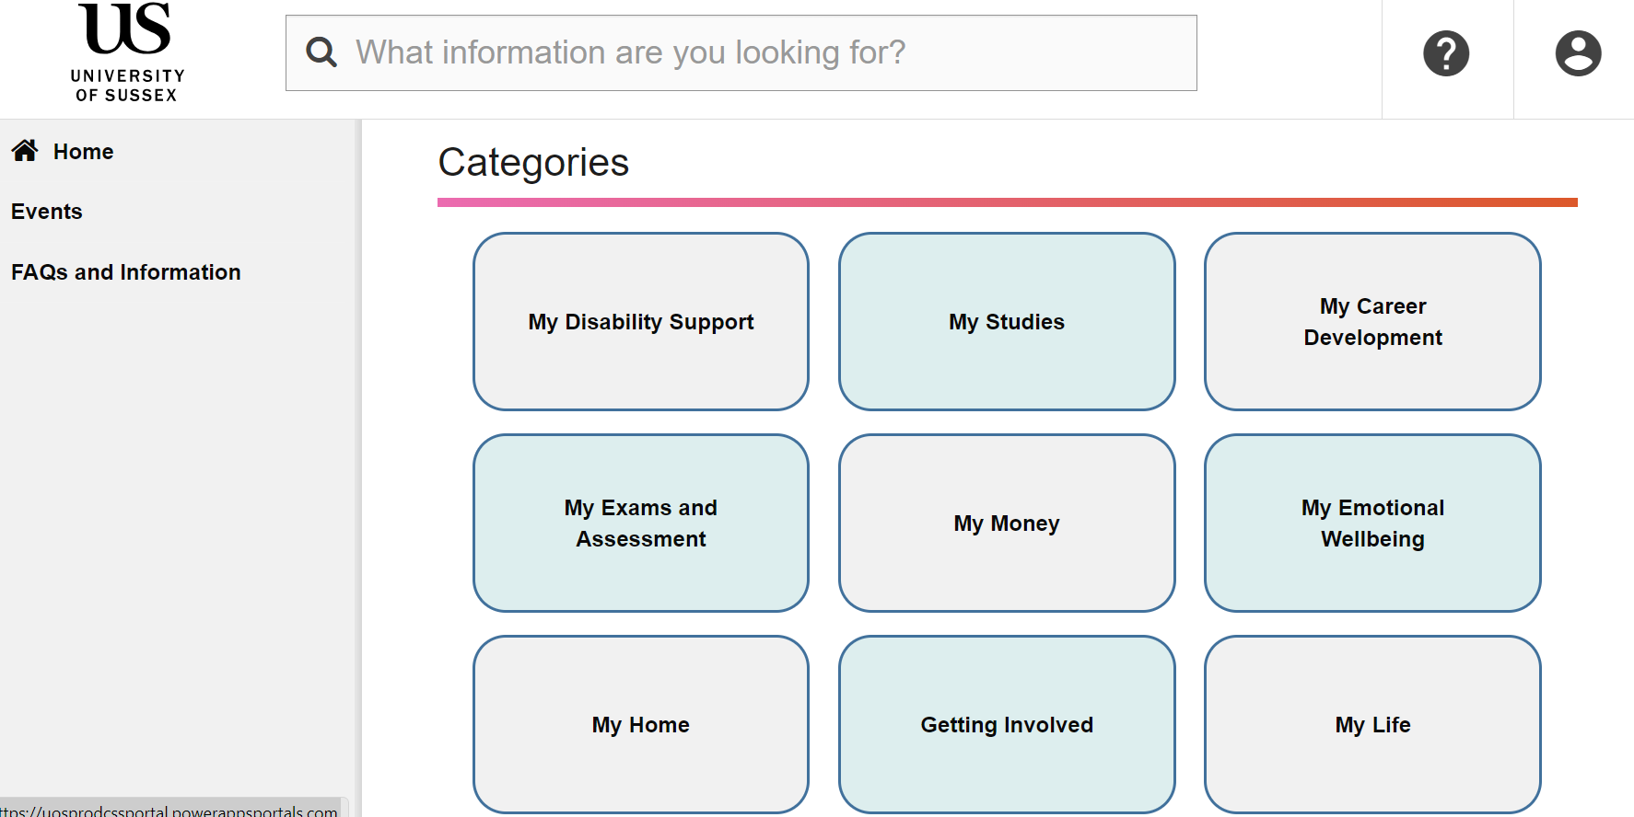
Our FAQs are designed to help you answer your question without having to submit an enquiry. However, if you cannot find what you are looking for, you can login to ask for help.

How do I log into My Sussex?
For full access to My Sussex you will need to log in using your Sussex username and password.
Look for the person icon in the top right corner and sign in using the Azure AD option.
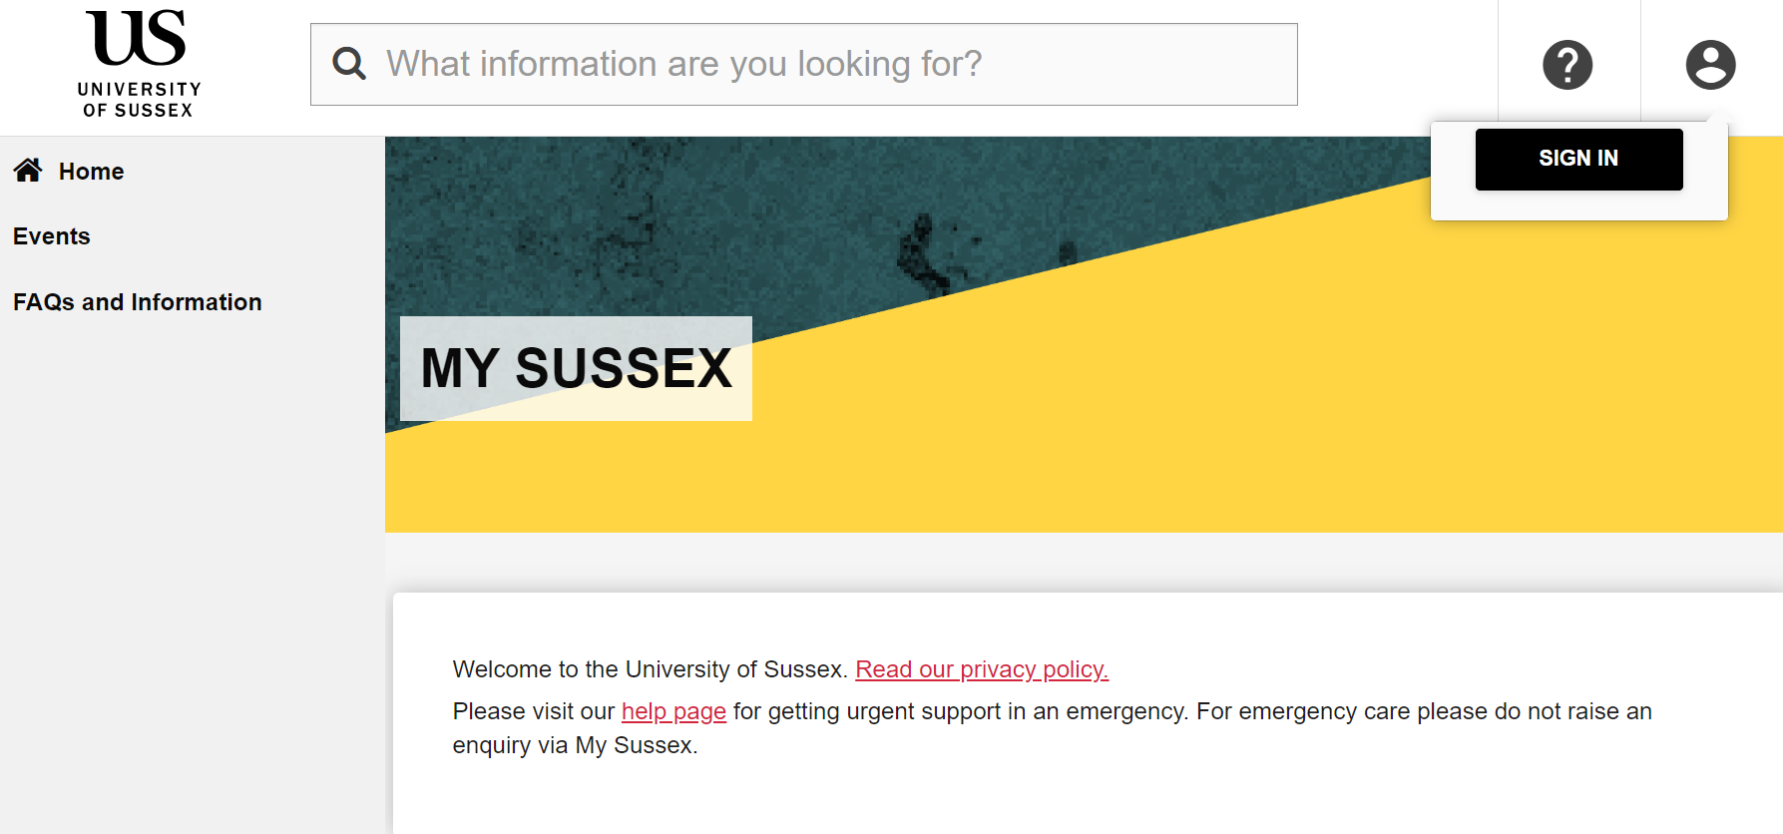
Once you have logged in, you will see a range of areas you can now explore. You can book and manage events, ask for help, and access your enquiries, cases and appointments.

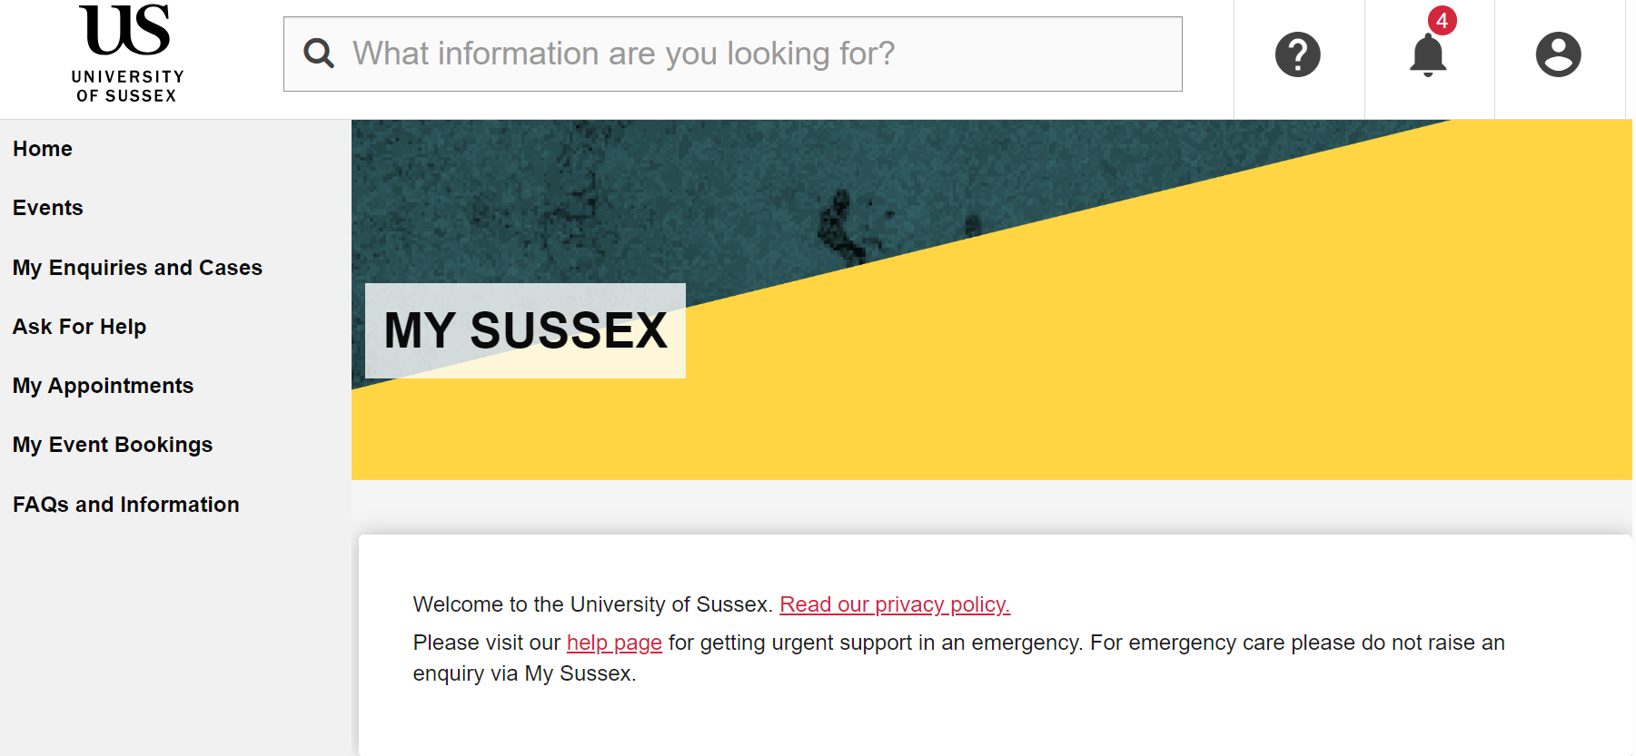

How do I make an enquiry in My Sussex?
If any FAQ does not answer everything you need to know, you can make an enquiry directly from the page. Just select the submit an enquiry link above the answer.
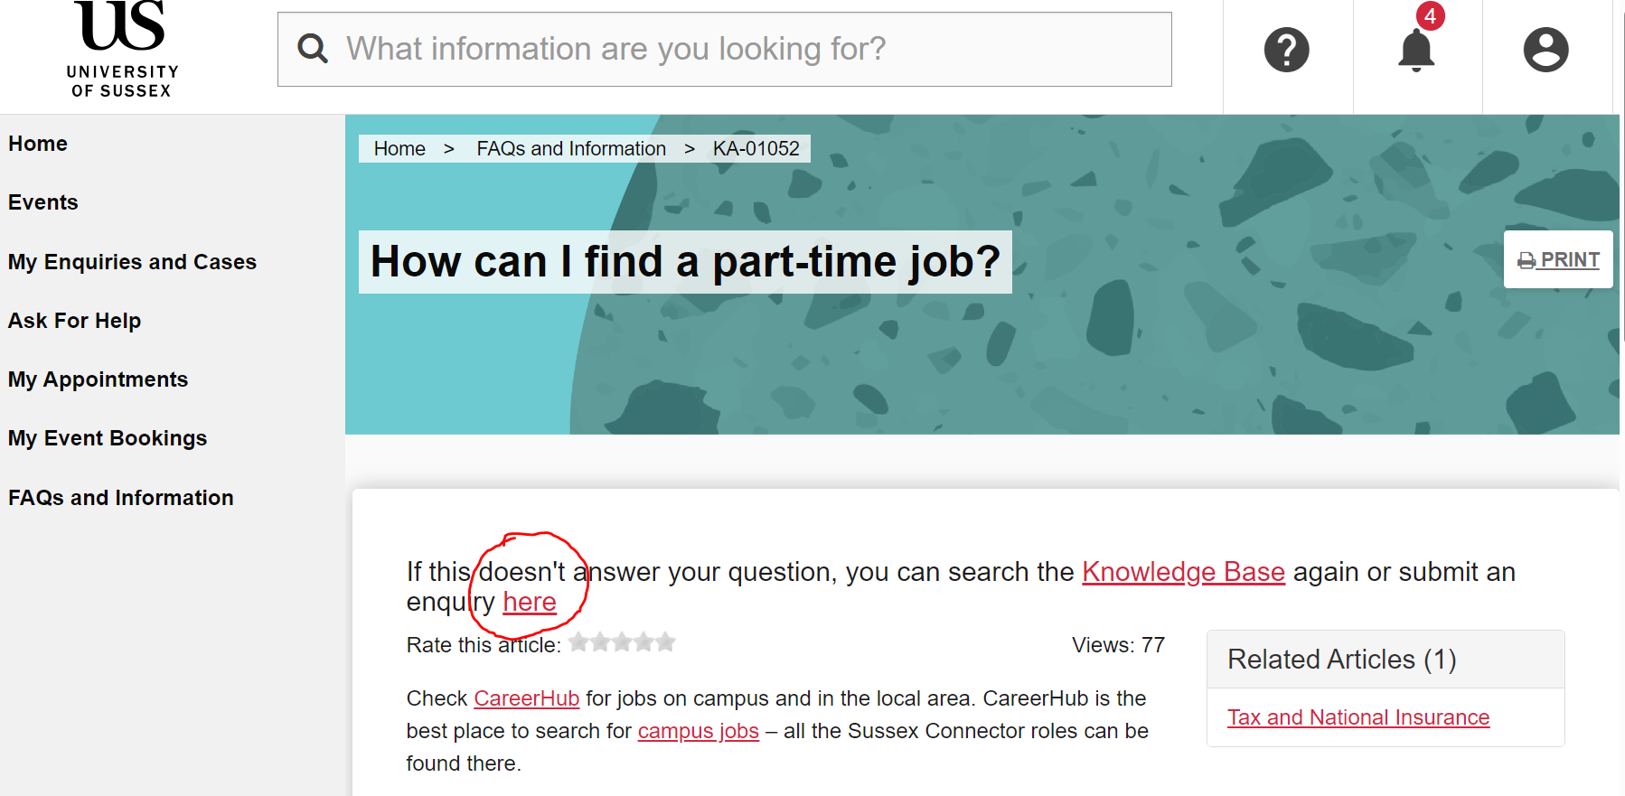
You can also submit an enquiry by going straight to the Ask for Help section.
When you raise an enquiry, you will need to complete the following steps:
  - Type in your ‘Area of enquiry’ – this is asking you what your enquiry is about (for example ‘council tax’). You will then see that we will try and help your question with some of our FAQs. 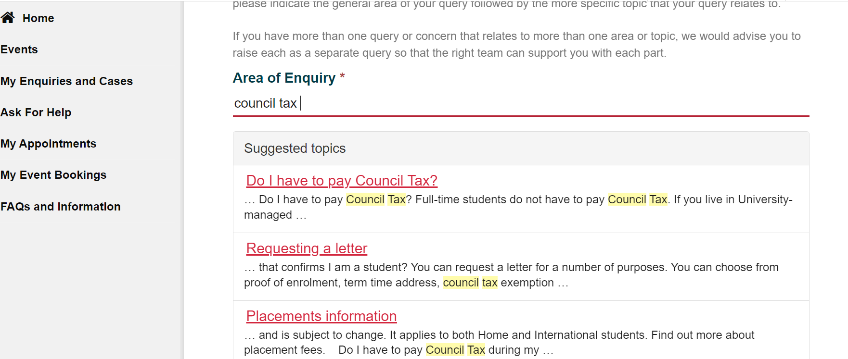
  - If the FAQs do not answer your question, you then choose your enquiry type. These correspond to the FAQ categories. From the drop-down menu, choose the enquiry type that best suits your need. 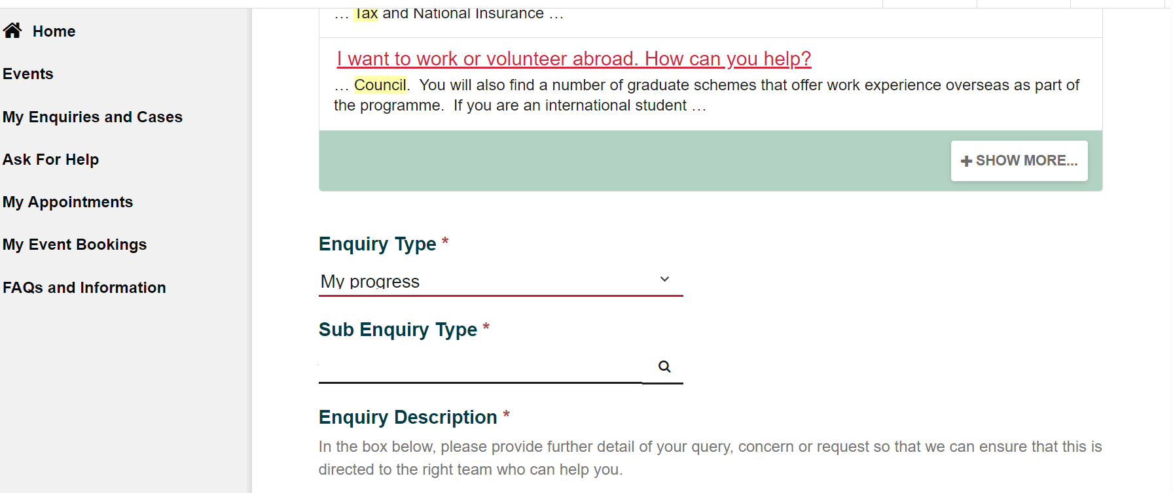
  - You will then need to choose a sub-enquiry type. Select the magnifying glass to find these and choose the one that best suits your enquiry. Do not worry if you cannot find an exact match, we will make sure it is answered correctly.
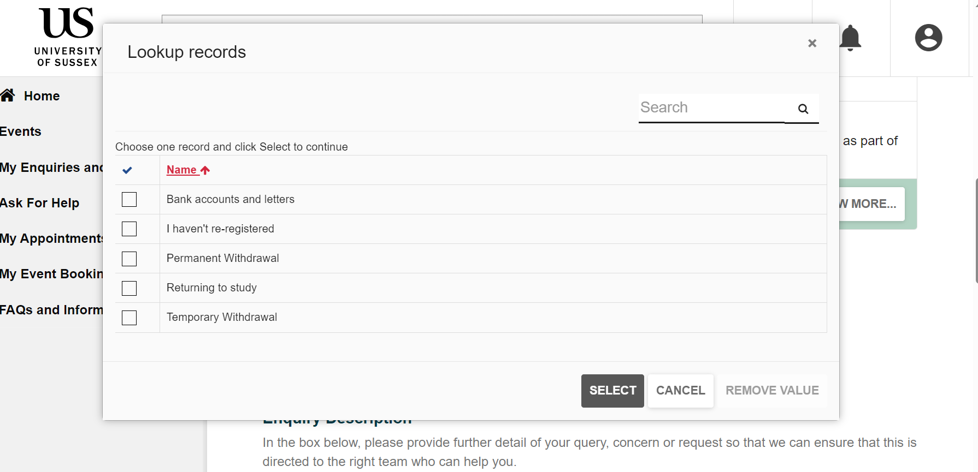
  - You need to write your enquiry in the enquiry description section. 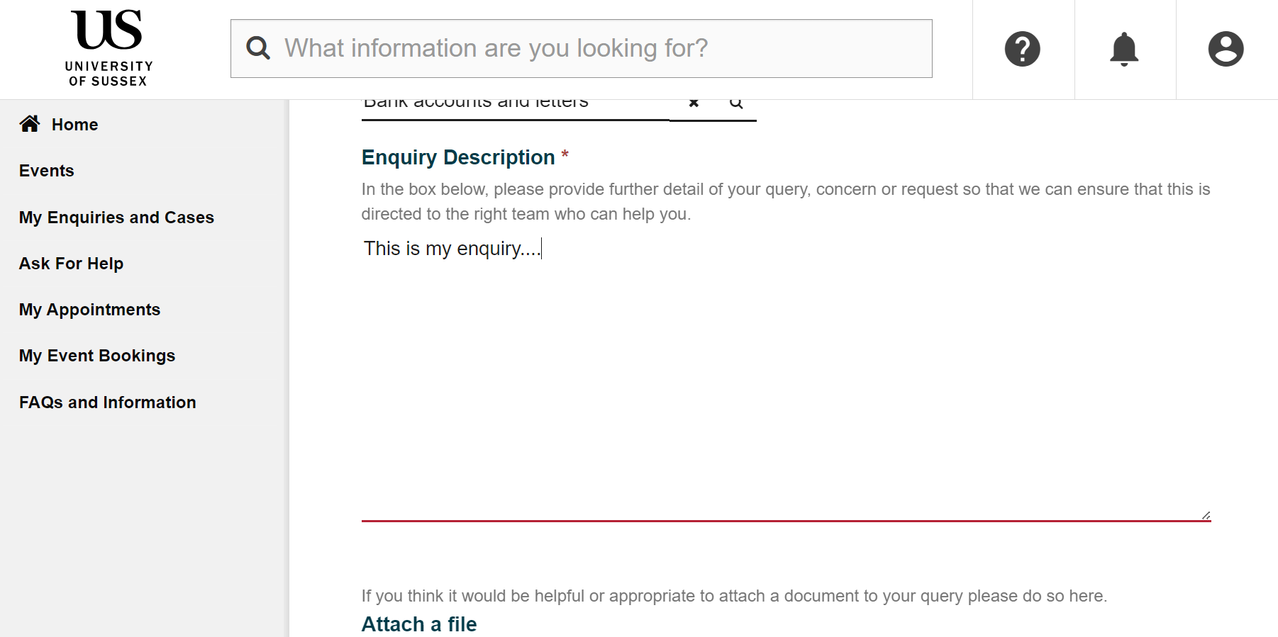
  - You can also attach a document to your enquiry, but this is optional. You then need to press ‘submit’. 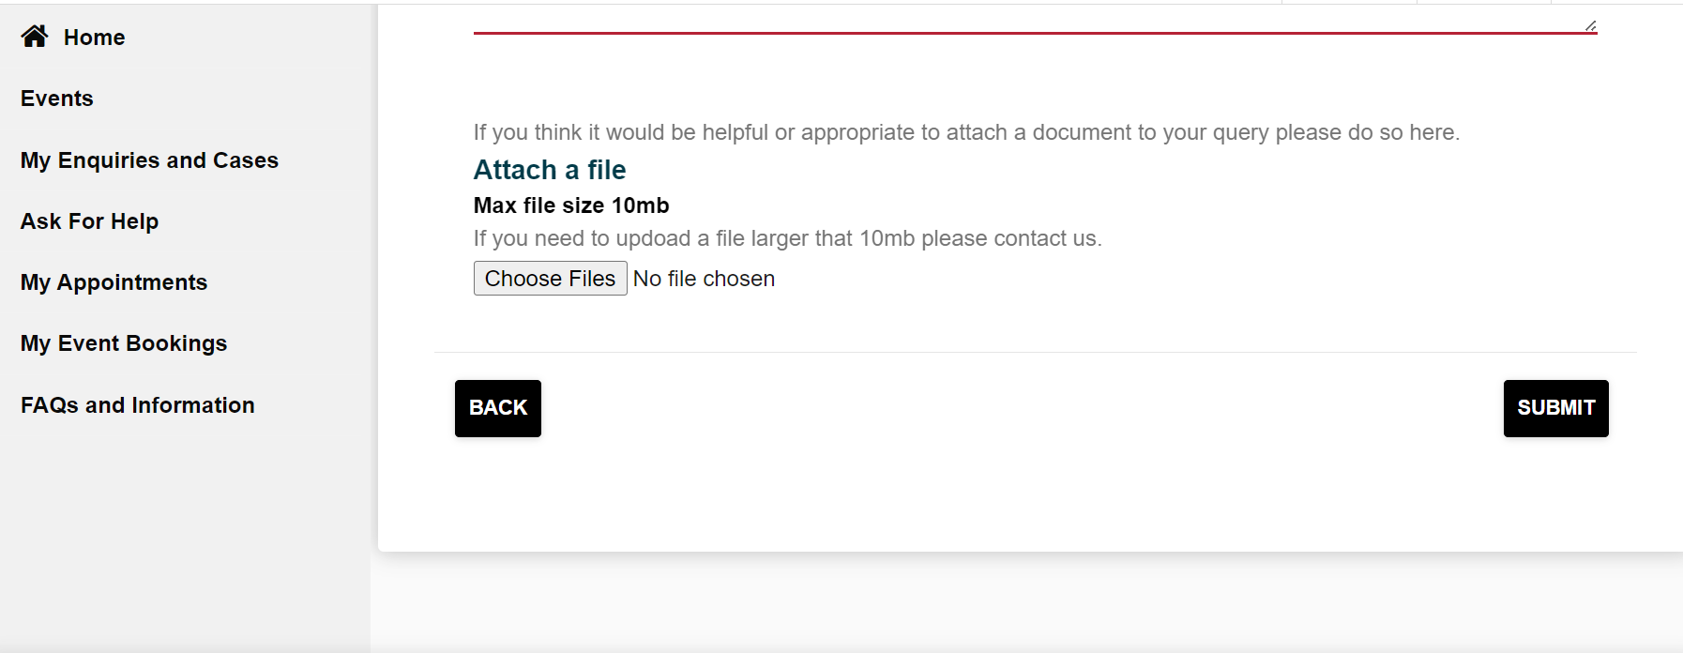

How do I view, edit or add to my enquiries?
Once you have created an enquiry, you will be able to see it in My Enquiries and Cases, along with any other enquiries you have submitted.
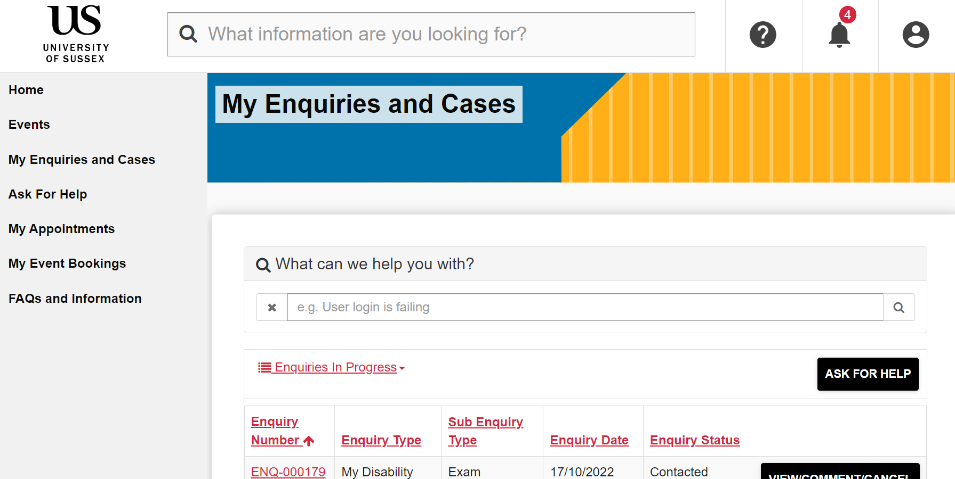
If you would like to add additional information to your enquiries, you can select ‘view/comment/cancel’.
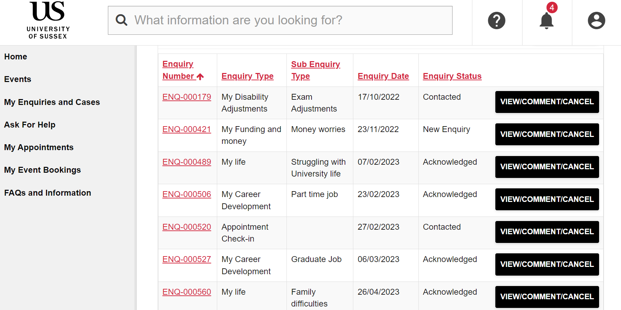
This will enable you to add a comment or a document, which will be sent to the member of staff that is supporting you.
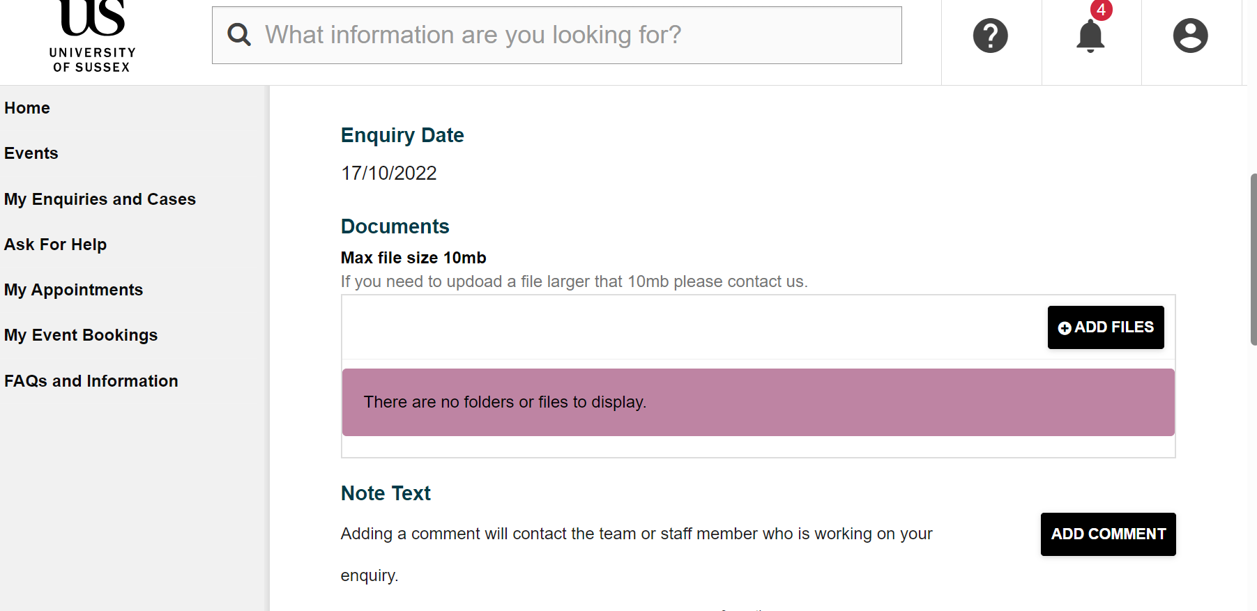

What is a ‘case’ and how can I find mine on My Sussex?
A case is when you require support from a member of staff for a longer period of time than an enquiry. We expect an enquiry to be a question and an answer, with opportunity to ask follow up questions through comments. A case will be created if a member of staff thinks that your issue needs longer to resolve or might need support from more than one of our support teams at Sussex.
Cases can be found in the My Enquires and Cases section. You will be able to view each case and add comments to them by selecting ‘view/comment’.
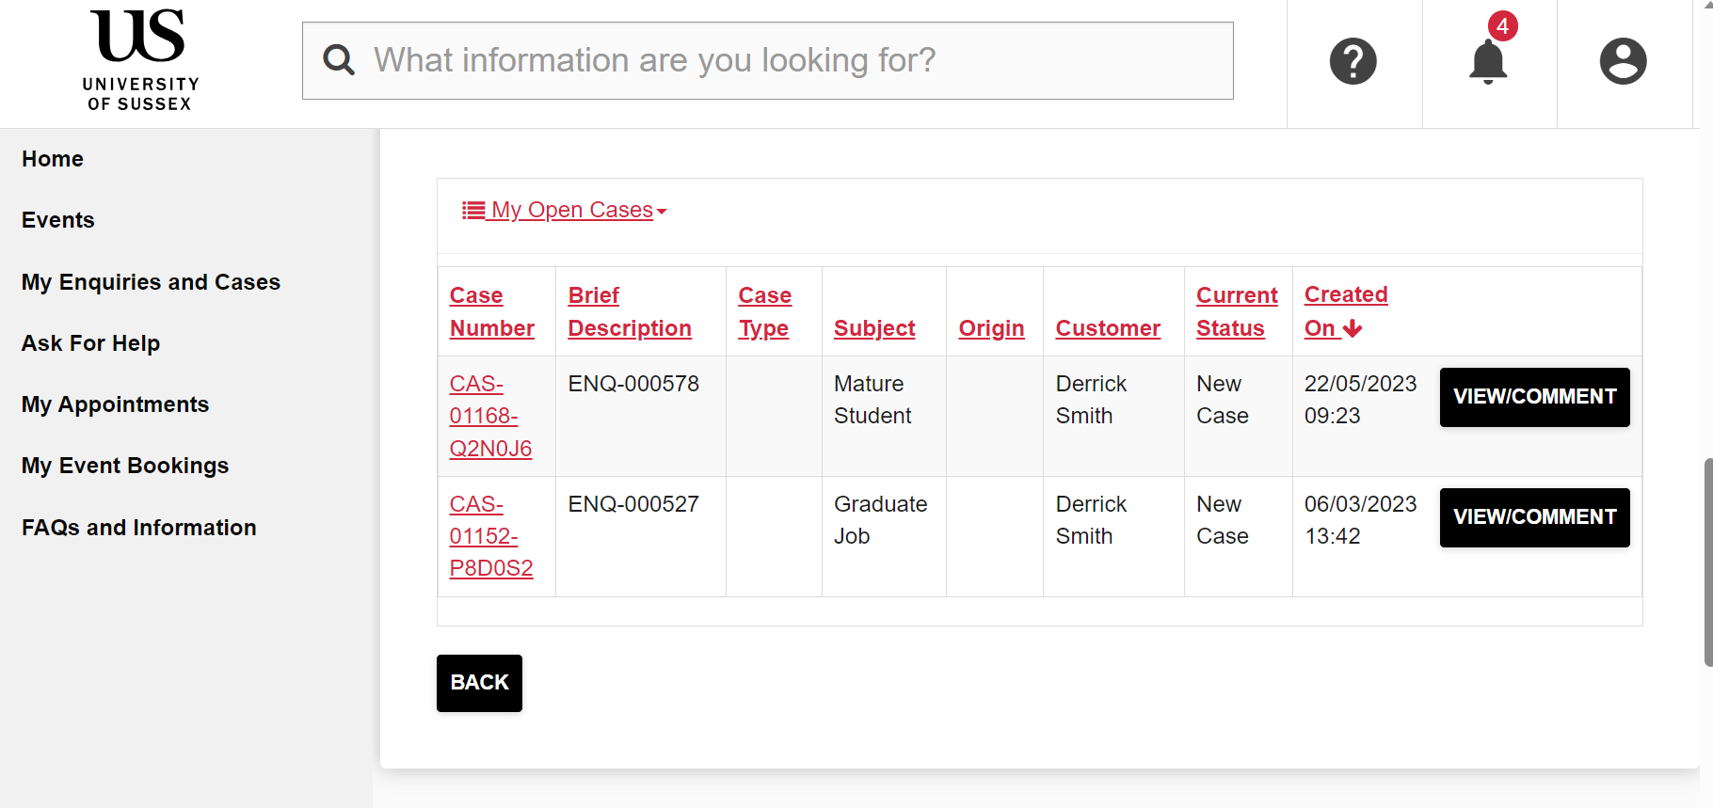

How can I view or change my appointments on My Sussex?
When an appointment is booked for you with one of our support teams at Sussex you will receive an email notification with all the details you need. If you would like to view what appointments have been made, you can see this on My Sussex in the My Appointments section.
You cannot book your own appointments on My Sussex. They will be booked for you by a member of staff. If you are unable to make your appointment you must give that staff member 24 hours’ notice. You can cancel your appointment in My Sussex.
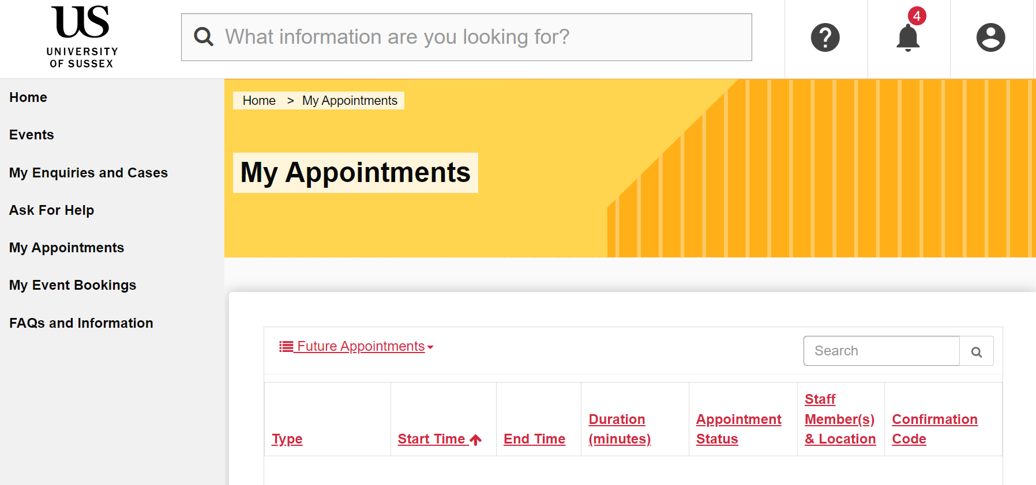

How do I book and manage events on My Sussex?
The Events section will show a collection of university-wide events that you can attend. After finding an event that you are interested in, you can find out more about it and select ‘register’ to book. There will also be a section for you to complete any special access requirements if you should need them.
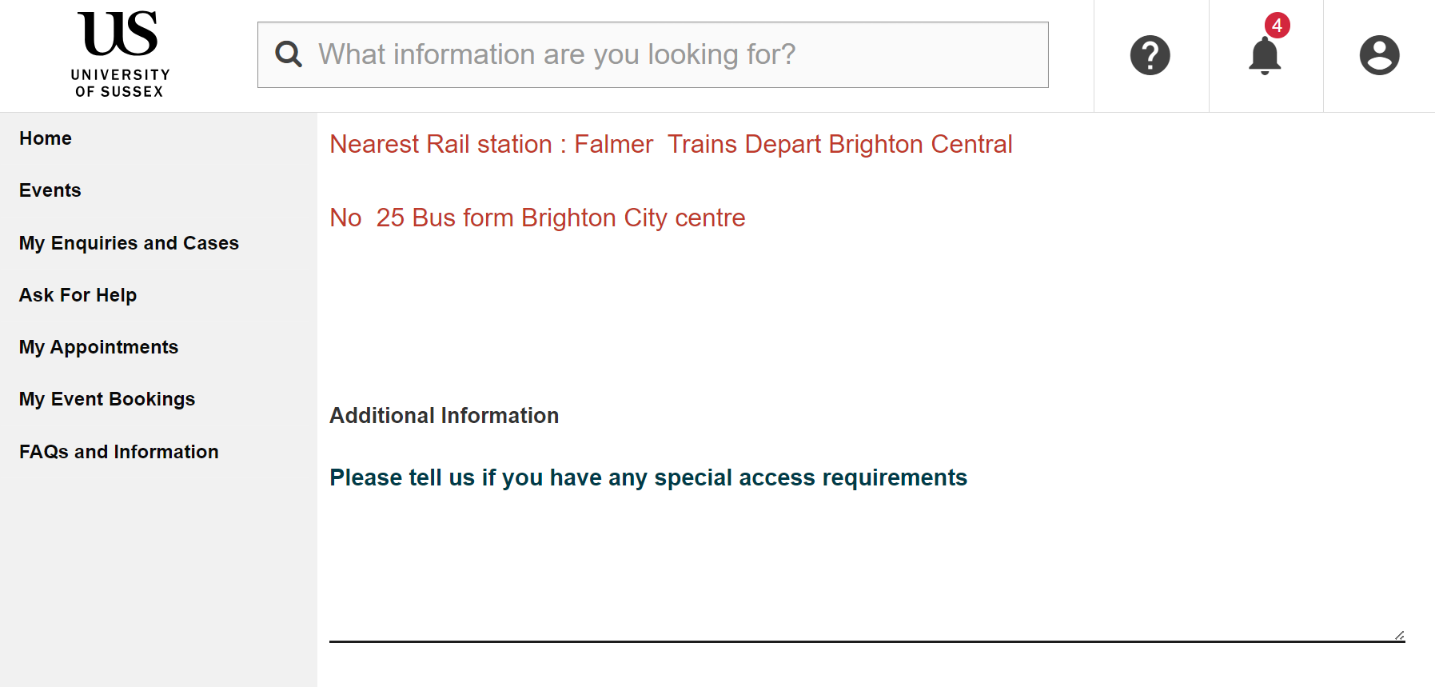
By selecting My Event Bookings, you can see which events you have registered onto. You will be able to view upcoming events and those you have previously attended. If you are unable to attend an event, you can cancel your booking, too. For fully-booked events, this will enable another student to take your place.

