,International Humanitarian Law:
Expanding its History (ies), Prospects and Challenges

Workshop at the University of Zürich, Rechtswissenschaftliche Fakultät
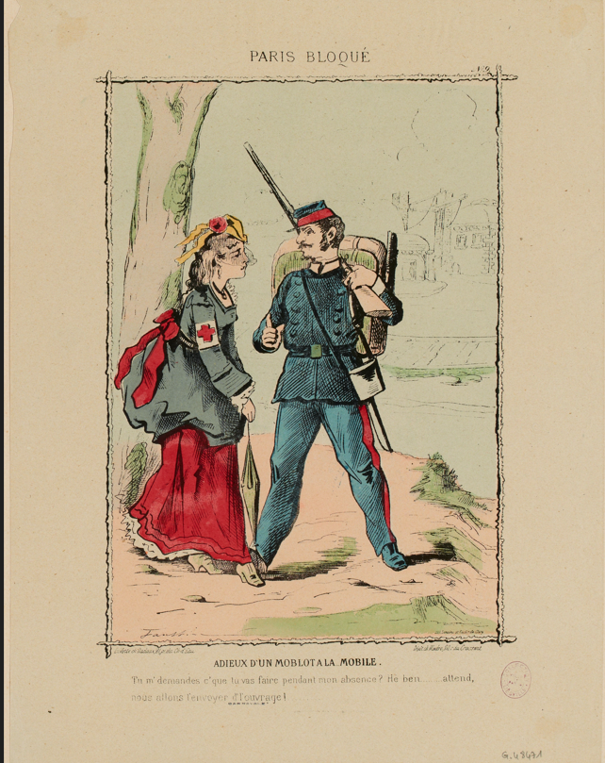
28-29 November 2024

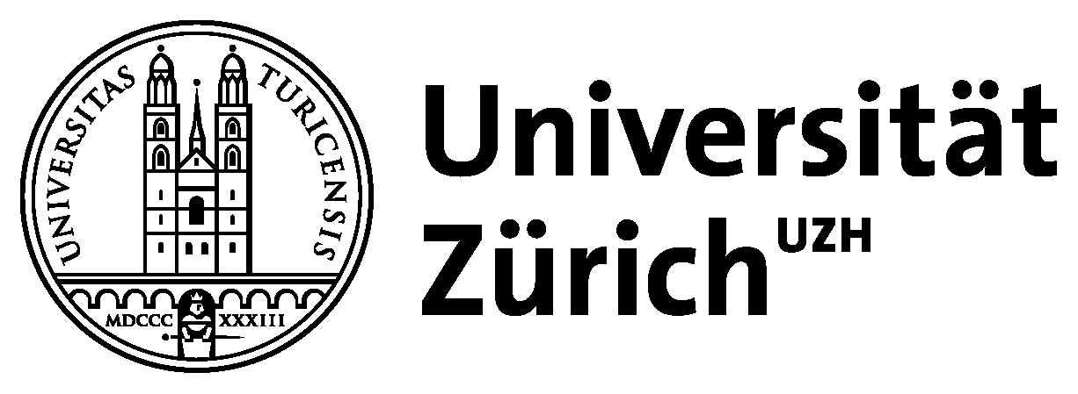
Faustin Betbeder, 1847-1917, Paris Bloqué, Paris Musées, Musée Carnavalet, Histoire de Paris


Rechtswissenschaftliche Fakultät
With the generous support of UZH GRC Grants
The Workshop Program:
Thursday November 28:
09.30-10.00 | Welcome & Registration
10:00-10.15 | Welcome by Prof. Elisabetta Fiocchi Malaspina
10.15-11.00 | Opening Note by Bruno Demeyere  Chief Editor of the International Review of the Red Cross
11.00-12.30 | Panel 1: From the Origins to Reinterpretations of International Humanitarian Law
Raphael Schäfer, Max-Planck-Institut, Heidelberg
"Humanity as a Vehicle - A New History for the Laws of War"
Alexa Stiller, Zürich University
“Between Decolonization and the End of the Cold War: Reinterpretations and Applications of International Humanitarian Law, 1970s to 1990s”
Moderator: Prof. Benjamin Straumann
12.45-14.00 | Lunch UZH Mensa
14.00-15.30 | Panel 2: Special Focus:  The “troubles” in Ireland and the role of the ICRC
Hellen Kinsella, University of Minnesota
Giovanni Mantilla, Cambridge University
"Politics, Law, and Power in Detention Visits: the Case of the ICRC in Northern Ireland’s 'Troubles'”
Moderator: Prof. Elisabetta Fioochi Malaspina
15.30-15.45 | Coffee Break
15.45-17.15 | Panel 3: Art & Emotions in the History of International Humanitarian Law
Giacomo Pace Gravina, University of Messina
“Colonialist Emotions. The 'Nobility of Defeat' in Late 19th-Century Paintings”
Tania Atilano, Zurich University
“The exchange of Belgian prisoners” in the painting of Francisco de Paula Mendoza Escobedo, Mexico, 1881
Moderator: Prof. Bardo Fassbender
18.00-19.30 | Guided Walking Tour: Colonial Legacy in Zurich
20.00 | Dinner: Restaurant Zum Grünen Glas

Friday November 29:
09.00-10.30 | Panel 4: Latin American Engagements with the Laws of War
Alonso Gurmendi Dunkelberg, LSE, London
“Recentering Quechua and Aymara Revolution in the History of Latin American International Law”
Liliana Obregón, Universidad de Los Andes, Colombia
“Racial Hierarchies in Early Latin American Military Codes”
Moderator: Tania Ixchel Atilano
10.30-10.45 | Coffee Break
10.45-12.15 | Panel 5: New Insights on Non-State Actors
Samuel White, Adelaide University, Australia
“War Without Limits - A Historical Critique of Sharp War Theory through Forgotten Histories”
Roberta Arnold, Zurich University
“Terrorism and War: A New «Partnership»?”
Moderator: Prof. Daniel Marc Segesser
12.30-14.00 | Lunch at the ETH Dozentenfoyer
14.00-15.30 | Roundtable  How to expand the histories of IHL?  Challenges and Future Perspectives  Next steps and publication of special issue in the IRRC
15.30 | Farewell

Location:

Address: University of Zurich, KO2-F-152 EV, Karl Schmid-Strasse 4
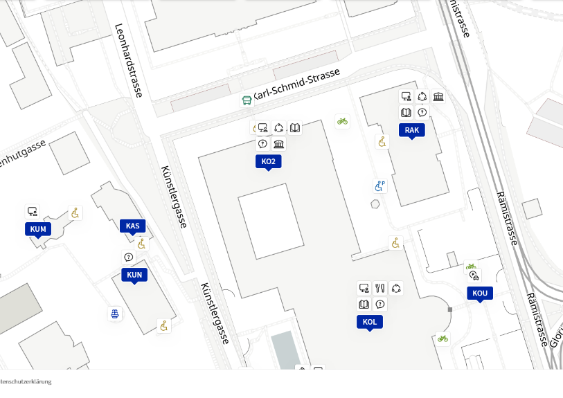
Streaming:
Zoom-Link: https://uzh.zoom.us/j/8751685913?pwd=V25DZUlVL1E4MTlBZ2s5SEF3UHhVZz09
ID meeting: 875 168 5913
Password: 359670

Contact Details:
Elisabetta Fiocchi: Tel: 0041 76 364 56 64, E-Mail : elisabetta.fiocchi@ius.uzh.ch
Tania Atilano; Tel: 0041 77 962 21 34, E-Mail: tania.atilanocamacho@ius.uzh.ch

