

Four-Year Academic Plan

- This template is a tool to aid in multi-year academic planning. Academic planning is an iterative process that helps you intentionally map out your course pathway, including College Curriculum requirements—like Gen Ed and Divisional Distribution courses—and concentration requirements, but it also involves introspection, goal-setting, and careful selection of courses, activities, and co-curricular opportunities, all with help from your advisors. We encourage you to use this planning template as a tool for your conversations with advisers across your four years.
- For each year and term, there are columns for courses, their credit categories, and the number of credits each course bears.
- Credit categories and abbreviations for each are: Concentration (C), Harvard College Curriculum (H), Elective Secondary (S), Elective Language Citation (L), and Elective (E).
- The "Total Credits" cells reflect the sum of credit value from all terms within each year. The “Total Credits” cell on this page reflects the sum of credits across all years. This addition function is built into this PDF.
- You need 128 credits to graduate.
- While creating a plan, keep in mind sequencing and availability of courses, concentration requirements, College Curriculum courses (General Education, Divisional Distribution, etc.), and other academic plans (secondary field, citation, electives).

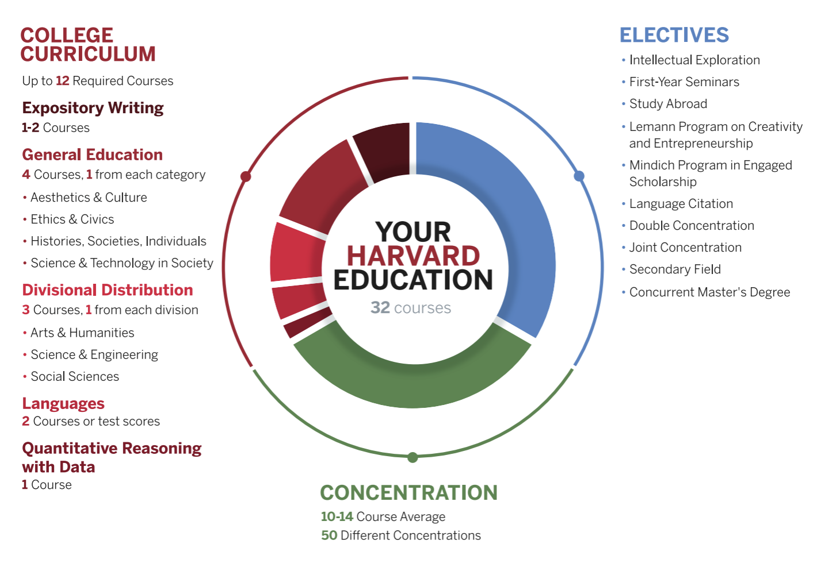

Name
Concentration(s)
Elective: Secondary
Elective: Language Citation
TOTAL CREDITS

First Year
Fall |  |  | Spring |  |  | Summer
Course | Category | Credits | Course | Category | Credits | Course | Category |  | Credits
 |  |  |  |  |  |  | TOTAL CREDITS

Sophomore Year
Fall |  |  | Spring |  |  | Summer
Course | Category | Credits | Course | Category | Credits | Course | Category |  | Credits
 |  |  |  |  |  |  | TOTAL CREDITS

Junior Year
Fall |  |  | Spring |  |  | Summer
Course | Category | Credits | Course | Category | Credits | Course | Category |  | Credits
 |  |  |  |  |  |  | TOTAL CREDITS

Senior Year
Fall |  |  | Spring |  |  | Summer
Course | Category | Credits | Course | Category | Credits | Course | Category |  | Credits
 |  |  |  |  |  |  | TOTAL CREDITS

