Pagination How-to (using MS Word)

1. Basic page settings

1) First, click Format → Document → Document Grid from the menu. Then click OK. (Note that this process is to write basic page numbers for the whole document.)
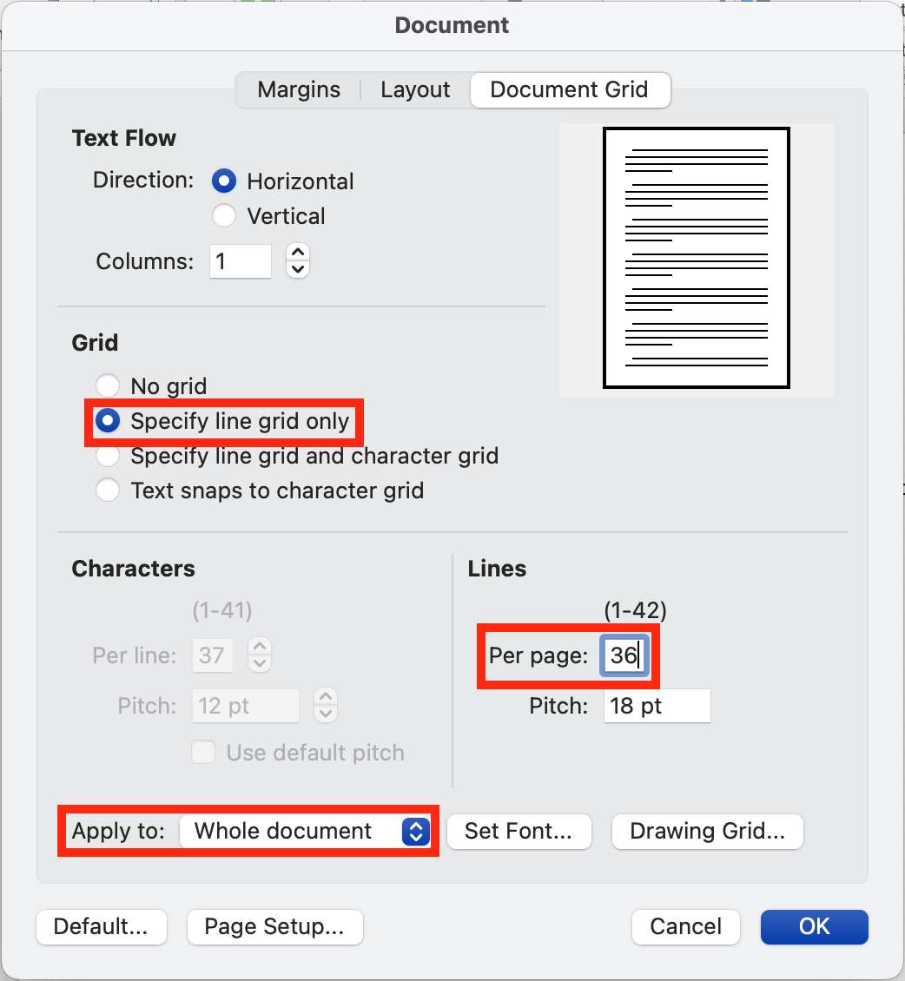

2) Click Insert → Header & Footer → Page Number and apply the following instructions:
Position: Bottom of Page (Footer)
Alignment: Center

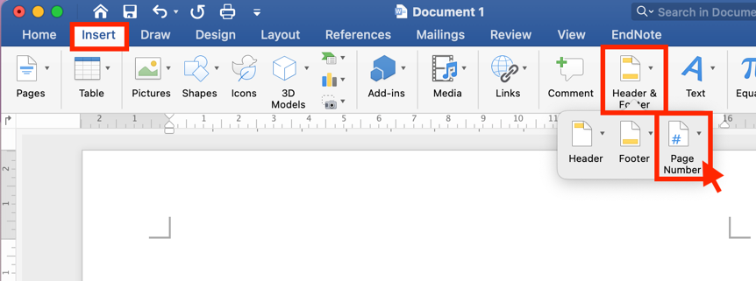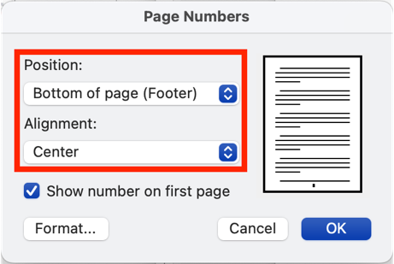

3) Click on Format from the Page Numbers window. Select the page number format of your choice in the Page Number Format window.

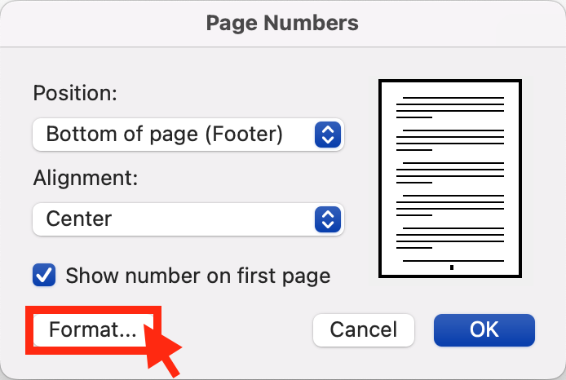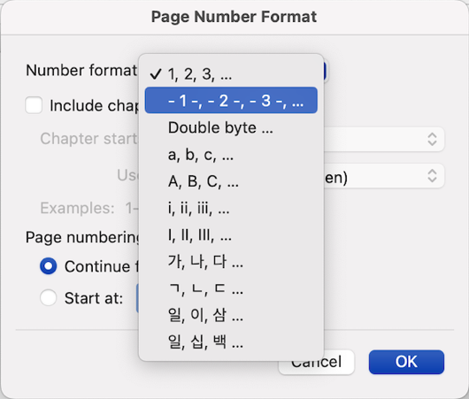

2. If you wish to have more than one page layout or page number setting in one document

1) To set a different page numbering system for certain pages, try a section break. By clicking Layout → Breaks → Section Breaks → Next Page, you will be able to start a new section on the next blank page.

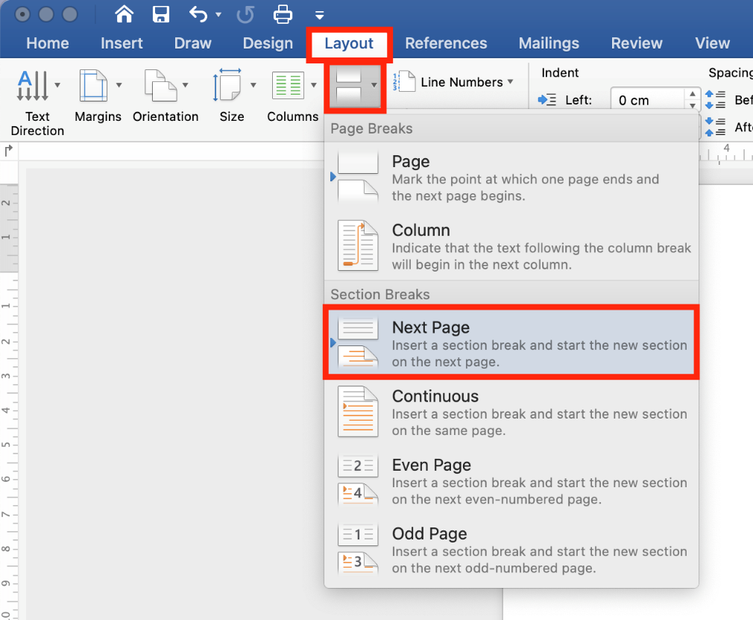

2) Click Format → Document and select ‘This section’ from the Apply to option. Press OK. (This allows the page section to function independently, enabling it to have its own separate page property.)

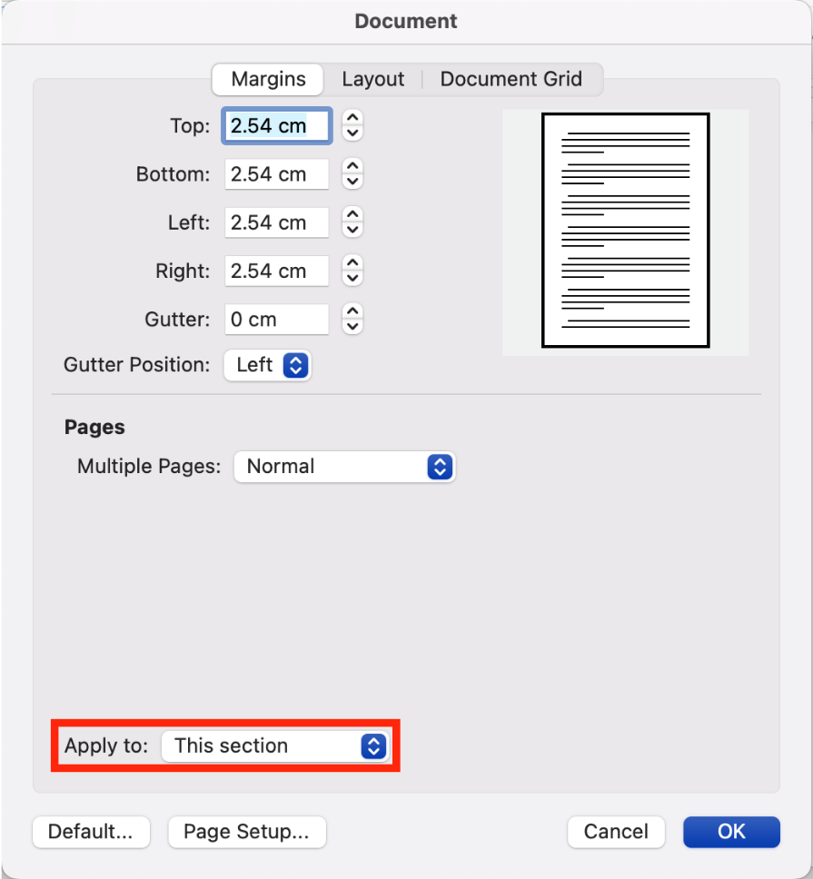

Apply the page number format and page numbering of your choice from the Header & Footer menu.

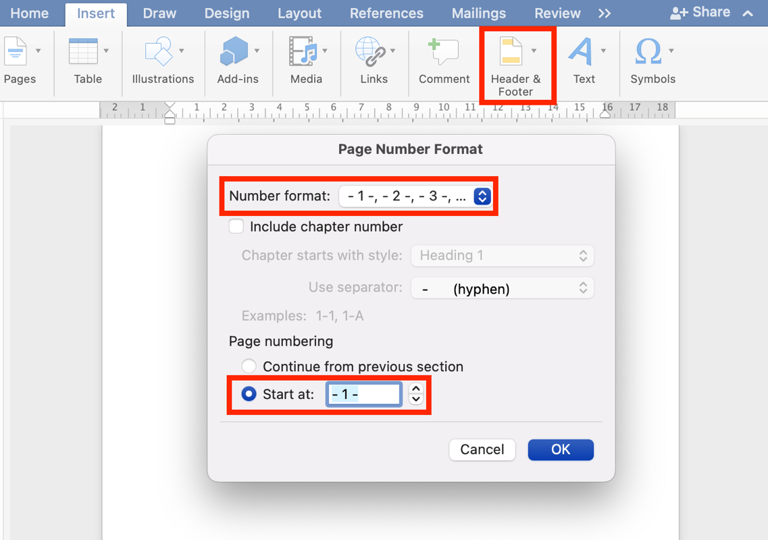

3) In the first header of each new section, double click on the footer and uncheck ‘Link to Previous’. Doing this is to ensure that even if you delete the page number field of the previous section, it will not affect the current section.

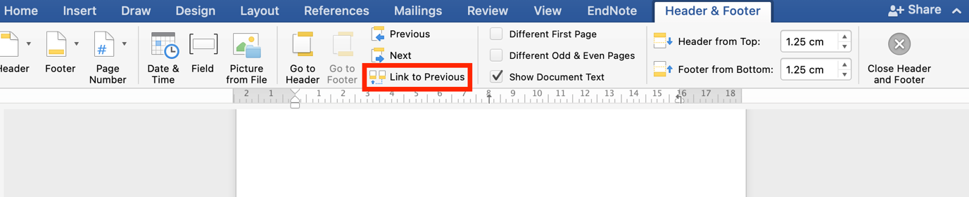

4) If you always want to start with a new page and a new format, you can repeat the steps described in step number 2.

