Dynamic Linear Programming

Disequilibrium- Known Life

Primal Algebra:

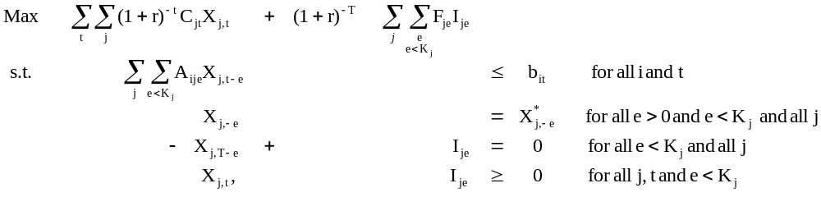

Where
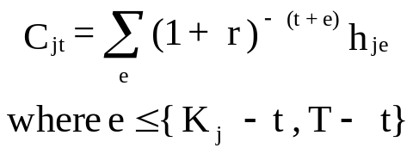

Inspecting the resource equation

$\sum_{j}{\sum_{e=0}^{e<K_{j}}{A_{ije}X_{j,t-e } ≤ { b}_{it}}}$ for year t

Suppose K_{j} =3 and for we expand the sum over e

$\sum_{j}{{( A}_{ij0}X_{j,t-0 }+A_{ij1}X_{j,t-1 }+A_{ij2}X_{j,t-2 }) ≤ { b}_{it}}$ This is for year t

$A_{ij0}X_{j,t }$ is the e=0 case and gives resource use in year when activity is new (e=0) ${ A}_{ij0}$times the amount started in year t-e or t-0 or t $X_{j,t }$

$A_{ij1}X_{j,t-1 }$ is the e=1 case and gives resource use when activity is one year old (e=1) ${ A}_{ij1}$times the amount started last year in year t-1 (t-e) $X_{j,t-1 }$

$A_{ij2}X_{j,t-2 }$ is the e=2 case and gives resource use when activity is two years old (e=2)${ A}_{ij2}$ times the amount started two years ago in year t-2 $X_{j,t-2 }$

So we add up resource use for new plus one year old plus two years old when we discontinue in start of year 3

Dynamic Linear Programming

Disequilibrium- Known Life / Example

The Strawberry Problem:
 | Year 0 | Year 1 | Year 2
Cost/Acre | 150 | 280 | 300
Yield/acre in tons | 0 | 7 | 7
Water/acre in acre-feet | .8 | 4.5 | 4.5

The price per ton of strawberries is $140. The farm has 700 acres, 50 planted in 0 year old strawberries and 10 in 1 year old strawberries. Water available consists of 1200 acre ft. per year.

We need terminal conditions to value those items which are carried into the fifth and beyond years. Assume that the following values have been derived.

Product Terminal Value

New strawberries (0 years old the year after the model) $160/acre
1 year old strawberries $110/acre

Dynamic Linear Programming

Disequilibrium- Known Life / Example

Table 8.1. Disequilibrium Known Life Example
 | Year 1 |  | Year 2 |  | Year 3 |  | Year 4 |  | Year 5 |  | Terminal  Conditions
Rows | Wheat | Straw-berries | Wheat | Straw-berries | Wheat | Straw-berries | Wheat | Straw-berries | Wheat | Straw-berries | Strawberries |  | RHS
 |  |  |  |  |  |  |  |  |  |  | Aje 0 | Aje 1
Objective | 340 | 1230 | 340 | 1230 | 340 | 1230 | 340 | 550 | 340 | -150 | 160 | 110 | Max
Land Year 1 | 1 | 1 |  |  |  |  |  |  |  |  |  |  | ≤ | 640
Water Year 1 | 1 | 0.8 |  |  |  |  |  |  |  |  |  |  | ≤ | 930
Land Year 2 |  | 1 | 1 | 1 |  |  |  |  |  |  |  |  | ≤ | 690
Water Year 2 |  | 4.5 | 1 | 0.8 |  |  |  |  |  |  |  |  | ≤ | 1155
Land Year 3 |  | 1 |  | 1 | 1 | 1 |  |  |  |  |  |  | ≤ | 700
Water Year 3 |  | 4.5 |  | 4.5 | 1 | 0.8 |  |  |  |  |  |  | ≤ | 1200
Land Year 4 |  |  |  | 1 |  | 1 | 1 | 1 |  |  |  |  | ≤ | 700
Water Year 4 |  |  |  | 4.5 |  | 4.5 | 1 | 0.8 |  |  |  |  | ≤ | 1200
Land Year 5 |  |  |  |  |  | 1 |  | 1 | 1 | 1 |  |  | ≤ | 700
Water Year 5 |  |  |  |  |  | 4.5 |  | 4.5 | 1 | 0.8 |  |  | ≤ | 1200
Strawberry 0 |  |  |  |  |  |  |  |  |  | -1 | 1 |  | ≤ | 0
Strawberry 1 |  |  |  |  |  |  |  | -1 |  |  |  | 1 | ≤ | 0

Dynamic Linear Programming
Disequilibrium- Known Life / Example

Solutions:
Objective = 1224296
Variables | Value | Reduced Cost | Equation | Slack | Shadow Price
Wheat Year 1 | 506.2 | 0 | Land Year 1 | 0 | 340.0
Strawberries Year 1 | 133.8 | 0 | Water Year 1 | 316.76 | 0
Wheat Year 2 | 539.9 | 0 | Land Year 2 | 0 | 283.1
Strawberries Year 2 | 16.3 | 0 | Water Year 2 | 0 | 56.9
Wheat Year 3 | 423.4 | 0 | Land Year 3 | 0 | 336.9
Strawberries Year 3 | 126.6 | 0 | Water Year 3 | 0 | 3.1
Wheat Year 4 | 557.1 | 0 | Land Year 4 | 0 | 279.8
Strawberries Year 4 | 0 | 0 | Water Year 4 | 0 | 60.2
Wheat Year 5 | 573.4 | 0 | Land Year 5 | 0 | 340.0
Strawberries Year5 | 0 | 0 | Water Year 5 | 57.05 | 0
Term Straw -0 | 0 | 0 | Strawberry 0 | 0 | -160
Term Straw -1 | 0 | -8 | Strawberry 1 | 0 | -118

Dynamic Linear Programming
Disequilibrium- Unknown Life

Primal Algebra

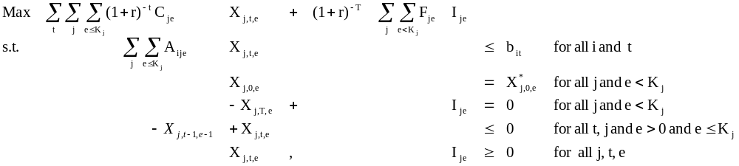

Dynamic Linear Programming
Disequilibrium- Unknown Life / Example

 | Year 0 | Year 1 | Year 2
Cost/Acre | 150 | 280 | 300
Yield/acre in tons | 0 | 7 | 7
Water/acre in acre-feet | .8 | 4.5 | 4.5

For this example we use the data above plus longer retention of strawberries. Assume they may be kept up to 4 years and that in the fourth year the planting costs $400 with the yield being 5, and water use being 5.7 acre feet. We will also assume that the terminal value of 3-year old strawberries is $20/acre.

Disequilibrium- Unknown Life / Example
Table 8.3 Disequilibrium Unknown Life Sample Problem
 |  | Year 1 |  |  |  |  | Year 2 |  |  |  |  | Year 3 |  |  |  |  | Year 4 |  |  |  |  | Year 5 |  |  |  |  | Terminal Conditions
 |  |  | Strawberries |  |  |  |  | Strawberries |  |  |  |  | Strawberries |  |  |  |  | Strawberries |  |  |  |  | Strawberries |  |  |  | Strawberries |  |  | RHS
Rows |  | Wheat | 0 | 1 | 2 | 3 | Wheat | 0 | 1 | 2 | 3 | Wheat | 0 | 1 | 2 | 3 | Wheat | 0 | 1 | 2 | 3 | Wheat | 0 | 1 | 2 | 3 | 0 | 1 | 2 | RHS
 |  |  |  |  |  |  |  |  |  |  |  |  |  |  |  |  |  |  |  |  |  |  |  |  |  |  |  |  |  | Max
Objective |  | 340 | -150 | 700 | 680 | 300 | 340 | -150 | 700 | 680 | 300 | 340 | -150 | 700 | 680 | 300 | 340 | -150 | 700 | 680 | 300 | 340 | -150 | 700 | 680 | 300 | 160 | 110 | 20 | Max
Land Year 1 |  | 1 | 1 | 1 | 1 | 1 |  |  |  |  |  |  |  |  |  |  |  |  |  |  |  |  |  |  |  |  |  |  |  | ≤ 700
Water Year 1 |  | 1 | 0.8 | 4.5 | 4.5 | 5.7 |  |  |  |  |  |  |  |  |  |  |  |  |  |  |  |  |  |  |  |  |  |  |  | ≤ 1200
Init Straw 0 |  |  |  | 1 |  |  |  |  |  |  |  |  |  |  |  |  |  |  |  |  |  |  |  |  |  |  |  |  |  | ≤ 50
Init Straw 1 |  |  |  |  | 1 |  |  |  |  |  |  |  |  |  |  |  |  |  |  |  |  |  |  |  |  |  |  |  |  | ≤ 10
Init Straw 2 |  |  |  |  |  | 1 |  |  |  |  |  |  |  |  |  |  |  |  |  |  |  |  |  |  |  |  |  |  |  | ≤ 0
Straw 0-1 Year 1 |  |  | -1 |  |  |  |  |  | 1 |  |  |  |  |  |  |  |  |  |  |  |  |  |  |  |  |  |  |  |  | ≤ 0
Straw 1-2 Year 1 |  |  |  | -1 |  |  |  |  |  | 1 |  |  |  |  |  |  |  |  |  |  |  |  |  |  |  |  |  |  |  | ≤ 0
Straw 2-3 Year 1 |  |  |  |  | -1 |  |  |  |  |  | 1 |  |  |  |  |  |  |  |  |  |  |  |  |  |  |  |  |  |  | ≤ 0
Land Year 2 |  |  |  |  |  |  | 1 | 1 | 1 | 1 | 1 |  |  |  |  |  |  |  |  |  |  |  |  |  |  |  |  |  |  | ≤ 700
Water Year 2 |  |  |  |  |  |  | 1 | 0.8 | 4.5 | 4.5 | 5.7 |  |  |  |  |  |  |  |  |  |  |  |  |  |  |  |  |  |  | ≤ 1200
Straw 0-1 Year 2 |  |  |  |  |  |  |  | -1 |  |  |  |  |  | 1 |  |  |  |  |  |  |  |  |  |  |  |  |  |  |  | ≤ 0
Straw 1-2 Year 2 |  |  |  |  |  |  |  |  | -1 |  |  |  |  |  | 1 |  |  |  |  |  |  |  |  |  |  |  |  |  |  | ≤ 0
Straw 2-3 Year 2 |  |  |  |  |  |  |  |  |  | -1 |  |  |  |  | 100 | 1 |  |  |  |  |  |  |  |  |  |  |  |  |  | ≤ 0
Land Year 3 |  |  |  |  |  |  |  |  |  |  |  | 1 | 1 | 1 | 1 | 1 |  |  |  |  |  |  |  |  |  |  |  |  |  | ≤ 700
Water Year 3 |  |  |  |  |  |  |  |  |  |  |  | 1 | 0.8 | 4.5 | 4.5 | 5.7 |  |  |  |  |  |  |  |  |  |  |  |  |  | ≤ 1200
Straw 0-1 Year 3 |  |  |  |  |  |  |  |  |  |  |  |  | -1 |  |  |  |  |  | 1 |  |  |  |  |  |  |  |  |  |  | ≤ 0
Straw 1-2 Year 3 |  |  |  |  |  |  |  |  |  |  |  |  |  | -1 |  |  |  |  |  | 1 |  |  |  |  |  |  |  |  |  | ≤ 0
Straw 2-3 Year 3 |  |  |  |  |  |  |  |  |  |  |  |  |  |  | -1 |  |  |  |  |  | 1 |  |  |  |  |  |  |  |  | ≤ 0
Land Year 4 |  |  |  |  |  |  |  |  |  |  |  |  |  |  |  |  | 1 | 1 | 1 | 1 | 1 |  |  |  |  |  |  |  |  | ≤ 700
Water Year 4 |  |  |  |  |  |  |  |  |  |  |  |  |  |  |  |  | 1 | 0.8 | 4.5 | 4.5 | 5.7 |  |  |  |  |  |  |  |  | ≤ 1200
Straw 0-1 Year 4 |  |  |  |  |  |  |  |  |  |  |  |  |  |  |  |  |  | -1 |  |  |  |  |  | 1 |  |  |  |  |  | ≤ 0
Straw 1-2 Year 4 |  |  |  |  |  |  |  |  |  |  |  |  |  |  |  |  |  |  | -1 |  |  |  |  |  | 1 |  |  |  |  | ≤ 0
Straw 2-3 Year 4 |  |  |  |  |  |  |  |  |  |  |  |  |  |  |  |  |  |  |  | -1 |  |  |  |  |  | 1 |  |  |  | ≤ 0
Land Year 5 |  |  |  |  |  |  |  |  |  |  |  |  |  |  |  |  |  |  |  |  |  | 1 | 1 | 1 | 1 | 1 |  |  |  | ≤ 700
Water Year 5 |  |  |  |  |  |  |  |  |  |  |  |  |  |  |  |  |  |  |  |  |  | 1 | 0.8 | 4.5 | 4.5 | 5.7 |  |  |  | ≤ 1200
Term Straw 0 |  |  |  |  |  |  |  |  |  |  |  |  |  |  |  |  |  |  |  |  |  |  | -1 |  |  |  | 1 |  |  | ≤ 0
Term Straw 1 |  |  |  |  |  |  |  |  |  |  |  |  |  |  |  |  |  |  |  |  |  |  |  | -1 |  |  |  | 1 |  | ≤ 0
Term Straw 2 |  |  |  |  |  |  |  |  |  |  |  |  |  |  |  |  |  |  |  |  |  |  |  |  | -1 |  |  |  | 1 | ≤ 0

Dynamic Linear Programming
Disequilibrium- Unknown Life / Example

Solutions:
Table 8.4. Disequilibrium Unknown Life Example Model Solution
Objective = 1280757.0
Variable | Value | Reduced Cost | Equation | Slack | Shadow Price
Wheat year 1 | 547.1 | 0 | Land Year 1 | 0 | 340
Straw 0 year old year 1 | 92.9 | 0 | Water Year 1 | 308.57 | 0
Straw 1 year old year 1 | 50.0 | 0 | Init Straw 0 | 0 | 490
Straw 2 year old year 1 | 10.0 | 0 | Init Straw 1 | 0 | 340
Straw 3 year old year 1 | 0 | -40 | Init Straw 2 | 0 | 0
Wheat year 2 | 557.1 | 0 | Straw 0-1 Year 1 | 0 | -490
Straw 0 year old year 2 | 0 | -8 | Straw 1-2 Year 1 | 0 | -130
Straw 1 year old year 2 | 92.9 | 0 | Straw 2-3 Year 1 | 10 | 0
Straw 2 year old year 2 | 50.0 | 0 | Land Year 2 | 0 | 280
Straw 3 year old year 2 | 0 | -322 | Water Year 2 | 0 | 60
Wheat year 3 | 464.3 | 0 | Straw 0-1 Year 2 | 0 | -470
Straw 0 year old year 3 | 142.9 | 0 | Straw 1-2 Year 2 | 0 | -340
Straw 1 year old year 3 | 0 | 0 | Straw 2-3 Year 2 | 50 | 0
Straw 2 year old year 3 | 92.9 | 0 | Land Year 3 | 0 | 340
Straw 3 year old year 3 | 0 | -40 | Water Year 3 | 203.57 | 0
Wheat year 4 | 557.1 | 0 | Straw 0-1 Year 3 | 0 | -490
Straw 0 year old year 4 | 0 | 0 | Straw 1-2 Year 3 | 0 | -110
Straw 1 year old year 4 | 142.9 | 0 | Straw 2-3 Year 3 | 92.857 | 0
Straw 2 year old year 4 | 0 | 0 | Land Year 4 | 0 | 274
Straw 3 year old year 4 | 0 | -349 | Water Year 4 | 0 | 65.7
Wheat year 5 | 557.1 | 0 | Straw 0-1 Year 4 | 0 | -470
Straw 0 year old year 5 | 0 | -330 | Straw 1-2 Year 4 | 0 | -360
Straw 1 year old year 5 | 0 | 0 | Straw 2-3 Year 4 | 0 | 0
Straw 2 year old year 5 | 142.9 | 0 | Land Year 5 | 0 | 340
Straw 3 year old year 5 | 0 | -40 | Water Year 5 | 0 | 0
Term Straw 0 |  | 0 | Term Straw 0 | 0 | -160
Term Straw 1 |  | 0 | Term Straw 1 | 0 | -110
Term Straw 2 |  | 0 | Term Straw 2 | 142.86 | -20

Dynamic Linear Programming
Equilibrium- Known Life

Equilibrium models are developed as follows: assume we have a variable with life of 4 periods and resource use, yield,7 etc., equal to A_{e}, where e is the elapsed age of the activity (0-3). Let us (assuming we start with zero initial activity) portray the resource use over several periods.
 | Begin Activity in Period
 | 1 | 2 | 3 | 4 | 5 | 6 | 7
Period 1 Resource Usage | A₀
Period 2 Resource Usage | A₁ | A₀
Period 3 Resource Usage | A₂ | A₁ | A₀
Period 4 Resource Usage | A₃ | A₂ | A₁ | A₀
Period 5 Resource Usage |  | A₃ | A₂ | A₁ | A₀
Period 6 Resource Usage |  |  | A₃ | A₂ | A₁ | A₀
Period 7 Resource Usage |  |  |  | A₃ | A₂ | A₁ | A₀
A₃X_{t-3}+ A₂X_{t-2}+ A₁X_{t-1}+ A₀X_{t}
X_{t-3}=X_{t-2}= X_{t-1}=X_{t} =X
A₃X+ A₂X+ A₁X+ A₀X
(A₃+ A₂+ A₁+ A₀)X
Algebraically
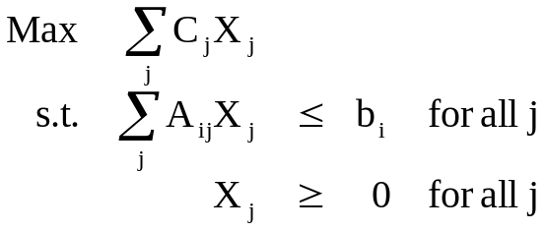

Dynamic Linear Programming
Equilibrium- Known Life
Example 1a

Table 8.5. Equilibrium Known Life Example Formulation
 | Wheat | Strawberries
Objective | 340 | 1230
Land | 1 | 3 | ≤ | 700
Water | 1 | 9.8 | ≤ | 1200

Table 8.6. Equilibrium Known Life Example Solution

Objective = 253441
Variables | Value | Reduced Cost | Equation | Slack | Shadow Price
Wheat | 479 | 0 | Land | 0 | 309
Strawberries | 74 | 0 | Water | 0 | 31

Dynamic Linear Programming
Equilibrium- Known Life
Example 1b

The above model can also be re-expressed in terms of average resource use. This is done in Table 8.7, where an average of one acre of land is used every year generates an average of $410 and the usage of 3.27 acre feet of water. The solution for this model essentially identical to the solution for the previous model, but the strawberry variable equals 221. This indicates that the equilibrium solution averages 221 acres of strawberries. Thus, in the strawberry rotation, one-third of the 221 acres (or 74 as in the earlier model) would be first year, one-third second year and one-third third year.

Table 8.7. Equilibrium Known Life Example Formulation with Average Activities
 | Wheat | Strawberries
Objective | 340 | 410
Land | 1 | 1 | ≤ 700
Water | 1 | 3.27 | ≤ 1200

Dynamic Linear Programming
Equilibrium- Known Life

Toward a crop rotation

Suppose we can grow 2 crops
Suppose their yields depend on what proceeds them on the land
(ie corn after corn has a different yield structure than does corn after soybeans and soybeans after soybeans has different performance than does soybeans after corn)

Lets look at modeling land precedence first in a one year model

 |  | ------------- Year1 ------------ |  |  |  |  |  | ------------- Year2 ------------
 |  | Plow after corn | Plow after Soy | Plant corn after corn | Plant corn after soy | Plant soy after corn | Plant soy after Soy | Plow after corn | Plow after Soy | Plant corn after corn | Plant corn after soy | Plant soy after corn | Plant soy after Soy
-Year 1 - | Land after corn | 1 |  |  |  |  |  |  |  |  |  |  |  | ≤ last yr corn
-Year 1 - | Land after soybeans |  | 1 |  |  |  |  |  |  |  |  |  |  | ≤ last yr soy
-Year 1 - | Land Plowed aft corn | -1 |  | 1 |  | 1 |  |  |  |  |  |  |  | ≤ 0
-Year 1 - | Land Plowed aft soy |  | -1 |  | 1 |  | 1 |  |  |  |  |  |  | ≤ 0
-Year 2 - | Land after corn next yr |  |  | -1 | -1 |  |  |  |  |  |  |  |  | ≤ 0
-Year 2 - | Land aft soybeans nxt yr |  |  |  |  | -1 | -1 |  |  |  |  |  |  | ≤ 0

Dynamic Linear Programming
Equilibrium- Known Life

Toward a crop rotation

Now Lets look at the land precedence in a two year model

 |  | ------------- Year1 ------------ |  |  |  |  |  | ------------- Year2 ------------
 |  | Plow after corn | Plow after Soy | Plant corn after corn | Plant corn after soy | Plant soy after corn | Plant soy after Soy | Plow after corn | Plow after Soy | Plant corn after corn | Plant corn after soy | Plant soy after corn | Plant soy after Soy
-Year 1 - | Land after corn | 1 |  |  |  |  |  |  |  |  |  |  |  | ≤ last yr corn
-Year 1 - | Land after soybeans |  | 1 |  |  |  |  |  |  |  |  |  |  | ≤ last yr soy
-Year 1 - | Plowed aft corn | -1 |  | 1 |  | 1 |  |  |  |  |  |  |  | ≤ 0
-Year 1 - | Plowed aft soy |  | -1 |  | 1 |  | 1 |  |  |  |  |  |  | ≤ 0
-Year 2 - | Land after corn |  |  | -1 | -1 |  |  | 1 |  |  |  |  |  | ≤ 0
-Year 2 - | Land after soybeans |  |  |  |  | -1 | -1 |  | 1 |  |  |  |  | ≤ 0
-Year 2 - | Plowed aft corn |  |  |  |  |  |  | -1 |  | 1 |  | 1 |  | ≤ 0
-Year 2 - | Plowed aft soy |  |  |  |  |  |  |  | -1 |  | 1 |  | 1 | ≤ 0

Dynamic Linear Programming
Equilibrium- Known Life
Toward a crop rotation

But what if we go equilibrium - Lets look at the land precedence
Since next years plowing equals this years

 |  | ------------- Year1 ------------ |  |  |  |  |  | ------------- Year2 ------------
 |  | Plow after corn | Plow after Soy | Plant corn after corn | Plant corn after soy | Plant soy after corn | Plant soy after Soy | Plow after corn | Plow after Soy | Plant corn after corn | Plant corn after soy | Plant soy after corn | Plant soy after Soy
-Year 1 - | Land after corn | 1 |  | -1 | -1 |  |  |  |  |  |  |  |  | ≤ 0
-Year 1 - | Land after soybeans |  | 1 |  |  | -1 | -1 |  |  |  |  |  |  | ≤ 0
-Year 1 - | Plowed aft corn | -1 |  | 1 |  | 1 |  |  |  |  |  |  |  | ≤ 0
-Year 1 - | Plowed aft soy |  | -1 |  | 1 |  | 1 |  |  |  |  |  |  | ≤ 0
-Year 2 - | Land after corn |  |  | -1 | -1 |  |  | 1 |  |  |  |  |  | ≤ 0
-Year 2 - | Land after soybeans |  |  |  |  | -1 | -1 |  | 1 |  |  |  |  | ≤ 0
-Year 2 - | Plowed aft corn |  |  |  |  |  |  | -1 |  | 1 |  | 1 |  | ≤ 0
-Year 2 - | Plowed aft soy |  |  |  |  |  |  |  | -1 |  | 1 |  | 1 | ≤ 0

 | -------- Typical Year -------
 | Plow after corn | Plow after Soy | Plant corn after corn | Plant corn after soy | Plant soy after corn | Plant soy after Soy
Land after corn | 1 |  | -1 | -1 |  |  | ≤ 0
Land after soybeans |  | 1 |  |  | -1 | -1 | ≤ 0
Plowed aft corn | -1 |  | 1 |  | 1 |  | ≤ 0
Plowed aft soy |  | -1 |  | 1 |  | 1 | ≤ 0

Dynamic Linear Programming
Equilibrium- Known Life
Example 2

Technical Data
 |  | Corn | Soybeans
Prices/Unit |  | $2.50 | $6.50
Production Cost/ Acre |  | 100 | 50

Labor Use in hrs/acre
Plowing |  | .4 | .3
Planting |  | .15 | .15
Harvesting |  | .35 | .17
Yields:
 |  | Corn after Corn Planting Period |  | Corn After Soybeans  Planting Period |  | Soybeans  (after Anything) Planting Period
 |  | Pd2 | Pd3 | Pd2 | Pd3 | Pd2 | Pd3
Harvest | Pd4 | 130 | 120 | 145 | 133 | 35 | 45
Period | Pd5 | 125 | 110 | 137 | 129 | 33 | 42

Labor Availability (hrs)
Period | Available Labor
Post harvest/Preplant (Pd1) | 80
Plant (Pd2) | 65
Plant (Pd3) | 75
Harvest (Pd4) | 100
Harvest (Pd5) | 80

Dynamic Linear Programming
Equilibrium- Known Life
Example 2

The Dynamic Process
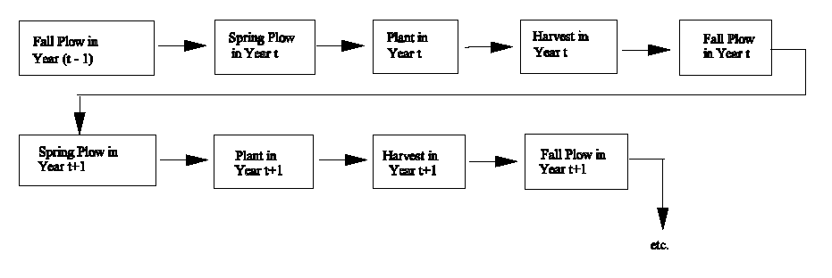
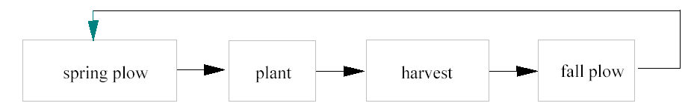

Dynamic Linear Programming
Equilibrium- Known Life / Example 2

Table 8.8 Rotation Example in Equilibrium Known Life Context
 |  |  |  |  |  |  |  |  |  |  | Plant Corn |  |  |  |  |  |  |  | Plant Soybeans |  |  |  |  |  |  |  | RHS
 | Plow after corn |  |  |  |  | Plow after soybeans |  |  |  |  | after corn |  |  |  | after soybeans |  |  |  | after corn |  |  |  | after soybeans
Rows |  |  |  |  |  |  |  |  |  |  | pl2 | pl2 | pl3 | pl3 | pl2 | pl2 | pl3 | pl3 | pl2 | pl2 | pl3 | pl3 | pl2 | pl2 | pl3 | pl3
 | pd1 | pd2 | pd3 | pd4 | pd5 | pd1 | pd2 | pd3 | pd4 | pd5 | hr4 | hr5 | hr4 | hr5 | hr4 | hr5 | hr4 | hr5 | hr4 | hr5 | hr4 | hr5 | hr4 | hr5 | hr4 | hr5
Objective |  |  |  |  |  |  |  |  |  |  | 225 | 213 | 200 | 175 | 263 | 243 | 233 | 223 | 178 | 165 | 243 | 223 | 178 | 165 | 243 | 223 | Max
Land | 1 | 1 | 1 | 1 | 1 | 1 | 1 | 1 | 1 | 1 |  |  |  |  |  |  |  |  |  |  |  |  |  |  |  |  | ≤ 400
Labor pd1 | .4 |  |  |  |  | .3 |  |  |  |  |  |  |  |  |  |  |  |  |  |  |  |  |  |  |  |  | ≤ 80
Labor pd2 |  | .4 |  |  |  |  | .3 |  |  |  | .2 | .2 |  |  | .2 | .2 |  |  | .2 | .2 |  |  | .2 | .2 |  |  | ≤ 65
Labor pd3 |  |  | .4 |  |  |  |  | .3 |  |  |  |  | .2 | .2 |  |  | .2 | .2 |  |  | .2 | .2 |  |  | .2 | .2 | ≤ 75
Labor pd4 |  |  |  | .4 |  |  |  |  | .3 |  | .4 |  | .4 |  | .4 |  | .4 |  | .3 |  | .3 |  | .3 |  | .3 |  | ≤ 100
Labor pd5 |  |  |  |  | .4 |  |  |  |  | .3 |  | .4 |  | .4 |  | .4 |  | .4 |  | .3 |  | .3 |  | .3 |  | .3 | ≤ 80
plow after corn pd4 |  |  |  | 1 |  |  |  |  |  |  | -1 |  | -1 |  | -1 |  | -1 |  |  |  |  |  |  |  |  |  | ≤ 0
plow after corn pd5 | 1 | 1 | 1 | 1 | 1 |  |  |  |  |  | -1 | -1 | -1 | -1 | -1 | -1 | -1 | -1 |  |  |  |  |  |  |  |  | ≤ 0
plow after soyb pd4 |  |  |  |  |  |  |  |  | 1 |  |  |  |  |  |  |  |  |  | -1 |  | -1 |  | -1 |  | -1 |  | ≤ 0
plow after soyb pd5 |  |  |  |  |  | 1 | 1 | 1 | 1 | 1 |  |  |  |  |  |  |  |  | -1 | -1 | -1 | -1 | -1 | -1 | -1 | -1 | ≤ 0
plnt aft plow corn pd2 | -1 | -1 |  | -1 | -1 |  |  |  |  |  | 1 | 1 |  |  |  |  |  |  | 1 | 1 |  |  |  |  |  |  | ≤ 0
plnt aft plow corn pd3 | -1 | -1 | -1 | -1 | -1 |  |  |  |  |  | 1 | 1 | 1 | 1 |  |  |  |  | 1 | 1 | 1 | 1 |  |  |  |  | ≤ 0
plnt aft plow soy pd2 |  |  |  |  |  | -1 | -1 |  | -1 | -1 |  |  |  |  | 1 | 1 |  |  |  |  |  |  | 1 | 1 |  |  | ≤ 0
plnt aft plow soy pd3 |  |  |  |  |  | -1 | -1 | -1 | -1 | -1 |  |  |  |  | 1 | 1 | 1 | 1 |  |  |  |  | 1 | 1 | 1 | 1 | ≤ 0

Hi

Dynamic Linear Programming
Equilibrium- Known Life / Example 2
Table 8.9. Solution to Rotation Model
Objective= 100777
Variable | Value | Reduced Cost | Equation | Slack | Shadow  Price
Plow After Corn |  |  | Land | 0 | 238
pd1 | 0 | 0 | Labor pd1 | 80 | 0
pd2 | 87.5 | 0 | Labor pd2 | 0 | 0
pd3 | 72.5 | 0 | Labor pd3 | 16 | 0
pd4 | 0 | -22 | Labor pd4 | 0 | 56
pd5 | 0 | 0 | Labor pd5 | 0 | 0
Plow After Soybeans |  |  | Plant After Plow
pd1 | 0 | 0 | corn pd2 | 128 | 0
pd2 | 0 | 0 | corn pd3 | 0 | 238
pd3 | 0 | 0 | soybeans pd2 | 0 | 0
pd4 | 0 | -17 | soybeans pd3 | 0 | 253
pd5 | 200 | 0 | Plow After
Plant corn after corn |  |  | corn pd4 | 200 | 0
pl2 hr4 | 0 | -33 | corn pd5 | 0 | 0
pl2 hr5 | 0 | -26 | soyb pd4 | 189 | 0
pl3 hr4 | 0 | -58 | soyb pd5 | 0 | 15
pl3 hr5 | 0 | -63
Plant Corn After Soybeans
pl2 hr4 | 200 | 0
pl2 hr5 | 0 | -11
pl3 hr4 | 0 | -30
pl3 hr5 | 0 | -31
Plant Soybeans After Corn
pl2 hr4 | 0 | -70
pl2 hr5 | 0 | -59
pl3 hr4 | 189 | 0
pl3 hr5 | 11 | 0
Plant Soybeans After Soybeans
pl2 hr4 | 0 | -70
pl2 hr5 | 0 | -74
pl3 hr4 | 0 | -5
pl3 hr5 | 0 | -15

Dynamic Linear Programming
Equilibrium- Unknown Life

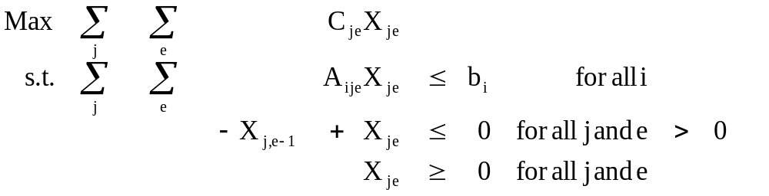
where: X_{je} is the quantity of the jth activity produced and kept until it is e periods old;
C_{je} is the per unit returns to X_{je};
A_{ije} is the per unit usage of resource i by X_{je};
b_{i} is the amount of resource i available;
Objective: The model maximizes profits subject to constraints on resource use and age sequencing.
Constraints: The age sequencing constraints state that the amount of enterprise j of age e must be less than or equal to the amount of that enterprise that was kept until age e-1.

Dynamic Linear Programming
Equilibrium- Unknown Life / Example

Table 8.10. Equilibrium Unknown Life Example Formulation
 |  | Strawberries |  |  |  | RHS
Rows | Wheat | 1 | 2 | 3 | 4 | MAX
Objective | 340 | -150 | 700 | 680 | 300
Land | 1 | 1 | 1 | 1 | 1 | ≤ | 700
Water | 1 | 0.8 | 4.5 | 4.5 | 5.7 | ≤ | 1200
Straw 1-2 |  | -1 | 1 |  |  | ≤ | 0
Straw 2-3 |  |  | -1 | 1 |  | ≤ | 0
Straw 3-4 |  |  |  | -1 | 1 | ≤ | 0

Dynamic Linear Programming
Equilibrium- Unknown Life / Example

Table 8.11. Equilibrium Unknown Life Example Solution

Objective = 253441
Variables | Value | Reduced Cost |  | Equation | Slack | Shadow  Price
Wheat | 479 | 0 |  | Land | 0 | 309
Strawberries 1 year old | 74 | 0 |  | Water | 0 | 31
Strawberries 2 year old | 74 | 0 |  | Straw 1-2 | 0 | 483
Strawberries 3 year old | 74 | 0 |  | Straw 2-3 | 0 | 232
Strawberries 4 year old | 0 | 185 |  | Straw 3-4 | 74 | 0

Table 8.12. Alternative Formulation of Equilibrium Unknown Life
 |  | Keep Strawberries |  |  |  | RHS
Rows | Wheat | 1 | 2 | 3 | 4
 |  |  |  |  |  | MAX
Objective | 340 | -150 | 550 | 1230 | 1530
Land | 1 | 1 | 2 | 3 | 4 | ≤ | 700
Water | 1 | 0.8 | 5.3 | 9.8 | 15.5 | ≤ | 1200

Dynamic Linear Programming
Recursive Programming

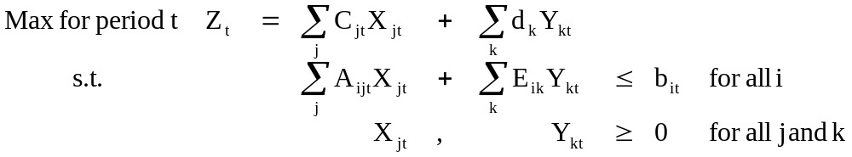

Where: C_{jt} are objective function parameters functionally dependent upon the previous objective function parameters (C_{j,t-1}), lagged optimal decision variables (X_{jt-1}, Y_{kt-1}), and exogenous events;

X_{jt} are the values of the decision variables at time t;

A_{ijt} are the resource i usages by X_{jt} functionally dependent upon lagged values, d_{k} are objective function coefficients which are stable over time;

Y_{kt} are the optimal values of the kth Y variable in time period t; E_{ik} are the usages of resource i which do not change over time;

b_{it} are the resource i limits, functionally dependent upon lagged phenomena.

Dynamic Linear Programming
Recursive Programming / Example

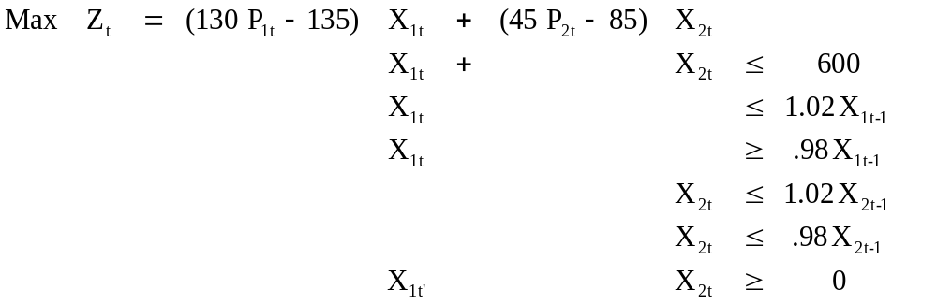

where: P_{lt+1} = 20 - 0.00045 Q_{it}
Q_{lt} = 130 X_{lt}
P_{2t+1} = 10.9 - 0.00045 Q_{2t}
Q_{2t} = 45 X_{2t}

Dynamic Linear Programming
Recursive Programming / Example

Solution
Time Period | X _{1t} | X_{2t} | P_{1t+1} | P_{2t+1} | Z_{t}
0 | 300.000 | 300.000 | 2.450 | 4.825 | ----
1 | 306.000 | 294.000 | 2.099 | 4.703 | 94995.750
2 | 311.880 | 288.120 | 1.755 | 4.584 | 79491.454
3 | 306.118 | 293.882 | 2.092 | 4.701 | 64163.394
4 | 311.995 | 288.005 | 1.748 | 4.582 | 79182.851
5 | 306.235 | 293.765 | 2.085 | 4.699 | 63860.831
6 | 312.110 | 287.890 | 1.742 | 4.580 | 78874.189

