Fixing Misbehaving Models

Bruce A. McCarl

Specialist in Applied Optimization
Distinguished Professor of Agricultural Economics,
Texas A&M University
Principal, McCarl and Associates

mccarl@tamu.edu
brucemccarl@gmail.com
http://agecon2.tamu.edu/people/faculty/mccarl-bruce/

Fixing Misbehaving Models
Portrait of a Bad Moment
fixmodel.pdf ch 9
newbook.pdf ch 2,17
GAMSchk.pdf

I finish a model

I eagerly send it to the solver

I fix my GAMS typing mistakes

The model has 10,000 variables and 4,000 constraints (Actually I should use a small data set, but emulating many modelers I do not)

Then usually several things happen

Oh no, the
- Darn thing is infeasible
- Darn thing is unbounded
- Solver says optimal, but on closer look the answer makes no sense

Fixing Misbehaving Models
Why do I have such problems?

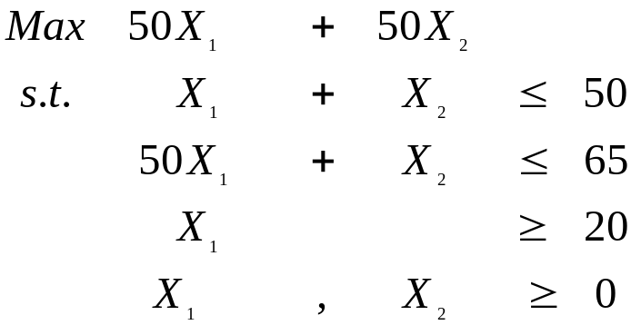Generally models are infeasible or unbounded because they have small components within them that interact to make an infeasible or unbounded solution. Consider the following infeasible example.
The second and third constraints cannot be simultaneously satisfied. The direct cause of the infeasibility is that the lower bound on X₁ cannot be satisfied given the second constraint. The underlying cause may be that

the 20 is too large for a lower bound on X₁,
the coefficient of 50 on X₁ in the second constraint is too large and should have been 0.5,
the X₂ coefficient in the second constraint should have been large and negative or
the 65 in the third constraint right hand side is too small;
as well as some combination of the above which the modeler would have to sort out.
Note in this case the first constraint has little to do with it
Fixing Misbehaving Models
Why do I have such problems?

A simple case can be developed in an unbounded problem. Consider the following unbounded example
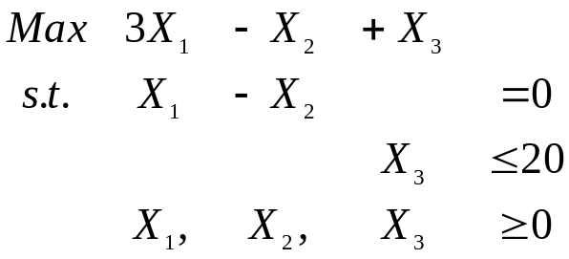here the problem is unbounded because of the interaction between X₁ and X₂. Namely when X₁ and X₂ are set equal they can be raised to infinity while still making money.

The underlying cause of this may be the
omission of constraints on X₁ or X₂ or
omission of some sort of decreasing marginal revenue or increasing cost function that affects X₁ or X₂.

Again one characteristic of the problem is the constraint on X₃ and X₃ itself have nothing to do with the unboundedness.

Fixing Misbehaving Models
What do I look for to fix such problems?

Inherent in the two examples is an identification of the type of information we look for when trying to fix a model that it is either unbounded or infeasible.

Namely within the problem formulation there’s a small set of variables and constraints which causes the infeasibility or unbounded outcome.

We need to identify that set sorting it out from the elements of the model which do not cause the infeasibility or unboundedness.

These notes cover ways to do that using solution information from GAMS.

Frequently such problems can be discovered using pre-solution analysis techniques such as covered in the pre-solution notes. Here we cover cases that would not be directly found by those procedures.
Fixing Misbehaving Models
Finding the cause of problems
(Newbook ch 17, fixmodel ch 9)

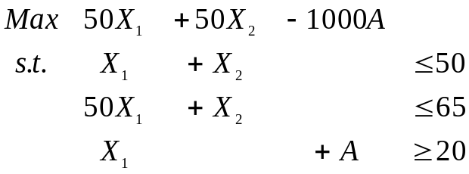When first learning about linear programming many are exposed to artificial variables. An artificial variable, when placed in a linear programming problem, allows feasibility at a very
high cost. In the example above, adding an artificial variable (A) makes the problem look as follows

Note this variable will allow X₁ to be less then 20 but at a cost of ten thousand dollars per unit. Given such a cost the A variable will only be in the optimum solution if absolutely required otherwise it will be driven to 0.
Suppose we set up and solve this problem (infeart.gms) , then we get the solution as follows:

Solution to Infeasible Example with Artificial Present
Objective Function = -18,699,935
Variable | Solution Value | Reduced Cost | Row | Slack Variable | Shadow Price
X₁ | 1.3 | 0 | 1 | 48.7 | 0
X₂ | 0 | 19950 | 2 | 0 | 20001
A | 18.7 | 0 | 3 | 0 | -1000000
Fixing Misbehaving Models
Finding the cause of problems
(Newbook ch 17, fixmodel ch 9)

This solution shows very high shadow prices for the second and third constraints. If we were to employ budgeting we would find out the reason for these very high shadow prices is the cost of A.

This shows a general mechanism for finding causes of feasibility. Namely

- Modify the problem by adding artificial variables.
- Solve the problem.
- Look at the optimum solution and collect a list of the variables with high (in absolute value) reduced costs and the constraints with very high shadow prices. The model components associated with those are the model components causing the infeasibility.

In the example we find the infeasibility is caused by the interaction of constraints two and three along with the non-negativity condition on X₂. The X₂ identification indicates that it would be desirable to let this variable go negative.

Fixing Misbehaving Models
Finding the cause of problems
(Newbook ch 17, fixmodel ch 9)

Procedures to help find the set associated with infeasibility problems have been implemented in GAMSCHK under the nonopt and advisory options. In particular when running nonopt on a solved model the reduced costs and shadow prices which are larger in absolute value than a tolerance given by 10 to the margfilt parameter set in the option file.

In turn GAMSCHK generates output such as

----### THESE VARIABLE BOUNDS MAY PARTIALLY CAUSE
INFEASIBLE MODEL
Since their marginals are so large

X2 marg -19951.00

----### THESE EQUATIONS MAY PARTIALLY CAUSE
INFEASIBLE MODEL
Since their marginals are so large

R2 marg 20001.00
R3 marg -1000000.

Generally margfilt should be three orders of magnitude smaller than the value of the artificial variable objective function.
Fixing Misbehaving Models
Finding infeasibility cause
(Newbook ch 17, fixmodel ch 9)

Step 1 Add artificial variables to constraints and bounds not feasible at X=0 The objective function entries are negative large numbers for maximization and positive for minimization. Artificials also have an entry in the constraints

Minus one in ≤ constraints with negative rhs including negative upper bounds
Plus one in  constraints with positive rhs including positive lower bounds
A plus or minus one in = constraints with nonzero right hand sides where the sign is the same as the rhs sign
GAMSCHK advisory or nonopt can list these.

Step 2 Solve

Step 3 If nonzero artificial variables are found, then find equations and variables with large marginals including nonnegativity conditions and bounds. Use the nonopt option in GAMSCHK.

Step 4 Examine that set and Repair model
Fixing Misbehaving Models
Infeasible Example (farminf.gms)

 |  |  | Profit | Feed Cattle |  | Move Crops |  |  |  | Grow Crops |  |  |  | Sell Crops |  |  |  | Rent Land |  | Artificial  Cattle |  | RHS |  |  | Slack | Shadow  Price
 |  |  | Profit | Farm 1 | Farm 2 | Farm 1 to Farm 2 |  | Farm 2 to  Farm 1 |  | Farm 1 |  | Farm 2 |  | Farm 1 |  | Farm 2
 |  |  |  |  |  | Corn | Hay | Corn | Hay | Corn | Hay | Corn | Hay | Corn | Hay | Corn | Hay | Farm 1 | Farm 2 | Farm 1 | Farm 2
Profit Accounting |  |  | 1 | -185 | -153 | 0.11 | 4 | 0.11 | 4 | 250 | 220 | 240 | 195 | -2.4 | -55 | -2.05 | -50 | 100 | 100 | 1000000 | 1000000 | = | 0 |  | 0 | 1
Crop on Hand | Farm 1 | Corn |  | 39 |  | 1 |  | -1 |  | -130 |  |  |  | 1 |  |  |  |  |  |  |  | ≤ | 0 |  | 0 | 2.77
Crop on Hand | Farm 1 | Hay |  | 0.75 |  |  | 1 |  | -1 |  | -5.5 |  |  |  | 1 |  |  |  |  |  |  | ≤ | 0 |  | 0 | 65.46
Crop on Hand | Farm 2 | Corn |  |  | 38.5 | -1 |  | 1 |  |  |  | -128 |  |  |  | 1 |  |  |  |  |  | ≤ | 0 |  | 0 | 2.66
Crop on Hand | Farm 2 | Hay |  |  | 0.74 |  | -1 |  | 1 |  |  |  | -4.8 |  |  |  | 1 |  |  |  |  | ≤ | 0 |  | 0 | 61.46
Land | Farm 1 |  |  | 10 |  |  |  |  |  | 1 | 1 |  |  |  |  |  |  | -1 |  |  |  | ≤ | 100 |  | 0 | 1e+5
Land | Farm 2 |  |  |  | 10 |  |  |  |  |  |  | 1 | 1 |  |  |  |  |  | -1 |  |  | ≤ | 100 |  | 0 | 100
Min. Cattle Sold | Farm 1 |  |  | 1 |  |  |  |  |  |  |  |  |  |  |  |  |  |  |  | 1 |  | ≥ | 50 |  | 1e+6 | -1e+6
Min. Cattle Sold | Farm 2 |  |  |  | 1 |  |  |  |  |  |  |  |  |  |  |  |  |  |  |  | 1 | ≥ | 50 |  | 0 | -944.49
Max  Rented Land | Farm 1 |  |  |  |  |  |  |  |  |  |  |  |  |  |  |  |  | 1 |  |  |  | ≤ | 200 |  | 0 | 99903
Max  Rented Land | Farm 2 |  |  |  |  |  |  |  |  |  |  |  |  |  |  |  |  |  | 1 |  |  | ≤ | 700 |  | 476 | 0
Optimal Level |  |  | -20000000 | 30 | 50 | 0 | 0 | 1170 | 22.5 | 0 | 0 | 24 | 12 | 0 | 0 | 0 | 0 | 200 | 437 | 20 | 0
Reduced Cost |  |  | 0 | 0 | 0 | -0.22 | -8 | 0 | 0 | -100000 | -100000 | 0 | 0 | -0.37 | -10.5 | -0.61 | -11.5 | 0 | 0 | 0 | -1000000

Fixing Misbehaving Models
Infeasible Example (farminf.gms)

Assistance from GAMSCHK
----#### Executing NONOPT
----### THESE VARIABLES ARE POTENTIALLY UNBOUNDED
To find the cause of unboundedness
bound them or the objective function
variable at a large value. Then solve and
manually or through GAMSCHK find
large levels for variables in solution
FEEDCATTLE(farm1)
FEEDCATTLE(farm2)
SELLCROPS(farm1,corn)
SELLCROPS(farm1,hay)
SELLCROPS(farm2,corn)
SELLCROPS(farm2,hay)

----### THESE EQUATIONS ARE POTENTIALLY INFEASIBLE
To find the cause of infeasibility
enter artificial variables with an
entry in these eqns and a penalty in the
objective function. Then solve the model
and manually or through GAMSCHK find
large marginals for equations or bounds
MINCATTLE(farm1)
MINCATTLE(farm2)
---### THESE VARIABLE BOUNDS MAY PARTIALLY CAUSE INFEASIBLE Since their marginals are so large
GROWCROPS(farm1,corn) marg -99892.92
GROWCROPS(farm1,hay) marg -99862.77
ARTCATTLE(farm2) marg -999005.5

----### THESE EQUATIONS MAY PARTIALLY CAUSE INFEASIBLE MODEL
Since their marginals are so large
LAND(farm1) marg 100002.8
MINCATTLE(farm1) marg -1000000.
RENTALLAND(farm1) marg 99902.79
Fixing Misbehaving Models
Infeasible Example (farminf2.gms)
CPLEX IIS

When using CPLEX one can use the irreducible infeasible set (IIS) finder to discover infeasibility. This involves an option file (cplex.op2) which invokes IIS and may require turning off presolve (see solve for options file discussion)
iis yes
presolve 0
In turn in the example with artificials dropped one gets

Starting infeasibility finder algorithm...
An IIS is a set equations and variables (ie a submodel) which is infeasible but becomes feasible if any one equation or variable bound is dropped. A problem may contain several independent IISs but only one will be found per run.
Number of equations in the IIS: 3.
upper: Land(farm1) ≤ 100
lower: mincattle(farm1) ≥ 50
upper: rentalLand(farm1) ≤ 200
Number of variables in the IIS: 2.
lower: growcrops(farm1,corn) ≥ 0
lower: growcrops(farm1,hay) ≥ 0

This indicates that the infeasible set involves the same items as found in our GAMSCHK supported exercise
Fixing Misbehaving Models

Unbounded

The basic approach to unbounded models is similar to that used for infeasibilities. We bound the model variables at very large values so that the model is no longer unbounded. In turn then the solution may have certain variables at very large values which are those contributing to the unbounded case. Consider the implementation of this in the case of the example (unbdbnd.gms) we used above
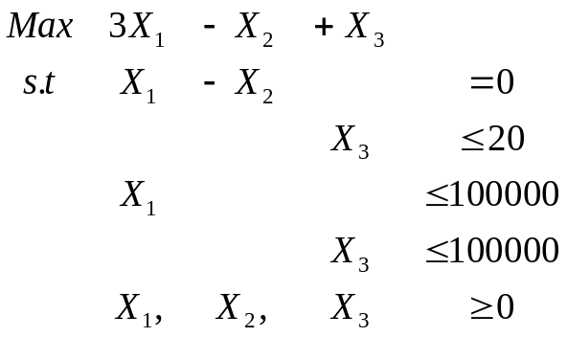
Note this formulation will stop the unboundedness but X₁ and X₂ will take on a very large value. Suppose we set up and solve this problem (unbdbnd.gms), than we get the solution as follows:
x1=x2=100000, x3=20
Fixing Misbehaving Models
Unbounded
Basic Approach — bound the unbounded variables with very large numbers

1 Add large bounds to all variables which improve the objective and if maximize
a. Non neg var with positive obj need large upper bound;
b. Non pos var with neg obj need large neg lower bound;
c. Unrestrict var with pos obj need a large upper bound;
d. Unrestrict var with neg obj need large neg low bound.

GAMSCHK will list these items when using advisory or nonopt.

2 Solve the resultant model.

3 If imposed large bounds are binding, then find set of all variables with solution levels which are unrealistically large in absolute value. GAMSCHK will list these items when using non-opt

4 Look over that set and find problem then Repair the model and go back to step 1.

Fixing Misbehaving Models
Unbounded Example (farmunb.gms)
 |  |  | Profit | Feed Cattle |  | Move Crops |  |  |  | Grow Crops |  |  |  | Sell Crops |  |  |  | Rent Land |  | RHS |  |  | Slack | Shadow  Price
 |  |  | Profit | Farm 1 | Farm 2 | Farm 1 to Farm 2 |  | Farm 2 to  Farm 1 |  | Farm 1 |  | Farm 2 |  | Farm 1 |  | Farm 2
 |  |  |  |  |  | Corn | Hay | Corn | Hay | Corn | Hay | Corn | Hay | Corn | Hay | Corn | Hay | Farm 1 | Farm 2
Profit Accounting |  |  | 1 | -76415 | -153 | 0.11 | 4 | 0.11 | 4 | 250 | 220 | 240 | 195 | -2.4 | -55 | -2.1 | -50 | 100 | 100 | = | 0 |  | 0 | 1
Crop on Hand | Farm 1 | Corn |  | 39 |  | 1 |  | -1 |  | -130 |  |  |  | 1 |  |  |  |  |  | ≤ | 0 |  | 0 | 2.69
Crop on Hand | Farm 1 | Hay |  | 0.75 |  |  | 1 |  | -1 |  | -5.5 |  |  |  | 1 |  |  |  |  | ≤ | 0 |  | 0 | 58.18
Crop on Hand | Farm 2 | Corn |  |  | 38.5 | -1 |  | 1 |  |  |  | -128 |  |  |  | 1 |  |  |  | ≤ | 0 |  | 0 | 2.58
Crop on Hand | Farm 2 | Hay |  |  | 0.74 |  | -1 |  | 1 |  |  |  | -4.8 |  |  |  | 1 |  |  | ≤ | 0 |  | 0 | 59.43
Land | Farm 1 |  |  | 0.5 |  |  |  |  |  | 1 | 1 |  |  |  |  |  |  | -1 |  | ≤ | 100 |  | 0 | 100
Land | Farm 2 |  |  |  | 0.5 |  |  |  |  |  |  | 1 | 1 |  |  |  |  |  | -1 | ≤ | 100 |  | 0 | 90.28
Min. Cattle Sold | Farm 1 |  |  | 1 |  |  |  |  |  |  |  |  |  |  |  |  |  |  |  |  | 50 |  | 1e+6 | 0
Min. Cattle Sold | Farm 2 |  |  |  | 1 |  |  |  |  |  |  |  |  |  |  |  |  |  |  |  | 50 |  | 0 | -35.21
Max  Rented Land | Farm 1 |  |  |  |  |  |  |  |  |  |  |  |  |  |  |  |  | 1 |  | ≤ | 200
Max  Rented Land | Farm 2 |  |  |  |  |  |  |  |  |  |  |  |  |  |  |  |  |  | 1 | ≤ | 700
Upper Bounds |  |  | -- | 1e+06 | 1000  000 | -- | -- | -- | -- | -- | -- | -- | -- | 1000  000 | 1000  000 | 1000  000 | 1000  000 | -- | --
Optimal Level |  |  | 7e+10 | 1e+06 | 50 | 0 | 0 | 6689 | 0 | 300000 | 100000 | 67 | 8 | 0 | 0 | 0 | 0 | 900000 | 0
Reduced Cost |  |  | 0 | 0 | 0 | -0.2 | -2.8 | 0 | -5.3 | 0 | 0 | 0 | 0 | -0.3 | -3.2 | -0.5 | -9.4 | 0 | -9.7
Model made unbounded by removing rental land limits. Also by entering cattle price in cents, not dollars, on farm 1
Fixing Misbehaving Models
Assistance from GAMSCHK

GAMSCHK will tell you variables and constraints to bound and list out variables and slacks with large values
---#### Executing NONOPT
----### THESE VARIABLES ARE POTENTIALLY UNBOUNDED
To find the cause of unboundedness
bound them or the objective function
variable at a large value. Then solve and
manually or through GAMSCHK find
large levels for variables in solution
FEEDCATTLE(farm1)
FEEDCATTLE(farm2)
SELLCROPS(farm1,corn)
SELLCROPS(farm1,hay)
SELLCROPS(farm2,corn)
SELLCROPS(farm2,hay)

----### THESE EQUATIONS ARE POTENTIALLY INFEASIBLE
To find the cause of infeasibility
enter artificial variables with an
entry in these eqns and a penalty in the
objective function. Then solve the model
and manually or through GAMSCHK find
large marginals for equations or bounds
MINCATTLE(farm1)
MINCATTLE(farm2)

----### THESE VARIABLES MAY BE UNBOUNDED
Since their levels are so large
FEEDCATTLE(farm1) level 1000000.
GROWCROPS(farm1,corn) level 299948.5
GROWCROPS(farm1,hay) level 136363.6
LANDRENT(farm1) level 936212.2

----### THESE EQUATIONS MAY BE UNBOUNDED
Since their levels are so large

MINCATTLE(farm1) level 1000000.
Fixing Misbehaving Models
A Simpler Bound Approach

There is also one quick and dirty way of finding an unbounded solution that should be mentioned.

One can just add a bound to just the variable being maximized. For example in the case of a model where the solve statement says the model is maximizing profit, one can just bound the profit variable at one billion and proceed as above. For an example implementation of this procedure can be found in the file unbbd2.gms

objmax.up=1000000000;

converting the problem to
Maximize objmax
objmax =e= CX
AX≤b;
objmax.up=1000000000;

The drawback to this approach is that it will find the most unbounded case in each run and will not identify all the unbounded cases at one time.

Fixing Misbehaving Models
Permanent Model Additions

One may wish to keep the large upper bound and artificial variable model modifications in the model at all times

In a project I did years ago we had a model which we used with a lot of farmers. In the model farmers could specify a minimum amount of each crop to be planted and also could specify a wage rate at which they could sell their family labor. This caused both infeasibility and unboundedness problems. Infeasibility problems occurred when the farmers specified the quantity of acres that needed to be planted which exceeded the acres available or implied usage of more resources than were available. The unboundedness occurred because when the sale wage rate was above the hired labor wage rate and an infinite amount of hired labor could be purchased, the model just went into the temporary employment brokerage business.

We fixed this by permanently leaving the artificials and large bounds in the model. Then when the farmer got a model solution they might find it cost a great deal of money to meet a particular acreage constraint and could identify the resources that were the problem. Similarly they might find the solution buying and selling a tremendous amount of labor. In either case they could diagnose and fix the problem. Often these model features let non-technical users fix their own problems.
Fixing Misbehaving Models
Theory -- Sensitivity Information

Two Equations

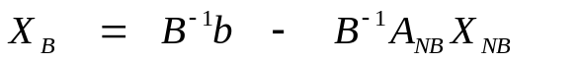

Sensitivity Results

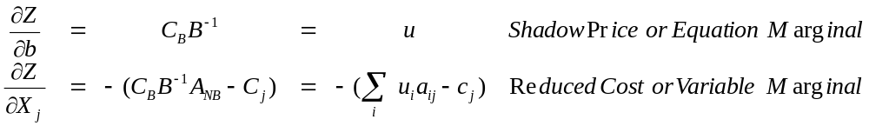
So
reduced costs or variable marginals are a function of u_{i}, a_{ij}, c_{j} and shadow prices

shadow prices or row marginals u are determined by a_{ij} and c_{j} terms for basic variables

So to find out why variable marginals or reduced costs are large enough to make variables non basic look at u along with A and c for non basic variables

So to find out why shadow prices or equation marginals are large look at variables are non basic look at u along with A and c for basic variables. They arise from setting reduced costs = 0 for basic variables.
Fixing Misbehaving Models – Budgeting

Reduced Cost or GAMS variable marginal reproduction

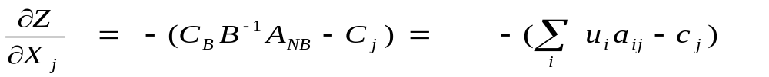

Budget for Variable X_{j}

Item | a_{ij}  from  model  data | Shadow  Price  from  solution | Product  your  calculation
Name for equation 1 | a_{1j} | u₁ | u₁ a_{ij}
Name for equation 2 | a_{2j} | u₂ | u₂ a_{2j}
 |  |  | 
Name for equation m | a_{mj} | u_{m} | u_{m} a_{mj}
Indirect cost sum | -- | -- | ∑_{i}u_{i}a_{ij}
Objective function | -- | -- | -c_{j}
Reduced cost | -- | -- | ∑_{i}u_{i}a_{ij}-c_{j}

Fixing Misbehaving Models
Base Example Model (Farmb.gms)

 |  |  | Profit | Feed Cattle |  | Move Crops |  |  |  | Grow Crops |  |  |  | Sell Crops |  |  |  | Rent Land |  | RHS
 |  |  | Profit | Firm 1 | Firm 2 | Firm 1 to Firm 2 |  | Firm 2 to  Firm 1 |  | Firm 1 |  | Firm 2 |  | Firm 1 |  | Firm 2
 |  |  | Profit |  |  | Corn | Hay | Corn | Hay | Corn | Hay | Corn | Hay | Corn | Hay | Corn | Hay | Firm 1 | Firm 2
Profit Accounting |  |  | 1 | -185 | -153 | .11 | 4 | .11 | 4 | 250 | 220 | 240 | 195 | -2.4 | -55 | -2.05 | -50 | 100 | 100 | = 0
Crop on Hand | Firm 1 | Corn |  | 39 |  | 1 |  | -1 |  | -130 |  |  |  | 1 |  |  |  |  |  | ≤ | 0
Crop on Hand | Firm 1 | Hay |  | 0.75 |  |  | 1 |  | -1 |  | -5.5 |  |  |  | 1 |  |  |  |  | ≤ | 0
Crop on Hand | Firm 2 | Corn |  |  | 38.5 | -1 |  | 1 |  |  |  | -128 |  |  |  | 1 |  |  |  | ≤ | 0
Crop on Hand | Firm 2 | Hay |  |  | 0.74 |  | -1 |  | 1 |  |  |  | -4.8 |  |  |  | 1 |  |  | ≤ | 0
Land | Firm 1 |  |  | 0.5 |  |  |  |  |  | 1 | 1 |  |  |  |  |  |  | -1 |  | ≤ | 100
Land | Firm 2 |  |  |  | 0.5 |  |  |  |  |  |  | 1 | 1 |  |  |  |  |  | -1 | ≤ | 100
Min. Cattle Sold | Firm 1 |  |  | 1 |  |  |  |  |  |  |  |  |  |  |  |  |  |  |  | ≥ | 50
Min. Cattle Sold | Firm 2 |  |  |  | 1 |  |  |  |  |  |  |  |  |  |  |  |  |  |  | ≥ | 50
Max  Rented  Land | Firm 1 |  |  |  |  |  |  |  |  |  |  |  |  |  |  |  |  | 1 |  | ≤ | 200
Max  Rented  Land | Firm 2 |  |  |  |  |  |  |  |  |  |  |  |  |  |  |  |  |  | 1 | ≤ | 700

Fixing Misbehaving Models Unrealistic Optimal (Farmbud.gms,Firmrsm.gms)
 |  |  | Profit | Feed Cattle |  | Move Crops |  |  |  | Grow Crops |  |  |  | Sell Crops |  |  |  | Rent Land |  | RHS |  |  | Slack | Shadow  Price
 |  |  | Profit | Firm 1 | Firm 2 | Firm 1 to Firm 2 |  | Firm 2 to  Firm 1 |  | Firm 1 |  | Firm 2 |  | Firm 1 |  | Firm 2 |  |  |  |  |  |  | Slack | Shadow  Price
 |  |  | Profit |  |  | Corn | Hay | Corn | Hay | Corn | Hay | Corn | Hay | Corn | Hay | Corn | Hay | Firm 1 | Firm 2 |  |  |  | Slack
Profit Accounting |  |  | 1 | -185 | -153 | .11 | 4 | .11 | 4 | 250 | 220 | 240 | 195 | -2.4 | -55 | -2.05 | -50 | 100 | 100 | = | 0 |  | 0 | 1
Crop on Hand | Firm 1 | Corn |  | 39 |  | 1 |  | -1 |  | -130 |  |  |  | 1 |  |  |  |  |  | ≤ | 0 |  | 0 | 2.40
Crop on Hand | Firm 1 | Hay |  | 0.75 |  |  | 1 |  | -1 |  | -5.5 |  |  |  | 1 |  |  |  |  | ≤ | 0 |  | 0 | 57
Crop on Hand | Firm 2 | Corn |  |  | 38.5 | -1 |  | 1 |  |  |  | -7168 |  |  |  | 1 |  |  |  | ≤ | 0 |  | 0 | 2.29
Crop on Hand | Firm 2 | Hay |  |  | 0.74 |  | -1 |  | 1 |  |  |  | -4.8 |  |  |  | 1 |  |  | ≤ | 0 |  | 0 | 61
Land | Firm 1 |  |  | 0.5 |  |  |  |  |  | 1 | 1 |  |  |  |  |  |  | -1 |  | ≤ | 100 |  | 0 | 96.49
Land | Firm 2 |  |  |  | 0.5 |  |  |  |  |  |  | 1 | 1 |  |  |  |  |  | -1 | ≤ | 100 |  | 0 | 16160
Min. Cattle Sold | Firm 1 |  |  | 1 |  |  |  |  |  |  |  |  |  |  |  |  |  |  |  | ≥ | 0 |  | 157 | 0
Min. Cattle Sold | Firm 2 |  |  |  | 1 |  |  |  |  |  |  |  |  |  |  |  |  |  |  | ≥ | 0 |  | 0 | 0
Max  Rented Land | Firm 1 |  |  |  |  |  |  |  |  |  |  |  |  |  |  |  |  | 1 |  | ≤ | 200 |  | 200 | 0
Max  Rented Land | Firm 2 |  |  |  |  |  |  |  |  |  |  |  |  |  |  |  |  |  | 1 | ≤ | 700 |  | 0 | 16060
Optimal Level |  |  | 1.3e+7 | 157 | 0 | 0 | 0 | 5.7e+6 | 0 | 0 | 21 | 800 | 0 | 5.7e+6 | 0 | 0 | 0 | 0 | 700
Reduced Cost |  |  | 0 | 0 | -8060 | -.22 | 0 | 0 | -8 | -34 | 0 | 0 | -16060 | 0 | -2.54 | -.24 | -11.5 | -3.51 | 0
Model made unrealistic by entering corn yield Firm 2 in lbs not bushels.
Also took off cattle minimum
This was done by altered lines 21 and 33 in Farmb.gms to get Firmrsm.gms
GCK file just
postopt
variables

Fixing Misbehaving Models
Budgeting for Unrealistic Optimal Case (Farmbud.gms)

Panel a FEEDCATTLE(Firm2) Budget

## FEEDCATTLE(Firm2)
SOLUTION VALUE .000000E+00

EQN Aij Ui Aij*Ui
PROFITACCT -153.20 1.0000 -153.20
CROPONHAND(Firm2,corn) 38.480 2.2880 88.042
CROPONHAND(Firm2,hay) 0.74000 61.543 45.542
LAND(Firm2) 0.50000 16160. 8080.2
MINCATTLE(Firm2) 1.0000 0.00000E+00 000
TRUE REDUCED COST 8060.6

Land too valuable

Panel b GROWCROPS(Firm2,CORN) Budget
## GROWCROPS(Firm2,corn)
SOLUTION VALUE 800.000

EQN Aij Ui Aij*Ui
PROFITACCT 240.00 1.0000 240.00
CROPONHAND(Firm2,corn) -7168.0 2.2880 -16400.
LAND(Firm2) 1.0000 16160. 16160.
TRUE REDUCED COST 0.00000E+00

I have found the faulty corn yield

Fixing Misbehaving Models
Steps to Using Budgets

1) Choose a variable to budget which exhibits a bad reduced cost in the solution information or which uses resources with bad shadow prices.

2) Make the above table

3) Examine the table results in the last column to find out how things balance out then examine rows where things look bad in terms of the contained shadow prices and a_{ij}’s to find either unrealistically high shadow prices or data errors.

4) If an excessively high shadow price has been found then budget other basic variables which use the resource involved

5) If an error in the a_{ij}’s is found which is causing the distortion then repair the model
Fixing Misbehaving Models

Row Summing

Allocation information comes from AX=b.

Row Sum layout for row i

Variable Names | Coefficients from data | Solution values | Calculated product
X₁ | a_{i1} | X₁* | a_{i1}X₁*
X₂ | a_{i2} | X₂* | a_{i2}X₂*
... | ... | ... | ...
X_{n} | a_{in} | X_{n}* | a_{in}X_{n}*
Sum | - - | - - | ∑_{j}a_{ij}X_{j}*
RHS | - - | - - | B
Slack | - - | - - | b-∑_{j}a_{ij}X_{j}*

Fixing Misbehaving Models
Row Summing for Unrealistic Optimal Case
(Firmrsm.gms)
Panel a Objective Function -- PROFITACCT Row Sum
VAR Aij Xj Aij*Xj
PROFIT 1.0000 0.12868E+08 0.12868E+08
FEEDCATTLE(Firm1) -185.00 157.14 -29071.
FEEDCATTLE(Firm2) -153.20 0.00000E+00 0.00000E+00
MOVECROPS(Firm1,Firm2,corn) 0.11200 0.00000E+00 0.00000E+00
MOVECROPS(Firm1,Firm2,hay) 4.0000 0.00000E+00 0.00000E+00
MOVECROPS(Firm2,Firm1,corn) 0.11200 0.57344E+07 0.64225E+06
MOVECROPS(Firm2,Firm1,hay) 4.0000 0.00000E+00 0.00000E+00
GROWCROPS(Firm1,corn) 250.00 0.00000E+00 0.00000E+00
GROWCROPS(Firm1,hay) 220.50 21.429 4714.3
GROWCROPS(Firm2,corn) 240.00 800.00 0.19200E+06
GROWCROPS(Firm2,hay) 195.00 0.00000E+00 0.00000E+00
SELLCROPS(Firm1,corn) -2.4000 0.5728E+07 -0.1375E+08
SELLCROPS(Firm1,hay) -55.000 0.00000E+00 0.00000E+00
SELLCROPS(Firm2,corn) -2.0500 0.00000E+00 0.00000E+00
SELLCROPS(Firm2,hay) -50.000 0.00000E+00 0.00000E+00
LANDRENT(Firm1) 100.00 0.00000E+00 0.00000E+00
LANDRENT(Firm2) 100.00 700.00 70000.
ARTCATTLE(Firm1) 0.10000E+07 0.00000E+00 0.00000E+00
ARTCATTLE(Firm2) 0.10000E+07 0.00000E+00 0.00000E+00
=E= =E=
RHS COEFF 0.00000E+00
Cause is money from Firm 1 corn sale

## CROPONHAND(Firm1,corn) VAR Aij Xj Aij*Xj
FEEDCATTLE(Firm1) 39.000 157.14 6128.6
MOVECROPS(Firm1,Firm2,corn) 1.0000 0.00000E+00 0.00000E+00
MOVECROPS(Firm2,Firm1,corn) -1.0000 0.57344E+07 -0.5734E+07
GROWCROPS(Firm1,corn) -130.00 0.00000E+00 0.00000E+00
SELLCROPS(Firm1,corn) 1.0000 0.57283E+07 0.57283E+07
=L= =L=
RHS COEFF 0.00000E+00
SLACK EQUALS 0.00000E+00
Cause is corn moving from Firm 2 to Firm 1

## CROPONHAND(Firm2,corn)
VAR Aij Xj Aij*Xj
FEEDCATTLE(Firm2) 38.480 0.00000E+00 0.00000E+00
MOVECROPS(Firm1,Firm2,corn) -1.0000 0.00000E+00 0.00000E+00
MOVECROPS(Firm2,Firm1,corn) 1.0000 0.57344E+07 0.57344E+07
GROWCROPS(Firm2,corn) -7168.0 800.00 -0.57344E+07
SELLCROPS(Firm2,corn) 1.0000 0.00000E+00 0.00000E+00
=L= =L=
RHS COEFF 0.00000E+00
SLACK EQUALS 0.00000E+00
Again the faulty yield is found
Fixing Misbehaving Models
Steps to use Row Sum

- Find a variable or slack with an unreasonable value

- Choose a constraint where this variable or slack appears

- Make the above table

- Examine the allocation calculations to find other unrealistic variable level values or aij/rhs data errors which balance off allowing the unreasonable value for the originally sought item.

- If no other bad variable or data are found then examine another constraint

- If another variable is found to have a bad level, then examine another constraint into which it falls

- If bad data are found repair the model

Fixing Misbehaving Models
Presolve Checking
chapter 8 of fixmodel.pdf
GAMSchk.pdf

Two Forms of Structural Examinations

Automatic -- Rule Based

Manual
Schematic based
Equation and variable display based

Within GAMSCHK these can either be at the block or individual variable/equation level

Fixing Misbehaving Models
Simple Structural Checking

Do you see anything wrong here with X2 (unbounded)

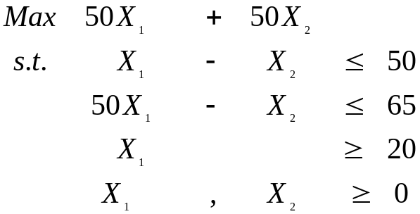

Do you see anything wrong here with X2 (zero)

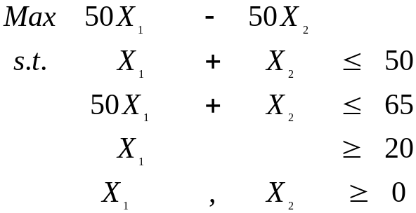
Fixing Misbehaving Models
Simple Structural Checking

Anything wrong here with first constraint (force zero)

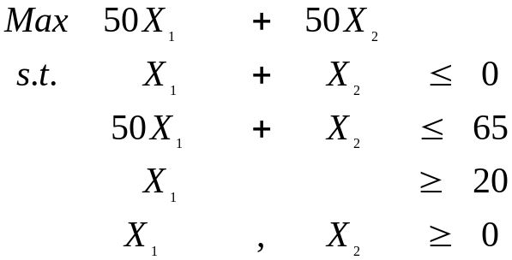

Anything wrong here with first constraint (infeasible)

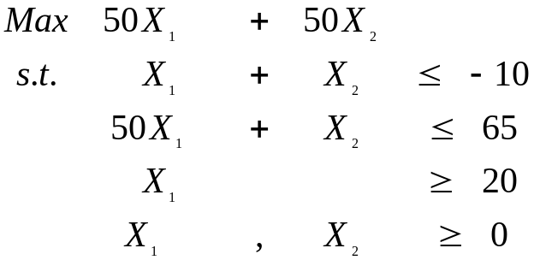

Anything wrong here with first constraint (redundant)

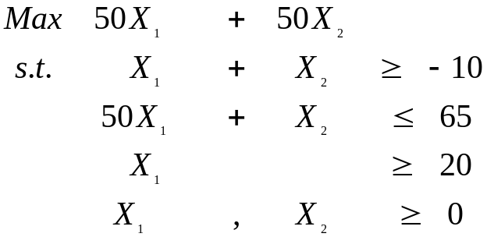
Fixing Misbehaving Models
Simple Structural Checking

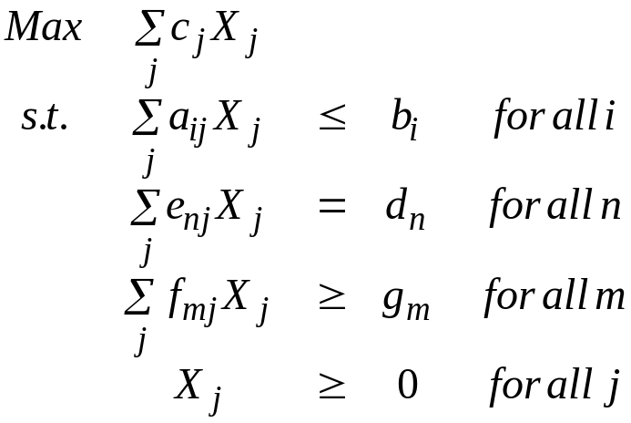
Cases Where the Model Must have an Infeasible Solution
b_{i} < 0 and a_{ij} > 0 for all j implies row i will not allow a feasible solution
d_{n} < 0 and e_{nj} > 0 for all j implies row n will not allow feasible solution
d_{n} > 0 and e_{nj} < 0 for all j implies row n will not allow feasible solution
g_{m} > 0 and f_{mj} < 0 for all j implies row m will not allow a feasible solution

Cases where certain variables in the model must equal zero
b_{i} = 0 and a_{ij} > 0 for all j implies all X_{j}'s with a_{ij} ≠ 0 in row i will be zero
d_{n} = 0 and e_{nj} > 0 for all j implies all X_{j} 's with e_{nj} ≠ 0 in row n will be zero
d_{n} = 0 and e_{nj} < 0 for all j implies all X_{j} 's with e_{nj} ≠ 0 in row n will be zero
g_{m} = 0 and f_{mj} < 0 for all j implies all X_{j} 's with f_{mj} ≠ 0 in row m will be zero

Cases where certain constraints are obviously redundant
b_{i} > 0 and a_{ij} ≠ 0 for all j means row i is redundant
g_{m} ≠ 0 and f_{mj} > 0 for all j means row m is redundant

Cases where certain variables cause the model to be unbounded
c_{j} > 0 and a_{ij} < 0 or e_{nj} = 0 and f_{mj} > 0 for all i, m, and n means variable j is unbounded

Cases where certain variables will be zero at optimality
c_{j} < 0 and a_{ij} > 0 or e_{nj} = 0 and f_{mj} < 0 for all i, m, and n means variable j will never be nonzero m, and n implies variable j will be zero

Fixing Misbehaving Models
Analysis Example
(Firman.gms)

 |  |  | Feed Cattle |  | Move Crops |  |  |  | Grow Crops |  |  |  | Sell Crops |  |  |  | Rent Land |  | RHS
 |  |  | Firm1 | Firm2 | Firm1 to Firm2 |  | Firm2 to Firm1 |  | Firm1 |  | Firm2 |  | Firm1 |  | Firm2
 |  |  |  |  | Corn | hay | Corn | hay | Corn | hay | Corn | Hay | Corn | hay | Corn | hay | Firm1 | Firm2
Profit Accounting |  |  | -185 | -153 | .11 | 4 | .11 | 4 | 250 | 220 | 240 | 195 | -2.4 | 5.5 | -2.45 | -5.6 | -100 | 100 | Min
Crop on Hand | Firm1 | Corn | 39 |  | 1 |  | 1 |  | 130 |  |  |  | 1 |  |  |  |  |  | ≤ | 0
Crop on Hand | Firm1 | Soy | 0.75 |  |  | 1 |  | 1 |  | 5.5 |  |  |  | 1 |  |  |  |  | ≤ | 0
Crop on Hand | Firm2 | Corn |  | 38.5 | 1 |  | 1 |  |  |  | 128 |  |  |  | 1 |  |  |  | ≤ | 0
Crop on Hand | Firm2 | Soy |  | 0.74 |  | 1 |  | 1 |  |  |  | 4.8 |  |  |  | 1 |  |  | ≤ | 0
Land | Firm1 |  | 0.5 |  |  |  |  |  | 1 | 1 |  |  |  |  |  |  | -1 |  | ≤ | 100
Land | Firm2 |  |  | 0.5 |  |  |  |  |  |  | 1 | 1 |  |  |  |  |  | -1 | ≤ | 100
Min. Cattle Sold | Firm1 |  | 1 |  |  |  |  |  |  |  |  |  |  |  |  |  |  |  | ≥ | 50
Min. Cattle Sold | Firm2 |  |  | 1 |  |  |  |  |  |  |  |  |  |  |  |  |  |  | ≥ | 50
Max. Rented  Land | Firm1 |  |  |  |  |  |  |  |  |  |  |  |  |  |  |  | 1 |  | ≤ | -200
Max. Rented  Land | Firm2 |  |  |  |  |  |  |  |  |  |  |  |  |  |  |  |  | 1 | ≤ | -700

Fixing Misbehaving Models
Assistance from GAMSCHK

Analysis Results

----### Analysis of Variables ( nonlinear terms at current
**** Warning These variables will equal zero
because they have a zero lower bound
an undesirable object function coefficient
all 0 or - coefficients in the =G= rows
all 0 or + coefficients in the =L= rows
and no coefficients in the =E= rows
## GROWCROPS(Firm1,corn)
GROWCROPS(Firm2,corn)
GROWCROPS(Firm2,hay)

----### Analysis of Equations ( nonlinear terms at current)
**** ERROR This =L= constr. causes an infeasible model
since the nonnegative variables present
have only 0 or + coefficients
the nonpositive variables present
have only 0 or - coefficents
the unrestricted variables
have only zero coefficients
and the RHS is negative
## RENTALLAND(Firm1)
RENTALLAND(Firm2)

----#### Using DISPLAYCR to show ANALYSIS Problems
Note only the first 5 problems found under each
Error or warning type will be displayed up to
maximum of 200 variables or equations
Fixing Misbehaving Models
Assistance from GAMSCHK

Analysis Results
Displaycr Called by Analysis

----### DISPLAYING VARIABLES
----## VAR GROWCROPS
## GROWCROPS(Firm1,corn)
PROFITACCT 250.00
CROPONHAND(Firm1,corn) 130.00
LAND(Firm1) 1.0000
## GROWCROPS(Firm2,corn)
PROFITACCT 240.00
CROPONHAND(Firm2,corn) 128.00
LAND(Firm2) 1.0000
## GROWCROPS(Firm2,hay)
PROFITACCT 195.00
CROPONHAND(Firm2,hay) 4.8000
LAND(Firm2) 1.0000

----### DISPLAYING EQUATIONS
----## EQU RENTALLAND
## RENTALLAND(Firm1)
LANDRENT(Firm1) 1.0000
=L= -200.00
## RENTALLAND(Firm2)
LANDRENT(Firm2) 1.0000
=L= -700.00
Fixing Misbehaving Models
Assistance from GAMSCHK
BLOCKPIC or BLOCKLIST
Analysis Output

----### Analysis of Variables(nonlinear terms at cur point)

### The variables pass all analysis tests

----### Analysis of Equations(nonlinear terms at cur point)

**** ERROR This =L= constr. causes an infeasible model
since the nonnegative variables present
have only 0 or + coefficients
the nonpositive variables present
have only 0 or - coefficents
the unrestricted variables
have only zero coefficients
and the RHS is negative

## RENTALLAND

Fixing Misbehaving Models
SCALING

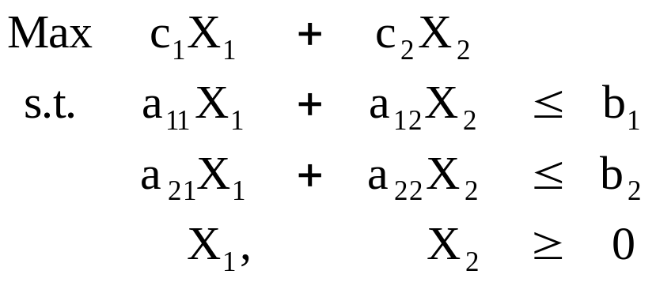

Suppose one wished to change the units of a variable (for example, from pounds to thousand pounds). The homogeneity of units test requires like denominators in a column.

Thus implies every coefficient under that variable needs to be multiplied by the scaling factor

i.e., if X_{j} is in old units and X'_{j} is to be in a new unit, then.
X_{j}' = X_{j}/ SC_{j};

where SC_{j} equals the scaling coefficient

and
a_{ij}' = a_{ij} / (SC_{j}).
Fixing Misbehaving Models
SCALING

The scaling procedure can be demonstrated by multiplying and dividing each entry associated with the variable by the scaling factor.

Suppose we scale X₁ using SC₁
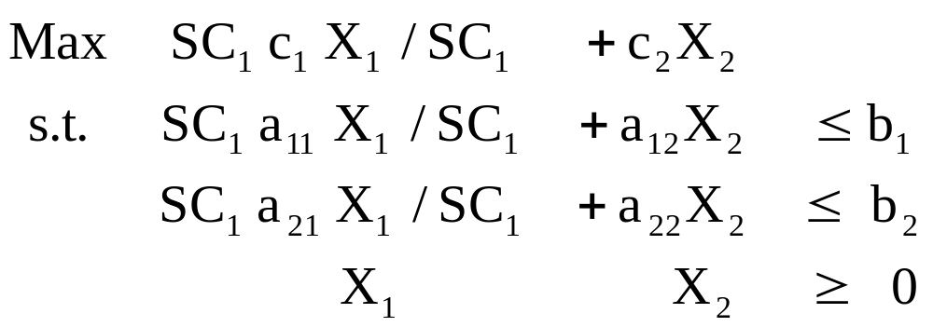

or substituting a new variable X₁' = X₁/SC₁ we get

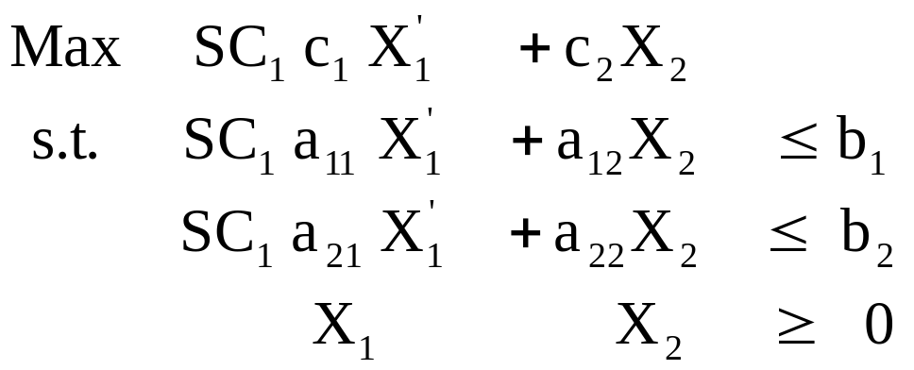
And at optimality
X₁ = X₁' *SC₁
Plus what happens to reduced cost?
Fixing Misbehaving Models
SCALING

Scaling can also be done on the constraints. When scaling constraints; e.g., transforming their units from hours to thousands of hours, every constraint coefficient is divided by the scaling factor (SR)
as follows:

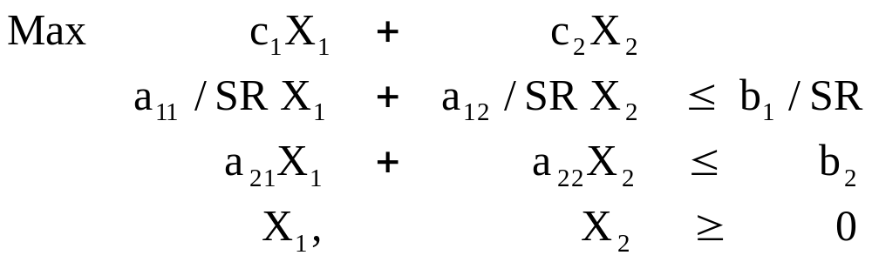

where SR is the number of old units in a new unit and must be positive.

Constraint scaling affects :1) the slack variable solution value, which is divided by the scaling factor; 2) the reduced cost for that slack, which is multiplied by the scaling factor; and 3) the shadow price, which is multiplied by the scaling factor.

Scaling In GAMS
Theory of Scaling

Numerical stability gains are made when rows and columns are simultaneously scaled. Scaling all variables multiplying by SC_{j} , all rows dividing by SR_{i} and the objective dividing coefficients by SO then we get (newbook.pdf ch 17)
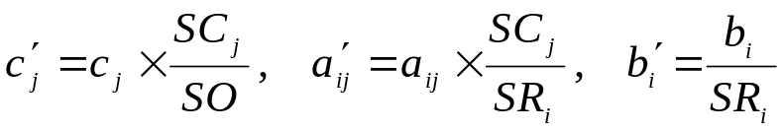
Relationships Between Items Before and After Scaling
Item | Symbol Before Scaling | Symbol After Scaling | Unscaled Value in Terms of Scaled Value | Scaled Value in Terms of Unscaled Value
Variables | X_{j} | X_{j}' | X_{j} = X _{j}'* SC_{j} | X_{j}' = X _{j} /SC_{j}
Slacks | S_{i} | S_{i}' | S_{i}= S _{i}'*SR_{i} | S_{i}' = S _{i} / SRi
Reduced Cost | z_{j} - c_{j} | z_{j} '- c_{j}' | z_{j} - c_{j} = (z_{j} '- c_{j}') * (SO/SC_{j}) | z_{j} '- c_{j} ' = (z_{j} - c_{j}) / (SO/SC_{j})
Shadow Price | U_{i} | U_{i}' | U_{i} = U_{i}' * (SO/SR_{i}) | U_{i} '= U_{i} / (SO/SR_{i})
Obj. Func. Value | Z | Z ' | Z = Z' * SO | Z '= Z / SO

Fortunately GAMS does this for us adjusting all solutions so they look as if they were never scaled. But this table does show the solutions are equivalent only differing by multiples of the scaling factors.

Scaling In GAMS
Example of Scaling

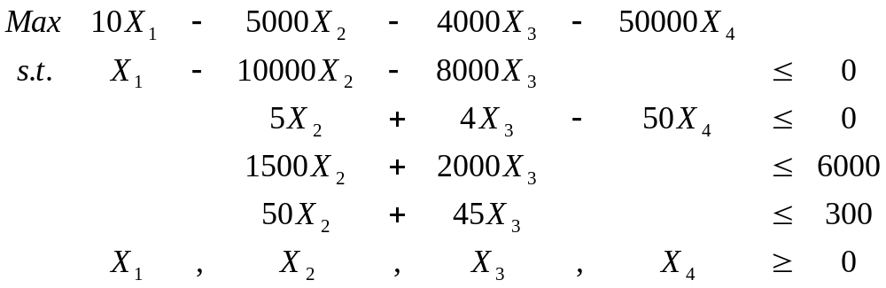

Divide first constraint by 10000 and multiply X₁ coefficients by 10000 while dividing third constraint by 1000 and in the fourth by 50. The resultant model is

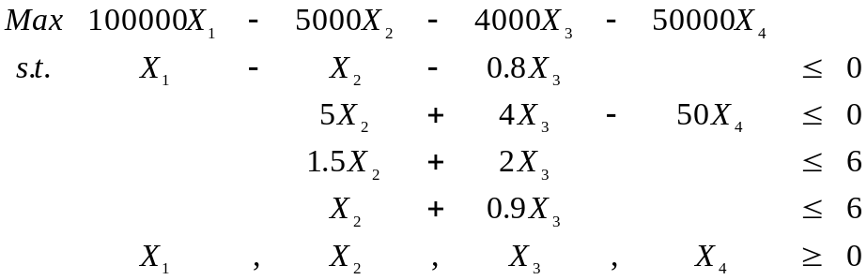

Now divide X₄ column by 50 and objective function by 10000. The final scaled problem then becomes

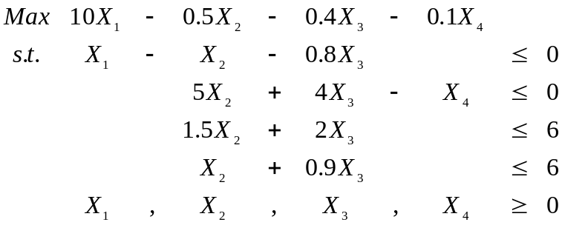
The disparity in numbers is now much less.

