Cost Benefit Analysis of Animal Disease Events and strategies—Theoretical Foundations
1 Introduction 2
2 Criteria for Judging Social Profitability 2
3 Measures of Welfare 3
3.1 Consumers' Surplus 4
3.2 Producers' Surplus 5
4 Developing Welfare Measures for Management or policy strategies 7
4.1 Conceptual Background types of changes 7
4.2 Towards Operational Approaches – Firm Level 9
4.2.1 Appraisal Based on Changes in Net Income 9
4.2.2 Appraisal Based on Changes in Total Costs 10
4.2.3 Appraisal Based on Changes in Input Demand 11
4.2.4 Appraisal Based on Changes in Output Supply 11
5 Appraisal of Total Value 12
5.1 Case 1: Estimate of Change in Total Net Income 13
5.2 Case 2: Estimates of a Change in Total Cost 13
5.3 Case 3: A Point Estimate of Change in Marginal Cost 14
5.4 Case 4: Point Estimate of Change in Prices Paid 14
5.5 Case 5: Shift in Supply of Output Schedule 15
5.6 Case 6: Change in the Factor Supply Schedule 15
5.7 Case 7: Estimate of a Change in Welfare With a Change in Yield 16
6 Avoiding Double Counting 16
7 Should Consumers' Surplus be Considered? 17
8 Should we consider Induced Effects 18
9 Valuation Methods 19
9.1 Valuation Based on Observed Economic Behavior 20
9.1.1 Net Income 20
9.1.2 Cost 20
9.1.3 Marginal Costs of Output 22
9.1.4 Marginal Values of Factors 22
9.2 Valuation Based on Elicited Responses 23
9.3 Developing Value Estimates from Synthesized or Simulated Behavior 24
10 Combining Diverse Estimates 24
11 Approach Classification 25
12 Theoretical Background to Farmer Technology Adoption 25
13 Dynamic Implications 26
14 Appendix A: Welfare and Consumers' Surplus, Producers' Surplus 39
14.1 Consumers' Welfare 39
14.2 Producers' Welfare 40
14.3 Summary 40
15 Appendix B Calculating Surplus 41
15.1 Calculating the Change in Surplus 42
15.2 Obtaining B’s and F’s 43

Introduction
Cost Benefit analysis (CBA) is the subject of many economic treatises and these notes only attempt to abstract the subject drawing out essential points. CBA has at its heart the objective of implementing socially profitable management alternatives while discarding socially unprofitable ones. However, the criteria for "social profitability' is anything but clear. Society involves many individuals. Management or policy strategies may affect the welfare of these individuals differentially. In addition, future members of society may also have their welfare altered. Virtually any judgment on social profitability involves a value judgment as to whether the benefits summed across some parts of society outweigh the costs to other parts of society.

Criteria for Judging Social Profitability
Several criteria have been proposed for making judgments on social profitability. The first is the Pareto criterion that states a climate impact or adaptation/mitigation action is socially profitable as long as the resultant welfare of every member of society is improved. Such a criterion is rarely if ever satisfied, but when it is satisfied true social profitability is attained. However, since the Pareto criterion is rarely satisfied other criterion have arisen.
The most widely discussed alternatives are known as the Kaldor-Hicks and Scitovsky compensation criteria. The Kaldor-Hicks criterion states a climate impact or adaptation/mitigation action is socially profitable as long as there is the potential for Pareto improvement, i.e., as long as the gainers from the climate impact or adaptation/mitigation action receive more than is lost by those who lose, then the gainers can potentially compensate the losers thereby improving the welfare of all. The Scitovsky criterion takes the opposite, but highly related, viewpoint that a climate impact or adaptation/mitigation action is socially profitable when the losers cannot bribe the gainers into not undertaking the climate impact or adaptation/mitigation action. The main difference between the Kaldor-Hicks-Scitovsky "compensation" and the Pareto criterion is that the compensation criteria do not impose differential welfare weights for individuals, whereas the Pareto does (if one individual is adversely affected then a climate impact or adaptation/mitigation action is not socially profitable).
A fourth measure of social profitability that has been proposed holds that a climate impact or adaptation/mitigation action is socially profitable as long as the differentially weighted sum of the welfare of individuals with the climate impact or adaptation/mitigation action is greater than a similarly weighted sum without the climate impact or adaptation/mitigation action. Squire and van der Tak present details on this procedure. There has been considerable discussion of these topics in the literature (see Just, Hueth and Schmitz for an overview and references).
For the purposes of these notes, the approach we follow will principally concentrate on the valuation of the various components of climate impacts or adaptation/mitigation strategies. When adding up is called for an unweighted sum will be used assuming that a positive sum is profitable in the sense of the compensation criteria. This assumes that society's marginal preferences for welfare increases of the various individuals involved is equal.

Measures of Welfare
The criteria for judging socially profitable impacts or policy actions relies upon measures of welfare. Economically accepted on measures of welfare are compensating and equivalent variations and economic surplus as commonly measures (approximately) through consumers' and producers' surplus, as elaborated on in Appendix A or Just, Hueth, and Schmitz.
Consumers' and producers' surplus are measures which, in some cases, represent the utility gained by individuals in a society when: (a) in consuming goods, they obtain goods at a price less than the maximum they would be willing to pay, and (b) in producing goods, they sell goods at a price above the minimum price they would have been willing to supply those goods. The surpluses are portrayed for a simple single commodity market in equilibrium in Figure 1.
In Figure 1 the curve labeled Demand gives the demand schedule (e.g., prices which the aggregate of individuals would pay to obtain a given quantity of goods). The curve labeled Supply gives the supply schedule (e.g., prices the aggregate of suppliers would charge to sell a given quantity of goods). In this setting, the market equilibrium would be at P*, Q*. Consumers' surplus (CS), in this case, is the area above the price line (horizontal at P*) but below the demand schedule (DD), while producers' surplus (PS) is the area above the supply schedule (SS) but below the price line.
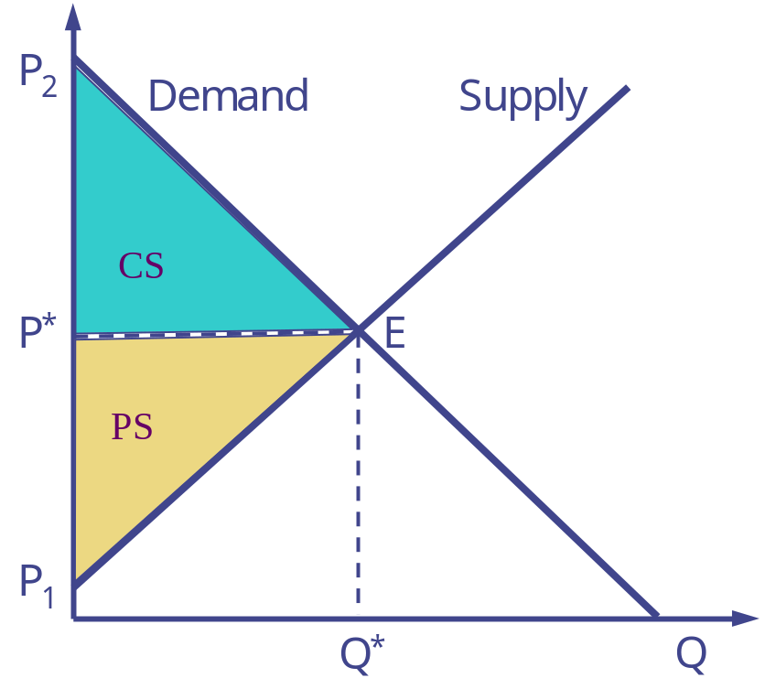
Figure 1 – Basic Welfare

Consumers' Surplus
Consumers' surplus as mentioned above, is the area CS. An economic definition of consumers' surplus given by Marshall (quoted in Currie, Murphy and Schmitz) is "the excess of the price which he would be willing to pay for the thing rather than go without it, over that which he actually does pay" (p.124). The question now comes to mind as to why this area should impart any measure of welfare.
Discussing for a moment an individual: an individual in consuming goods derives utility. Utility is a very difficult concept to measure, but in making tradeoffs and paying for goods, individuals reflect the value or utility they place on a good. Adopting this premise then, we follow Harberger and assume that the individual's demand schedule is the collection of price-quantity points representing the marginal utility of consumption (equaling the price) of a given quantity of goods to the consumer. Thus, when the individual consumes goods at price P*, the total utility (or a measure of welfare) that an individual would gain from this consumption process is the sum of the satisfaction from consuming the first unit of good at this lower price (a)₁ plus the second (a)₂, etc. as illustrated in Figure 2. This sum equals the integral of the area under the demand curve from zero to Q* less the total amount paid (i.e., P* Q*).
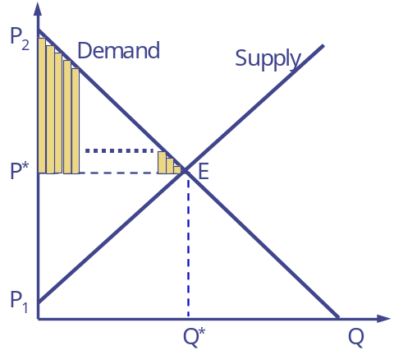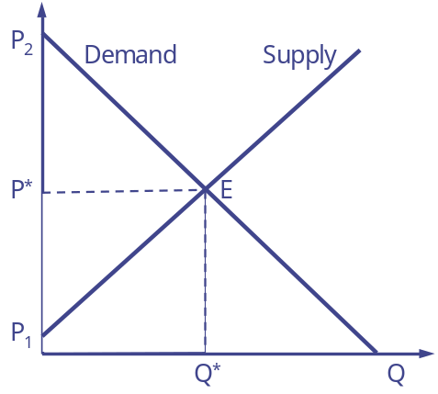
Satisfaction from paying less Integral minus PQ
Figure 2 Consumers surplus
Aggregate consumers' surplus is defined in analogous manner. In theory, the aggregate demand function is simply the horizontal sum of the individual demand functions. The area under the aggregate demand function is the summation of the individual consumer's surpluses and constitutes a measure of aggregate welfare. Following Harberger, acceptance of this statement requires that one be interested in a measure of welfare in which the welfare to the individuals is summed without regard to the individuals to which the welfare change accrues. Calculation procedures for consumers' surplus are given in Appendix 2.

Producers' Surplus
Producers' surplus, as mentioned above, is the excess that producers receive over the minimum price at which a seller would be induced to part with a bundle of goods. The minimum price at which a seller is "induced" is given in theory by the supply curve and is, in fact, the marginal cost of producing that unit for the seller. Figure 3 portrays such a situation. Here, producers' surplus is the area between the price line and the supply curve. Equivalently, producers' surplus is the equilibrium price (assuming that increases in price are not due to such things as technological externalities) times the equilibrium quantity (total revenue) minus the area under the supply curve from zero the equilibrium quantity which is the sum of the marginal costs of producing each unit of the good. Notes on calculating producers' surplus appear in Appendix 2.
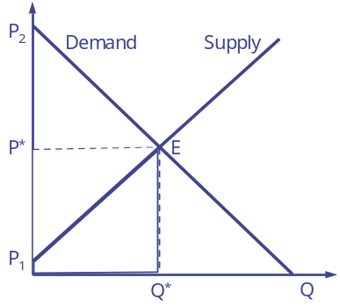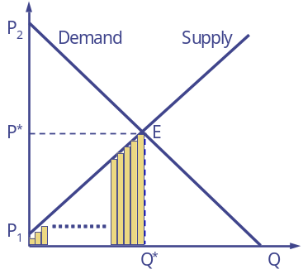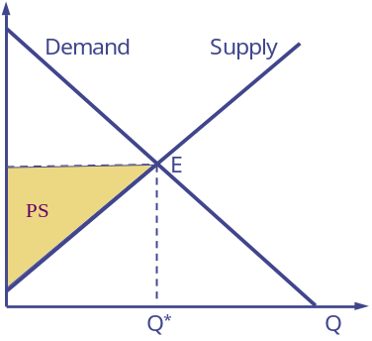
Revenue-Cost Forming total cost Resulting Producers' surplus
Figure 3 Producers' surplus
Producers' surplus is not as readily accepted a welfare measure as is consumers' surplus. The reasons for this are twofold. First, there has been semantic, also pragmatic, discussion over whether economic rent is a more meaningful term for the description of this quantity. Second, there has been controversy over whether the concept has any meaning or more correctly, to whom the surplus accrues.
Mishan (1968) in discussing the names "producers' surplus" versus "economic rent" states that economic rent provides "a money measure of the welfare change arising from a movement of factor prices in exactly the same way that consumer's surplus provides a money measure of the welfare change arising from a movement in product prices." Mishan, in a most convincing argument, states that the quantity called "producers' surplus" is, more properly "economic rent," based on the fact that when this quantity exists it is an imputed rent to the factors of production. Thus, producers' surplus and economic rent are analogous, with the argument advanced that economic rent is a semantically better term that correctly focues attention upon the factor markets. On the other hand, while Just and Hueth use the economic rent terminology, they show that producers' surplus measured for a producer group is the sum of rents to all producer groups below them in the vertical chain of production plus the ultimate (final) producers' surplus. Thus, they would argue that producers' surplus is a valid term.
Aside from the semantic argument, Mishan also raised the controversial issue as to whether producers' surplus – economic rent is a measure of anything analogous to welfare. This controversy revolves around the theoretical definition of a supply curve as related to the dynamic nature of this curve. Following economic theory, a short run supply curve is a marginal cost schedule. The area under the marginal cost schedule is total cost. Producers' surplus or economic rent therefore in the short run, is a measure of the difference between total revenue and total cost. Therefore, the short run concept is analogous to profit. In the short run, this profit would be called return or rent to the fixed factors of production. In the longer run, the return to these fixed factors would be capitalized into the value of these factors and measure quasi rents to factor owners.
Formally, in the long run, an increase in long run supply arises through an increase in the usage of all factors of production or in effect an expansion in the number of firms. Short run profits would be bid away by each producer offering to produce at a cheaper and cheaper price until producers produce at a point where short run marginal cost equals average cost equals price. "Profit" would not exist at this point, rather total revenue would be exactly imputable to all factors priced at their marginal value products. Mishan (1968) advances this argument and states that in the long run producers' surplus or economic rent is simply irrelevant, as in the long run any short run rents will be capitalized into the factor prices. However, the developments by Just and Hueth argue against this, stating that in a general equilibrium system, producers' surplus in any market consists of value added by production (which in the long run will be returns to fixed factors in that market plus the ultimate factor markets economic surplus) accruing to factors owners. In addition, Currie, Murphy, and Schmitz indicate that when the long run average cost curve, including rents, equals the short run marginal cost curve excluding rents (a condition which requires some long run supply curves to be less than perfectly elastic, e.g., supply of land), then economic rent does exist.
In summary, as a welfare measure producers' surplus is useful but it does need to be used carefully with thought on: a) its dynamic nature and form of the supply curve and, b) to who the surpluses accrues. The term producers' surplus, while common, should be used at least along with the term economic rent, indicating that this "surplus" is really a return to factors of production.

Developing Welfare Measures for Management or policy strategies
Unfortunately consumers' and producers' surplus cannot be measured directly in terms of either direct demand for a climate impact or related action or demand for all of the results of a climate impact or related action (i.e., higher quality water). Some results of a climate impact or adaptation/mitigation action do lead to direct measurement (i.e., increased agricultural production) however for the most part one must value the welfare impact of a climate impact or adaptation/mitigation action indirectly through related markets.
Below we review procedures for two aspects of the appraisal: developing proxy prices from related markets, and developing total estimates of benefit. First, however, we will review the general theoretical background for the various measures which could be employed.

Conceptual Background types of changes
Not all climate impacted items particularly environmental quality items (i.e., pollution increases) are not often directly traded within markets. Thus, valuation of changes in their levels is then done by related markets to discover resultant welfare effects. The influences of climate change could be examined by examining the effects of alterations on the firm in one of several ways: by examining changes in: a) the profits obtained by production, b) the costs of production, c) the prices paid for and quantity used of inputs, and d) the prices obtained for and quantity produced of outputs.
Economic duality theory provides a useful theoretical basis for unifying the various traditional approaches to climate impact analysis. Assume that we have a firm (this approach can also be justified in terms of households – see Deaton and Muellbauer or Freeman) producing a product Y which is produced by the production function f(X,e) where X is a vector of non climate inputs and e is a vector of climate inputs. Further, assume that the price of X is known and equals W, that f(X.e) is well behaved (so that a duality exists as in Varian or Silberberg) and that either a level of output (Y) is known or a price for the output (P). this leads to either a net income-profit function R(P,W,e)=Maximum PY-WX where Y=f(X,e) or a cost function C(Y*,W,e)=Minimum WX where f(X,e)=Y*
Given these functions, the cost of climate impacts may be measured
- Through changes on net income where one finds the marginal value product of alterations in a climate attribute
∂R(P,W,e)
∂e

as has been done when one does a farm budget comparing the net present value of the income stream with and without use of a climate impact or adaptation/mitigation action;
- Through changes in costs where one finds the marginal cost for changes in climate
∂C(Y*,W,e)
∂e
as has been done when one examines value of a climate impact or adaptation/mitigation action by budgeting the difference in the cost of replacing reduced rainfall with pumped irrigation water.
- Through changes in input market where one observes the shift in the marginal value product (prices the firm would pay) for factors. By Hotelling's (in the profit function case) or Shepards's lemma, the demand curve for a factor can be found by
X = -∂R(P,W.e)
∂w
and the effect of changes in climate found by first discovering the inverse demand function for factor usage
W = g(X,P,e)
then differentiating with respect to e. This type of approach is common as it is implicit in the approaches where on observes the effect of a cliate impact or policy action by examining the differences in property values or wage rates between regions with and without the impact or action.
- Through changes in output supply where one observes shifts in the marginal cost schedule for producing outputs. By Hotelling's lemma the supply of output may be found by differentiating the profit function with respect to P
Y = ∂R(P,W.e)
∂P

Which then can be used to form an inverse supply equation or marginal cost schedule. Further the marginal cost of Y* may be found by differentiating the cost function with respect to Y*
P = -∂C(Y*,W.e)
∂Y*
In turn, the cost of the climate alteration may then be discovered by differentiating the marginal cost schedule with respect to e. This approach has been used when appraising changes, for example the increased cost of pf pesticides when the climate induces larger pest populations.

Towards Operational Approaches – Firm Level
These conceptual approaches encompass virtually all of the possible approaches to climate impact or action economics evaluation. The basic methodology of each approach is reviewed below.

Appraisal Based on Changes in Net Income
The basic approach when conducting such an appraisal involves the appraiser
- examining situations where economic agents are operating in a setting characterized by varying climate attributes and where all other factors either do not vary or can be controlled
- estimating a relationship between net income and the climate attribute (i.e., the R function above)
- calculating the change in net income induced by the change in climate attributes, all other things held constant, and
- utilizing the quantitative relationship between climate change and net income along with a quantitative estimate of environmental changes due to the climate impact or adaptation/mitigation action under appraisal to generate a price estimate either as a functional relationship (across varying levels of p,w,e) or as a point estimate given p,w, and e.

This particular valuation approach is heavily used in climate impact or adaptation/mitigation action appraisal when, for example, the change in yields due to a climate impact or adaptation/mitigation action is utilized in a farm budgeting context to develop a change in net income (Gittenger, Brown). There are numerous assumptions involved with the empirical implementations such as whether acreage in various crops can change and assumptions about the demand curve.

Appraisal Based on Changes in Total Costs
The basic approach when conducting such an appraisal involves the appraiser
- examining a situation where economic agents are operating in a setting where the climate attributes vary and where all other factors either do not vary or can be controlled.
- estimating a relationship between cost and the climate attributes (i.e., the C function above),
- calculating the change in costs induced by the change in climate attributes, all other things held constant, and
- utilizing the quantitative relationship between the climate attribute and cost along with estimates on environmental quality change stimulated by the climate impact or adaptation/mitigation action under appraisal to determine an economic estimate of the value of the climate impact or adaptation/mitigation action.
Such an approach requires data on the costs, levels of the climate attribute and levels of other factors that influence costs. The approach can be very formal involving estimation of a cost equation or relatively informal where something like partial budgeting is carried out. Either point estimates or functional relationships may be obtained. Such an approach is common in adaptation strategy appraisal such as the cost of adding sprinklers to a feedlot for cooling or moving an operation. There are many variants of these techniques as discussed below.

Appraisal Based on Changes in Input Demand
The appraiser executing such an analysis again needs to examine a situation in which event protection is varying wherein other factors do not change or can be controlled for. The appraiser then gains an estimate of how the price of the input is affected by the change in the climate attribute. Finally this is related to the climate impact or adaptation/mitigation action under appraisal.
This approach is commonly used in project appraisals when one measures the benefits to management or policy strategies through the factor markets. It is the theoretical basis upon which "hedonic" estimates are done e.g. estimating the effects of climate on land values (see the review section in Freeman or the Riccardian work of Mendelsohn and others). Specifically it could be the basis for approaches where the land rental value under different climate is compared to get an estimate of the effects of different climate conditions. Appraisers utilizing this approach require data on input prices along with data on climate, other factor prices, and factor usage. This has generally been done with land values or transportation costs but it could also be done in other markets for essential inputs (as defined in Just, Hueth and Schmitz). The approach again could be very formal involving econometric estimation or relatively informal. The approach yields point estimates of factor prices or whole demand for factor schedules depending upon the particular methodology used. This particular approach may not be all that usable in many developing country settings because of the lack of data.

Appraisal Based on Changes in Output Supply
This approach again involves the appraiser examining a situation in which a number of agents are operating in a setting characterized by factors which can be controlled and a change in climate which can somehow be interpreted as relevant to the climate impact or adaptation/mitigation action under appraisal. Using these data, estimates are made of the shift in the output supply curve induced by changes in climate. This is commonly done in crop yield studies where one examines the change in crop yield induced by a change in climate or climate adaptation/mitigation strategy.
The method requires either:
- formal estimation of the profit or cost function and derivation of the supply function,
- formal estimation of the supply function, or
- a less formal derivation of the changes in the marginal costs of the supply of a given quantity.
This approach on profits has not been extensively used but crop yield studies are common where one examines how much more or less would be produced because of a climate shift or mitigation/adaptation action, i.e., the changed per unit crop yield due to the hot temperatures or more co2. Again, specific implementations of this will be discussed below. This kind of analysis yields either point estimates or estimates of the whole supply equation depending on the particular methodology involved.

Appraisal of Total Value
The estimates discussed above will result in individual farm or firm level estimates of change of total net income, total costs, marginal cost of outputs, and marginal value product schedule for factors. The latter two may be either be point estimates of the change in the schedule of estimates of the whole change in the schedule. In addition, one may have an estimate of the change in gross income developed by multiplying yield times the change in profits. These particular items do not give direct welfare estimates, therefore they need to be converted into welfare estimates using economic principles.
The basic methodology used herein will be that of producers' and consumers' surplus. Ideally, surplus is calculated from the schedules for either the demand for factors or the supply of output as they change with climate decisions. However, one may not have these schedules and alternative approaches are called for. The purpose of this section is to discuss the various cases under which welfare estimates can be calculated. Each of the approaches below assumes the market examined is in equilibrium with and without climate impact or adaptation/mitigation strategy situations.

Case 1: Estimate of Change in Total Net Income
Given an estimate of change in net income, remember that net income is a measure of producers' surplus or economic rent. Thus, the change in net income with a change in climate gives the change in producers' surplus which is an estimate of the change in producers' welfare stimulated by the climate impact or adaptation/mitigation action induced changes in climate. However, an assumption needs to be added in order for this to be an adequate welfare measure. That assumption is one of a totally elastic demand curve. Under a totally elastic demand curve, when there is a supply shift, the change in net income will be a change in producer welfare. Thus, this estimate can be used when one assumes the climate impact or adaptation/mitigation action does not influence demand prices.
This situation is illustrated graphically in Figure 4. Here the supply curve before is assumed to be S. The supply curve after the climate impact or adaptation/mitigation action is assumed to be S'. The total societal welfare before is the area above the curve S and below the curve D which is in this case equivalent to producers' surplus before the climate impact or adaptation/mitigation action. With the climate impact or adaptation/mitigation action the total welfare is the area below D but above S' which is net income after the climate impact or adaptation/mitigation action. The shift in net income between the with and without climate impact or adaptation/mitigation action is the shaded area in Figure 4. This area can be seen as a change in producers' and consumers' surplus, since with the totally elastic demand curve consumer surplus is zero, thus, only the change in producers' surplus (i.e., net income) is relevant in developing a total benefit estimate.
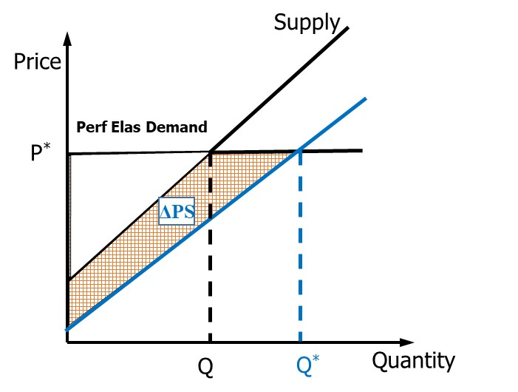
Figure 4 Welfare change based on change in net income

Case 2: Estimates of a Change in Total Cost
The change in total cost required to deliver a quantity of output can be utilized as a measure of the change in total social – welfare consumers' plus producers' surplus. When society is assumed to have a totally inelastic (i.e., fixed quantity) demand curve for a good. Total consumers' plus producers' surplus is defined as the area underneath the supply curve. Thus, when there is a shift in the total cost of providing a fixed bundle of goods then this cost can be equated to the change in consumers' plus producers' surplus obtained when this change in total cost is incurred.
This situation is illustrated graphically in Figure 5. Here the supply curve without the climate impact or adaptation/mitigation action is assumed to be S'S'. The area supply curve with the climate impact or adaptation/mitigation action is assumed to be S'S'. The area below the supply curves S up to the quantity sold which is given by the demand curve DD is the cost of producing this good. The cost after the climate impact or adaptation/mitigation action is the area below S'S' and up to the supply curve DD. Consumers' plus producers' surplus in both of these cases is the area above the supply curve, thus the change in producers' and consumers' surplus can be equated to this change in total costs. Under these conditions, and the shaded area gives a change in total costs or equivalently total social benefits.
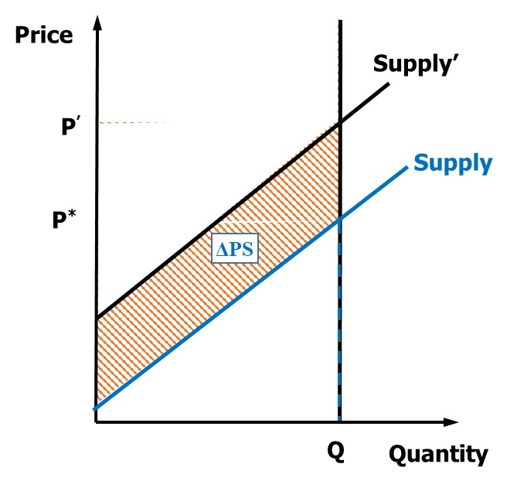
Figure 5 Change in total Cost

Case 3: A Point Estimate of Change in Marginal Cost
Given a point estimate of the change in the marginal costs of the firm, a welfare estimate may be derived by multiplying the change in the cost by the total quantity produced. This requires one to assume a fixed quantity demand curve for the goods and a totally elastic supply curve. Under such assumptions, total social welfare as measured by the area above the demand curve but below the supply curve of the goods will equal the quantity calculated above.
This is illustrated in Figure 6 where DD is the demand curve SS is the supply curve without the climate impact or adaptation/mitigation action is implemented: S'S' is the supply curve with the climate impact or adaptation/mitigation action, reflecting a lowering in output price. The shaded area between the curves is the change in price times quantity. This particular shaded area reflects the change in total welfare which is the area above the supply curve but below the demand curve. In this case total welfare is infinite but the difference in the two social welfare estimates is the shaded area. Again, in the way of an example, this case would be implemented by one calculating the increase in water purification costs per unit times the quantity purified.
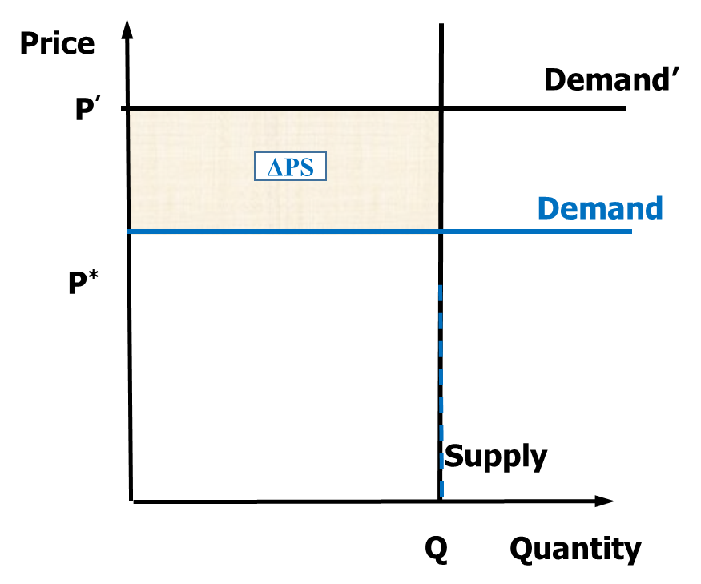
Figure 6 change in marginal cost

Case 4: Point Estimate of Change in Prices Paid
One may also derive a welfare estimate using point estimates of the change in the prices paid for a factor by a firm affected by the change in climate. This requires the assumption that the supply curve of the factor is totally inelastic, and the demand curve for the factor is totally elastic. In this particular case, the difference in the price with and without the climate impact or adaptation/mitigation action induced climate change times the quantity of the factor consumed gives an estimate of the change in the producers' and consumers' surplus due to the climate impact or adaptation/mitigation action.
This is illustrated by Figure 7 where SS is the inelastic supply curve of the factor; DD is the demand curve without the climate impact or adaptation/mitigation action; and D'D' is the demand curve with the climate impact or adaptation/mitigation action. Thus, the difference between DD and D'D' is the change in the factor price (or the change in the marginal value product of the factor) to the firm due to the climate impact or adaptation/mitigation action. The resultant change in welfare is the area below the demand curve and above the supply curve, which shifts between the situation before and after the climate impact or adaptation/mitigation action by the shaded area.
Figure 7 change in price paid for a factor

Case 5: Shift in Supply of Output Schedule
Given an estimate of the shift in the supply curve for output, welfare may be estimated by calculating the change in the area above the curve which occurs when the curve has been intersected with the demand curve. This will involve determination in the change of the quantity of supply and the change in the product price. Special cases of this may be considered by looking at totally inelastic factor supply or totally elastic demand. One would also need to calculate in this case the changes to the consumer surplus at the same time one was considering the changes in the rents to the producers.
This situation is illustrated by the curve in Figure 8 where DD is the demand curve for the product; SS is the supply curve after the climate impact or adaptation/mitigation action. In this case, consumer welfare before the climate impact or adaptation/mitigation action is given by the area labeled a; producer welfare is given by areas labeled b plus the area labeled e. After the climate impact or adaptation/mitigation action, consumer welfare increases by the areas labeled b + c + d, and producer welfare changes but producer welfare get smaller by area b and larger by area f + g, thus, the net change in producer welfare is f - b, and the net increase in the social welfare is c + d + f + g (this graph shows that given a demand curve with an elasticity other than infinity that one is unsure as to whether producers gain or lose from the introduction of a climate impact or adaptation/mitigation action).
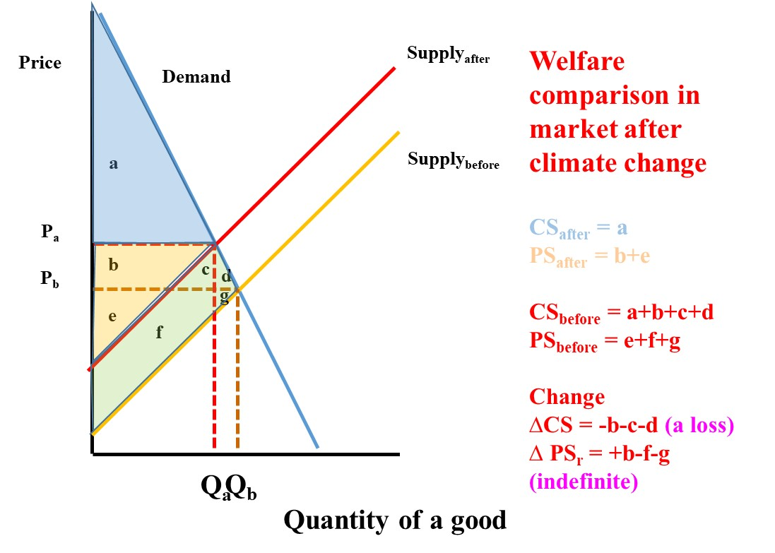
Figure 8 Shift in output supply

Case 6: Change in the Factor Supply Schedule
Given an estimate of the change in the factor demand schedule, one can compute the change in social welfare by considering both the producer and consumer affects given the shift in the market equilibrium point. This is illustrated in Figure 9 in which SS is the supply curve of factors; DD is the demand curve for factors before climate impact or adaptation/mitigation action and D'D' is the demand curve for factors after the climate impact or adaptation/mitigation action. In this case, without climate impact or adaptation/mitigation action consumers' surplus (which equals ultimate consumers' surplus plus value added in the production process) equals a + c and producers' surplus equals b+d+e. After the climate impact or adaptation/mitigation action; producers' surplus (or the returns to factor owners equals e, whereas consumers' surplus (by Just and Hueth, the returns to the immediate producer plus consumers' surplus equals a + b). The net effect of the climate impact or adaptation/mitigation action is a loss in total welfare of an area amounting to -c -d. However, this shows that the factor owners clearly lose, i.e., a loss of b + d, but consumers' (including producers in a vertical chain) lose c but gain b for a net welfare change of b - c.
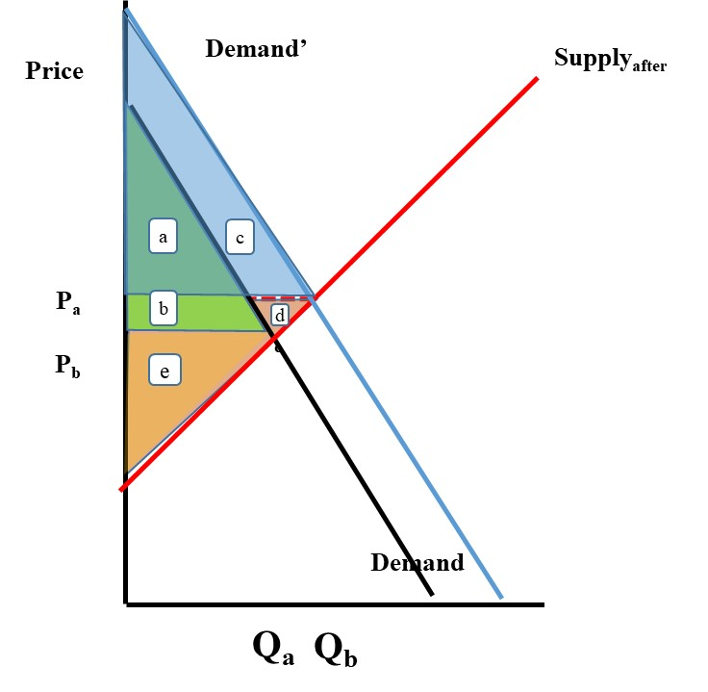

Case 7: Estimate of a Change in Welfare With a Change in Yield
Quite often one attempts to estimate the change in welfare by taking the price times the change in yield with and without the climate impact or adaptation/mitigation action. This is a form of a profit approach, however, it is assuming that the demand curve is totally elastic and that the supply curve is totally inelastic. This is illustrated graphically in Figure 10, where DD is the demand curve for the product; SS is the supply curve without the climate impact or adaptation/mitigation action; and S'S' is the supply curve with the climate impact or adaptation/mitigation action. The shaded area then gives the change in total economic welfare which is the area below the demand curve and above the supply curve.
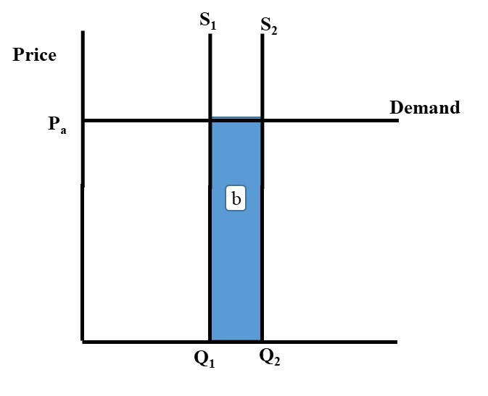

Avoiding Double Counting
Above we have discussed a number of different ways of obtaining the welfare effects of a climate impact or adaptation/mitigation action. All of these methods, under different assumptions, lead to an estimate of the change in consumers' and producers' surplus or total social welfare. The appraiser must be careful not to double count, measuring the same benefit in more than one way. Just, Hueth, and Schmitz show that consumers' surplus in a factor market is equal to either: a) the sum of consumers' surplus in the ultimate market for the good plus the sum of producers' quasi rents (profits or returns to fixed factors) obtained in the intermediate markets when product prices vary with changes in output; or b) the producers' profits (or rents to fixed factors) when the demand price to the producer is fixed. Thus, consumers' surplus as measured in a market is consumers' surplus at the consumption stage plus the rents to fixed factors used in transforming production into the final output. Similarly, Just, Hueth, and Schmitz show that producers' surplus in a factor market equals a) producers' surplus in the lowest level factor market plus any rents to producers occurring in transforming the factor through the string of vertical markets leading to the particular market being analyzed or b) profits accruing to production when lower market prices are fixed. The implications are that a) a marvelous opportunity exists for double counting by, for example, measuring consumers' surplus in both the product and factor markets or by measuring profits and factor market consumers' surplus; b) measurements should not be done on an effect in terms of net income, costs in the factor market and supply in the output markets, only one should be used, and c) the nature of the price assumptions determines the answer one gets. Furthermore, one needs to measure surplus in only one of the firms factor (assuming the factor is essential) or product markets.

Should Consumers' Surplus be Considered?
The above discussion introduces both consumers' and producers' surplus. (There have been whole books devoted to the subject, i.e., Just, Hueth, and Schmitz) In many climate impact or adaptation/mitigation action appraisals welfare analysis has been done using the concepts of producers' surplus (i.e., changes in producers' profits only) assuming that the demand curve for the items covered by the climate impact or adaptation/mitigation action is perfectly elastic (i.e., fixed price). This brings up the question whether or not this is true. In some management or policy strategies, the climate impact or adaptation/mitigation action certainly will be small enough so that the demand for various items affected by the climate impact or adaptation/mitigation action will not be altered.
A simple method for investigating the magnitude of errors involved is as follows. The Hicks approximation of the change in consumers' surplus is (as developed in Appendix B) the change in price (P – P') times the average quantity (Q + Q')/2. Assuming that the price before the climate impact or adaptation/mitigation action is P, the quantity is Q, the demand elasticity is e, and the change induced by the climate impact or adaptation/mitigation action is Q*. Then, Q = Q + Q* and using the definition of price elasticity (assuming a constant elasticity demand curve) the change in price equals
ΔP = e Q*/Q * P
and the resultant estimate of the change in consumers' surplus equals
ΔP(Q+Q*)/2
Thus, given an estimate of the elasticity of demand the equilibrium price (P) and quantity (Q) without the climate impact or adaptation/mitigation action and the sizes of climate impact or adaptation/mitigation action output Q* one can determine an estimate of consumer effects and see whether it is worthwhile to do a more detailed analysis.

Should we consider Induced Effects
One potential category of benefits and costs which we will not provide a lot of discussion on herein is induced (secondary) impacts. Induced impacts refer to economic effects which are stimulated by climate impacts or policy strategies. Examples include increased economic activity within the marketing channel caused by an increase in farm production. The evaluation of such impacts and their inclusion in climate impact or adaptation/mitigation action appraisals has been a controversial theoretical subject.
This controversy has involved discussion of secondary affects from both a national cost benefit prospective and from a regional distributional perspective. Stoevener and Kraynick review the literature and summarize the theoretical arguments relating to national benefits stating "Secondary effects in the region in question would be offset by effects with the opposite sign in other regions. There are only two conditions under which secondary benefits could arise. The first deals with surpluses in fixed as well as variable capital stock. The second involves the capacity utilization of the existing resources. The extent to which unemployed and underemployed labor resources in a potential area can be employed has emerged as a bonafide benefit…capacity utilization of other existing resources has not received as much attention". The surplus resources argument portends a role for induced impacts in area of the world where there are unemployed or underemployed resources. This subject has been estimated empirically in several different settings (See Bell and Hazell or Haveman and Krutilla).
Induced effects also play a role in the analysis of regional distributional effects. Here the concept has clear applicability, although one cannot state unequivocally that these effects are contributions to social welfare. However the empirical measurement of such effects can be complex utilizing techniques like Input-Output analysis. Those interested should consult the literature as cited in Stoevener and Kraynick or Bell and Hazell.

Valuation Methods
The above discussion has indicated the general theoretical approaches to valuation. Attention is now turned to the theory as implemented in the various empirical approaches to valuation. We, as of yet, retain a general flavor to our discussion reserving specificity for later.
There are a number of methods for deriving the value of alterations in the economy due to a climate event. There are a number of important principles (following Freeman, p. 10-12) involved in the formation of these methods.
- the methods must yield measures of value in monetary terms.
- the methods must be based on a "willingness to pay" concept in which one is considering the amount of utility individuals are willing to give up in order to achieve or accept climate impact or adaptation/mitigation action induced climate alterations.
- the impacts predicted by the methods must be related to alterations in the economy and in turn related to the magnitude of alterations induced by a climate impact or related action.
- the methods should ultimately based upon theoretical models of individual behavior and interactions among individuals.
- the numerical measures used in an implementation should correspond closely to the measures assumed in the theoretical model.
- the method employed in a study must be selected so that it is appropriate in terms of the producer-consumer behavior and the data at hand.
The methods we will discuss fall into three classes: a) development of value estimates from observed economic behavior, b) development of value estimates from elicited responses, and c) development of value estimates from synthesized or simulated economic behavior. Each of these classes encompasses a range of specific valuation techniques which will be discussed individually. Examples of many of the various approaches appear in the sections on on-site and off-site appraisal below.

Valuation Based on Observed Economic Behavior
Economists quite commonly develop welfare estimates by observing the ways economic behavior of different parties is altered when items vary. Such an approach would involve observing a number of individuals producing, over time or over space, obtaining data on both the economic variables of interest (prices, profits, costs, etc.) and data on those items which differ across individuals including data on climate quality. Then, using these data an estimate is formed on the consequences of changes in climate variables. This type of approach may be done for any of the types of estimates above.

Net Income
An estimate may be made of the change in net income via a scheme which attempts to develop estimates on net income as a function of climate, factor usage, factor prices, input prices, the output price, production level, and the alterations in these caused by the climate impact or adaptation/mitigation action. This information may then be used to do a profit function type estimation following duality theory (as in Varian or Silverberg, or as above) which in turn may be used to derive input demand equations or output supply equations. An example of this approach would be an analysis where a regression equation is estimated relating profits to climate and prices, then, differentiating with respect to prices. The basic approach may also be implemented through a comparative budgeting framework wherein one would derive estimates of net income change due to changes in climate protection, all other things held constant. An example of this approach would be an exercise when one budgeted through the income consequences of varying degrees of protection.

Cost
Quite a number of cost approaches appear in the literature. Basically, here one would observe the change in costs encountered when an economic agent produces a constant mix of goods is subjected to a change. This approach is commonly implemented when one studies changes in the costs of maintenance, mitigation, replacement or damage, or prevention due to a change. These items may or may not be mutually exclusive depending on the case.
Maintenance cost is a basis for a cost estimate when one believes that the effect of the climate quality changes are entirely manifest in the increasing costs of equipment. An example would be the increased costs of detection due to an increase in frequency.
Mitigation costs refers to those costs incurred in overcoming the effect of the changes in environmental quality. An example of this would be an increase in water purification costs arising due to an increase in pollution and/or sediment load in water. Similarly, the costs of sediment removal when dredging reservoirs or river channels would be examples.
Replacement costs deal with the costs incurred when replacing assets because of their demise due to changes. Here one deals with the questions of either replacing the flow of services form some other costlier source or the replacement of capacity at the effected source through capital construction. We will identify flow activities following conventional by the term "the shadow climate impact or adaptation/mitigation action approach." Therefore, a replacement example would be the costs of replacing hydroelectric power from thermal sources when hydroelectric capacity has been reduced by siltation of a new capacity is not constructed. The costs of building a new dam would be an example of the shadow climate impact or adaptation/mitigation action approach, as would the costs of replacing bridges or roadways which were damaged by erosion.
The final category of costs is prevention costs. Here one accounts for costs which were incurred in preventing the damages resulting from climate events. Such costs include, for example, the construction of holding area to prevent animals from entering feedlots until after a latency period expires. Another cost approach which could be used is to estimate the cost function in a duality sense using the amount of output as an argument in the function, then differentiating to obtain the change in the supply of output and demand for input schedules as discussed under the marginal cost section below.
All of these cost approaches are founded on the assumption that the same level of demand is to be supplied before and after the climate impact or adaptation/mitigation action and the resultant change in climate quality. The approaches should be used to value only the marginal change in climate quality caused by the climate impact or adaptation/mitigation action when doing an assessment. The cost categories may or may not be mutually exclusive and may need adding up.

Marginal Costs of Output
Observed behavior may also be manipulated so one obtains estimates of changes in the marginal cost of producing output. Here the basic approaches are identical to those used for cost above, when on concentrates on the marginal changes due to a change in the climate impact or adaptation/mitigation action rather than a total cost estimate. Again, this may be derived through a cost function type approach or through a profit type approach. Also, estimates may be done assuming that demand is inelastic and that factor supply prices are elastic, then the total change in cost incurred by a change in climate quality may be divided by the product being sold and this used as the incremental marginal cost of delivering the product.

Marginal Values of Factors
Observed economic behavior may be used to generate estimates of changes in the price a firm is willing to pay for factors with and without a climate impact or adaptation/mitigation action. This is commonly employed in environmental economics as manifest in the "hedonic" approach to climate quality valuation (Freeman). Within this approach land values are estimated as a function of a number of parameters including climate quality, subsequently the land values are differentiated with respect to climate quality in order to obtain an implicit price for changes in climate quality (See Freeman for details). This procedure may also be done informally in which two situations are examined where all the factors except climate quality are assumed constant and then one divides the difference in land prices divided by the change in climate quality to get an estimate of the marginal effect of the change in climate quality on factor price. The manifestation of climate quality in the factor markets may also be done examined utilizing the factor demand and supply schedules as directly estimated or in the case of factor demand derived either through profit or cost function estimation. Given these schedules, one may simply calculate the relevant producers' and consumers' surplus as described below in an Appendix B. One needs to examine whether or not the price of the output is allowed to change when using the factor schedule. If so, a consumers' surplus, by looking in the produce market at the area underneath the demand curve and above the price line.

Valuation Based on Elicited Responses
An entirely different approach to valuation can be carried out based on data directly elicited relative to environmental or other attribute changes. This type of data is commonly called nonmarket data and refers to data obtained through surveys, questionnaires, bidding games, and voting. Examples of these types of questions in an environmental context would involve the willingness of individuals to pay for increased water quality (i.e., reduced pollution), or the willingness of individuals to pay for retained future productive capacity (i.e., non contaminated land). This particular technique, while important in the overall economics of economic evaluation, may not be all that important in the climate setting. Thus, we only provide an overview, Freeman provides a much more comprehensive discussion.
The basic approach is directed toward the development of benefit estimates for changes in climate attributes using elicited data. The data development process involves one of three approaches. First, one can ask individuals to state their willingness to pay to obtain some specified level of change in climate protection. This particular type of question could take the form of: "How much would you be willing to pay for a 5 percent reduction in the risk of contaminated food?" The second approach would be to ask individuals how much of a change in the climate quality attribute they would demand if they had a certain price to pay (i.e., "If you had to pay $100 for reducing risk, how much would expect to be cleaned up?) A third approach would involve whether or not society approves a vote on whether or not to incur a levy designed to alter climate quality.
There are a number of difficulties regarding developing demand equations from this kind of data. The first is that the way questions are asked can lead to biased responses. The second is that it may be very difficult to provide incentives to obtain responses which are representative of reality. Bias in the answers that are obtained may arise because of the public good nature of climate quality (see Freeman for elaboration on the point). Inaccuracy in responses may also occur because individuals may not fully understand the questions or may have no judgmental basis for making an accurate decision (again, Freeman discusses this point).

Developing Value Estimates from Synthesized or Simulated Behavior
It is often very difficult to develop or obtain data pertinent to climate situations in which all factors other than climate can be held constant or controlled. Consequently, a very common valuation technique used in climate impact or adaptation/mitigation action appraisal is based upon a synthesized economic model of the situation involved. The economic model may range in complexity from formal modeling techniques such as linear programming (see the chapter by Miller in Halcrow, Heady and Cotner), simulation (see the work by Young), or optimal control (see the work by Burt); or the work may be done using farm budgeting to develop estimates of the changes in profits (See Gittinger or Brown). We will not go into modeling techniques greatly as we expect most people reading this primer will be familiar with modeling. However, we will go into some of the assumptions.
The assumptions of any model fall into two major classes. First, there are assumptions leading to the exact structure of the model (i.e., identification of the relevant and irrelevant variables, the conceptualization of the factors which change or do not change with changes in climate quality, etc). Second, there are assumptions involved with the model solution process, i.e., in the budgeting exercise, one may assume acreage and cost may remain unchanged thus price times change in yield gives change in total firm net revenue, or the more detailed assumptions of additivity, divisibility, certainty and continuity used in linear programming exercise, for example. Synthesized approaches have been done in terms in changes in net income, changes in costs and even changes in schedules of demand or supply. Using modeling it is certainly possible to alter the climate attributes simulating the climate impact or adaptation/mitigation action thereby deriving in the models a forecast of climate impact or adaptation/mitigation action effects. However, in doing this, one places great reliance upon the validity of the model structure (for references on validation see Gass; Anderson; Johnson and Rausser; Shannon; and McCarl and Nelson).

Combining Diverse Estimates
Many different ways of developing estimates from different viewpoints are given above. It is possible for an appraiser to develop a number of different estimates for the same phenomena, particularly using the cost basis such as prevention cost versus maintenance costs versus mitigation costs versus eventual replacement costs. The benefit estimate obtained to particular change in climate quality should be the lowest of any mutually exclusive groups of these costs, assuming the estimate is developed using reasonable assumptions. A climate impact or adaptation/mitigation action's benefits to society should be no more than the costs of generating the effect on society via the cheapest alternative method. In addition, when combining diverse estimates one must be careful to avoid double counting not only in terms of an effect at a level but between several levels, for example, measurements of the increased cost of supplying and the deceased marginal value of land could be double counting. The appraiser must be careful to think about the nature of each estimate avoiding capturing the same effect more than once.

Theoretical Background to Farmer Technology Adoption
The above theoretical background relates only to climate impact or adaptation/mitigation action appraisal. There is a very important second area which is also relevant when regarding management or policy strategies. Clearly farmers have to adopt the climate impact or adaptation/mitigation action in order to have it be successful. Thus the body of theory relating to technology adoption is important and relevant. This section briefly abstracts this theory behind farmer technology adoption. However, there are more complete treatises, such as the whole area of production economics as treated in books like Henderson and Quandt, or the more general theory of technology adoption as treated in the literature review by Feder, Just and Zilberman.
Farmers in deciding to adopt new technology must somehow be convinced that this technology will lead to an improvement in their welfare position. The welfare of farmers in developing countries has been dealt with a number of times. Common assumptions regarding welfare are what the farmers are interested in profit maximization, risk avoidance, and subsistence consumption assurance. We will not talk at great length about how to value these market effects, rather we refer to the standard text, such as Squire and van der Tak, which talk about shadow pricing and implicitly discuss treatment of risk in subsistence behavior. However, we do make the point that in appraising the climate impact or adaptation/mitigation action the climate impact or adaptation/mitigation action should be designed such that one shifting from the new technology to the old technology that the utility weight times the change in profits plus the utility weight times the change in ability to meet subsistence plus the utility weight times the change in risk bearing characteristics must be greater than or equal to zero in order for the technology to be adopted. This may often may not be the case and also on the effects technologies have on risk and subsistence.

Dynamic Implications
Another very relevant body of theory deals with the dynamic issues: discounting, intergenerational equity, irreversibilities, and uncertainties. The whole area have been extensively studied in the areas of natural resource and climate economics particularly discounting. Virtually every book on the subject contains a section on it (see Page; Howe; Krutilla and Fisher; Fisher; and Maler, for example). The arguments revolving around the appropriate discount rate may be summarized into three issues: first, there is a question of whether discounting is inherently fair; second, there is a question of what the relationship should be between the public and private discount rate; and third, there are the difficulties introduced when investment or exploitation lead to irreversibilities.

Intergenerational equity
Regarding the question of fairness, basically discounting is implemented through construction of net present value of a climate impact or adaptation/mitigation action. Comparing two management or policy strategies, if one has a higher net present value than the other, then the one with the higher net present value would be judged to be :socially optimal". However, even in the face of the Kaldor-Hicks compensation criteria there may be difficulties with this procedure. Kaldor-Hicks essentially requires that it be possible for gainers to compensate losers. However, even though there is a current (i.e., net present value) compensation possibility under current exploitation of resources, that at some point in the future, the gainers from exploitation will have lower benefits than the losers if any depletion in the stock resource level is encountered.
While the Kaldor-Hicks compensation principal may work on average over the life of the climate impact or adaptation/mitigation action, it may not work at certain points in times. Discounting by its very nature puts the present generation in the role of responsibility. In fact, it has been argued that any choice of the discount rate embodies a value judgment about the relative importance of the present generation's equity to the future generation's equity. Discounting naturally implies that less is cared about welfare in the future. Returning to the Kaldor-Hicks argument, compensation cannot really occur between generations, thus, the welfare of the future generation is very dependent upon decisions of the current generation. The future generation cannot bribe the current generation explicitly to not undertake the investment (in the Scitovsky sense), even though it is certainly possible that a discounted stream of current benefits imply a ;future exhaustion of resource and a change in the livability characteristics of the future generations. Thus, it has been argued that discounting is inherently not fair in all cases, and the discount rate must be chosen with great caution in order to adequately take into account the welfare of both the current and future generations.
Thus, we recommend one be careful to not add up the final effect across generations until the last stage of the appraisal. In this way, we hope to encourage the appraiser to not only look at the net present value of benefits/costs but also to examine the stream as it varies over time, highlighting the intergenerational effects. For example, a climate impact or adaptation/mitigation action may show negative returns initially and positive later, implying that there is a net transfer of welfare from current to future generations. This information is important in the context of climate impact or adaptation/mitigation action acceptance/rejection and any major trends should be pointed out in any appraisal document.

Private and public discount rates
The second issue regards the relationship of private and public discount rates. Fisher (1930) stated that the discount rate should equal the marginal rate of return on invested capital in a simple neoclassical framework. However, when regarding social discount rates it has been argued that individuals may under invest in the future given their finite planning horizon leaning to excessive current consumption. The argument follows that the state should provide for the future by increasing investment, thereby decreasing the marginal rate of return of investment. Thus, it has been argued that a lower social discount rate should be used and that this will stimulate resource conservation. It has also been argued that the private discount rate reflects an adjustment upwards to account for risk that individuals face when making investment, and the social discount rate should be lower, given that many investments are spread over many individuals thus, lowering average risk.
On the other hand, there have been arguments that the social discount rate should be higher than the private rate die to factors such as taxation (Baumol). All in all, most of the literature argues for lower social discount rate than a private discount rate when considering the conservation of resources when the investment in resource conservation strategies. However, again, the relationship of the private and public discount rate have not been established and this again calls for a careful consideration of discounting particularly regarding welfare of future generations, and perhaps the construction of an analysis involving the discounted and undiscounted streams.

Irrreversibility
The third issue regarding economic theory and dynamic concerns involves irreversibilities. Some climate management or policy strategies could permanently contaminate areas thereby causing future irreversible loss of hectares for farming purposes. This involves the notion of irreversibility.
In the theory that has brought about the concept of option value wherein it has been argued there is a value to preserving society's future options for the usage of resources rather than consuming the resources at this point in time. Option value arises because of the demands from future generations for resources. This uncertainty about the future has implications for the value of resources held in inventory (i.e., clan land and water and lowers the rate of optimal exploitation). This may be reflected in an analysis by a lower discount rate.

Appendix A: Welfare and Consumers' Surplus, Producers' Surplus
Actually consumers' and producers' surplus are proxies for theoretically appropriate welfare measures. Several appropriate measures have been defined by Hicks (1941) and Mishan (1959).

Consumers' Welfare
Hicks introduces four concepts to measure welfare gain of consumers (drawn from Currie, Murphy, and Schmitz):
- "Compensating variation" The amount of compensation which would leave the consumer in his initial welfare position after a price change if any quantity may be purchased.
- "Compensating surplus" The amount of compensation which would leave the consumer in his initial welfare position after a price change if the quantity purchased after the price change were still purchased.
- "Equivalent variation" The amount of compensation which would leave the consumer in his new welfare position in the absence of a price change is any quantity may be purchased.
- "Equivalent surplus" The amount of compensation which would leave the consumer in his new welfare position in the absence of a price change if he were constrained to purchase the original quantity.
These four concepts of consumer welfare (discussed at length in Currie, Murphy, and Schmitz) have been narrowed to two by Mishan (1947) who states that only compensating and equivalent variation should be considered. (Patinkin argues the other concepts need to be considered in noncompetitive situations.) Hicks (1941) shows the relationship between consumers' surplus and these measures, while Willig (1973, 1976, 1979) derives error bounds (which in his numerical work are generally small) between consumers' surplus and these other measures. In addition, Hicks (1956) shows that when using the compensated demand function (a function which gives the quantity demanded assuming income changes so that a consumer remains on his original indifference curve), consumers' surplus equals compensating variation. When the income effect is zero (or small) consumers' surplus equals (or closely approximates these other measures for regular demand curves).

Producers' Welfare
Mishan (1959) in his arguments regarding economic rent has provided several welfare measures which are analogous to the consumer measures.
- "Compensating variation" The amount of compensation that will leave the factor owner in his original welfare position after the price change if any quantity can be supplied.
- "Compensating surplus" The amount of compensation that will leave the factor owner in his original welfare position after the price change if the quantity supplied equals the quantity supplied after the price change.
- "Equivalent variation" The amount of compensation that will leave the factor owners in their final welfare position before the price change with unconstrained quantity.
- "Equivalent surplus" The amount of compensation that will leave the factor owner in his final welfare position when the quantity supplied must equal the quantity supplied aft the price change.

Mishan argues that the compensating and equivalent variations are likely to be useful. Currie, Murphy, and Schmitz indicate that under this assumption the concepts are consistent with rent as defined by areas.

Summary
The consumer's and producers' surplus measures are proxies to the welfare measures: compensating, and equivalent variation and/or surplus. Under appropriate assumptions (zero income effect for consumers, parallel indifference curves for factor suppliers) the surplus concepts may be computed as outlined below in Appendix B. Under non-zero effects use of compensated curves lead to the true effects. Willig derives maximum errors for the consumer surplus case which are presented in Appendix B.

Appendix B Calculating Surplus
The calculation on consumer’s surplus requires the usage of path integration. Actually, the concepts are extremely simple when viewed economically. The following example will hopefully serve to motivate the mathematics. Assume that we have two commodities which are interdependent in demand. Given the demand curves
P₁ = a₁ - b₁₁Q₁ - b₁₂Q₂
P₂ = a₂- b₂₁Q₁ - b₂₂Q₂
assume that an equilibrium is reached P₁*, P₂*, Q₁*, Q₂*. Then consumer surplus is given by a path of events. First let us assume that the point P*, Q* is reached. Then the point P₂*’, Q₂* occurs. Consumers' surplus is then portrayed as in Figure 1 below.
Here D₁ is the demand curve for product 1 ignoring the presence of product 2 and D₂ is vice versa. D’₂ however, is the demand curve for product 2 given that product 1 is already present. Note that consumers’ surplus (CS) for the situation is then CS₁ and CS_{2.}
A formula for calculating this with n goods assuming the path of change is from o to Q* is
n a_{i} i -1
CS = ∑ [ ⌡ ( a_{i} - ∑ (b_{ij}Q_{j}* - b_{ii}Q_{i} ) dQ_{i} - P_{i}*Q_{i}* ]
i=1 o j = 1
n
Assuming the demand curve is: P_{i} = a_{i} - ∑ b_{ij}Q_{j}
j= 1

This simplifies to:
n n
CS = ∑ [½ b_{ii}Q_{i}*² + ∑ b_{ij} Q_{i}*Q_{j}*]
i=1 j=i+1

This quantity will yield different totals under different orderings of the commodities. (This is due to the fact that an iteration i the terms b_{ij}, j>i are ignored and under reordering then different b_{ij}’s are present.) However, in demand theory the b_{ij}‘s (which are close in concept to cross elasticities) will be symmetric (i.e., b_{ij} = b_{ji}) if the income effect is symmetric, (or zero) which results in consumers’ surplus being a perfect measure. (See Zusman for discussion of this symmetry.)
Via similar arguments producers’ surplus (assuming it is valid) may be calculated by the formula
n m
PS = ∑ [ ½ f _{ii} Q_{i}² + ∑ f_{ij} Q_{i}*Q_{j}*
i=1 j=i+1

This quantity, however, may be calculated in a more straight forward fashion as revenue minus costs. Further according to theory path dependency is not a problem as the matrix of slopes, b_{ij}, should be symmetric (See Zusman for elaboration)

Calculating the Change in Surplus
The most common use of consumers’ and producers’ surplus involves the measurement of changes in welfare due to an external stimulus (such as a project). Two approaches are presented to calculate consumers’ surplus. Hicks (1942) and later Burns show that the welfare change is approximated by the average of index numbers formed using Laspayres and Paasche concepts.
The measure of welfare then is
n
∆CS = ∑ (P_{i}^{n} – P_{i}º ) (Q_{i}^{n} + Q_{i}º)/2
i=1
Where the superscripts n and o refer to before (o) and after (n) equilibrium equilibrium points. This measure has proven to be very close in experimentation to consumers’ surplus.
Willig (1973) in a most rigorous treatment provides a formula which gives the change in consumers’ surplus:
n P_{i}^{n} i -1 n
∆CS = ∑ ∫ (S_{i} - ∑ r_{ij} P_{j}^{n} - r_{ii} P_{i} - ∑ r_{ij} P_{j}º)dP_{i}
i=1 P_{i}º j=1 j=i+1
where the demand curve is: Q_{i} = S_{i} - ∑ r_{ij} P_{j}
j=1
which reduces to:
n n
∆CS = ∑ [(P_{i}^{n} – P_{i}º) Q_{i}^{n} + ½ r_{ii} (P_{i}^{n} - P_{i}º) + ∑ r_{ij} (P_{j}^{n} - P_{j}º)]
i=1 j=i+1
Willig provides bounds on this formula as an approximation to the true welfare impacts involved with compensating and equivalent variation (See appendix 3).
The third method involves the following:
For producers’ surplus a direct analog of either the Willig or differencing method permits calculation of the change in producer surplus. For the Willig method, the unsimplified formula would be the sum over i of the integrals which holds commodities 1 through i minus 1 at new price levels integrates over the price of i and holds commodities i plus 1 through n at the old levels. The direct approach of observing changes in profits may also be used.

Obtaining B’s and F’s
Assuming that one is to use the above formulas, there is a need to have numerical values of b_{ij} and f_{ij} which are coefficients from the inverse demand and supply equations. Assuming one has regular supply and demand elasticities, we construct B and F as follows:
∑ _{ij =} ∆Q_{i} P_{j}
∆ P_{j} Q_{i}

We may form a linear system (Q = S + RP) with elasticities equal to ∑_{ij} at the point P_{j}, Q_{i} for all i, j by forming a slope

r_{ij} = ∆Q_{i} = ∑_{ij} Q_{i}
∆ P_{j} P_{j}
n
and the intercept S_{i} = Q_{i} - ∑ r_{ij} P_{j}
j=1
The quantities b and f, however, are from inverse curves, and (doing some violence to the economics) we may invert the equations. Therefore if:
Q = S + RP
OR
P = - R⁻¹S + R⁻¹Q
Then b_{ij} equals the ijth element from R inverse.

Squire and van der Tak present material on differential weighing schemes for cases where this is inappropriate.
This is the second of Harberger's postulates.

